📁 6. 粉碎系统（Shredding System Solutions）
集成式系统粉碎、收集与打包解决方案，涵盖“上料—初级粉碎—二次精细粉碎—除尘—物料收集—打包”完整处理流程。
集成式粉碎、收集与减容解决方案
越都粉碎系统解决方案，覆盖从上料、初级粉碎、精细粉碎、除尘、物料收集到压缩打包的完整处理流程，
以模块化系统架构为核心，专为政府、军队、金融机构及大型企业的高等级保密销毁需求而设计。
系统可根据不同应用场景，灵活组合 单机设备或集成生产线，
满足从日常涉密文件销毁到 一级 / 绝密级集中式销毁中心 的长期稳定运行需求。

🧩 系统类型System Categories
📂 书本粉碎 & 打包系统 Book Shredding & Baling Systems
📂 货币粉碎 & 压块系统 Banknote Shredding & Compaction Systems
📂 三合一保密销毁系统 Three-in-One Secure Destruction Systems
📂 1mm 超高保密粉末级销毁系统 1mm Ultra-Fine Powder Destruction Systems

🎯 典型应用场景Typical Applications
- 🔒 保密室 / Confidential Rooms
- 🏭 集中式保密销毁中心 / Secure Destruction Centers
- 💰 银行与央行 / Banks & Central Bank Institutions
- 🪖 军事与政府机构 / Military & Government Agencies
- 🏢 大型企业涉密资料销毁 / Enterprise-Level Confidential Disposal

📁 6. Shredding System Solutions
Integrated system solutions for shredding, collection, and baling, covering the complete process of feeding, primary shredding, secondary shredding, dust removal, material collection, and baling.
Integrated Shredding, Collection & Volume Reduction Solutions
YUEDU Shredding System Solutions provide a fully integrated process, covering:
Feeding → Primary Shredding → Secondary Fine Shredding → Dust Removal → Material Collection → Baling / Compaction
Designed for government agencies, military units, financial institutions, and large enterprises,
these systems address high-level confidentiality and centralized destruction requirements.
Modular system architecture allows flexible configuration, from standalone shredders to complete secure destruction lines, supporting long-term, stable operation.
🧩 System Categories
📂 Book Shredding & Baling Systems
📂 Banknote Shredding & Compaction Systems
📂 Three-in-One Secure Destruction Systems(1mm Shredding + Hard Drive Crushing + Degaussing)
📂 1mm Ultra-Fine Powder Destruction Systems
🎯 Typical Applications
- 🔒 Confidential Rooms
- 🏭 Secure Destruction Centers
- 💰 Banks & Central Bank Institutions
- 🪖 Military & Government Agencies
- 🏢 Enterprise-Level Confidential Disposal

🔍Quick Selection快速选型
🖼️Front View | 🏗️OVERALL | 🆔Model |  | 💰Price(USD)
📂 Book Shredding & Baling Systems
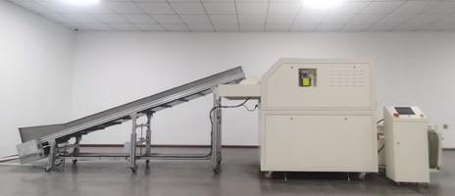 | 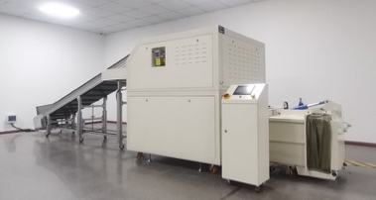 | 5001
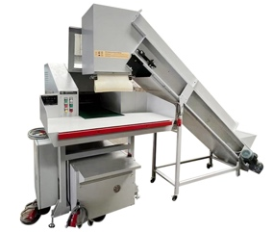 | 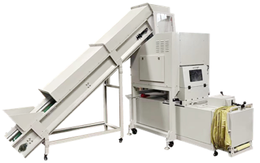 | 5002
📂 Banknote Shredding & Compaction Systems
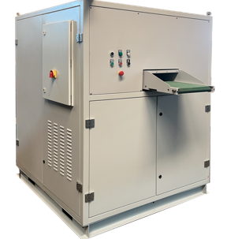 | 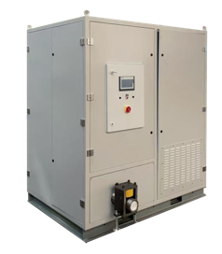 | BM3002P-9075
📂 Three-in-One Secure Destruction Systems (1mm Shredding + Hard Drive Crushing + Degaussing)
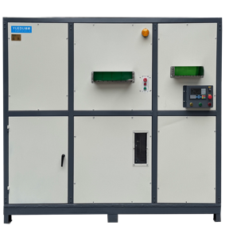 | 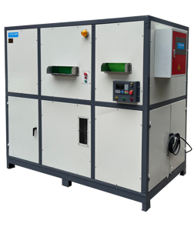 | PZ3020
📂 1mm Ultra-Fine Powder Destruction Systems
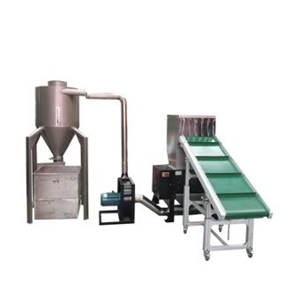 | 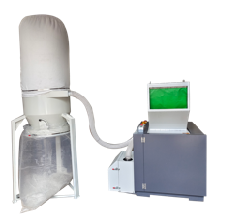 | YTJ300BM1
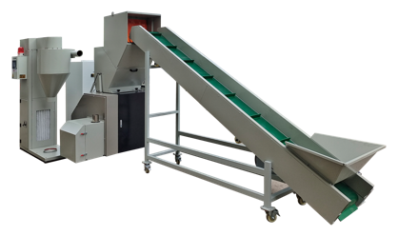 | 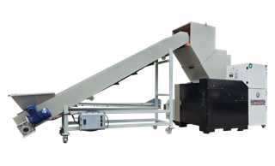 | BM6002
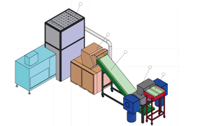 | 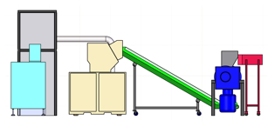 | BM6002P

📂 书本粉碎打包一体机
书本粉碎 & 打包系统
系统定位：
用于成册书本、档案资料、纸质文件的集中销毁，并通过压缩打包实现减容处理。
典型特点：
- 粉碎 + 压块一体化
- 明显降低废料体积，便于运输
- 适合成册书本与厚档案资料
覆盖型号：
YD-4001 ｜ YD-5001 ｜ YD-5002

📂 Book Shredding & Baling Systems
Efficient destruction and compaction of bound books and archives.
• Integrated shredding and baling design
• Optimized for bound books and thick paper archives
• Significant volume reduction for easier handling and transport

Included Models:
YD-4001 ｜ YD-5001 ｜ YD-5002

📄 YD-4001 Integrated Shredding & Baling Machine
40CM入口，每次粉碎90-130张
40 cm feed opening (optional 46 cm or 50 cm), shredding capacity: 90–130 sheets per pass
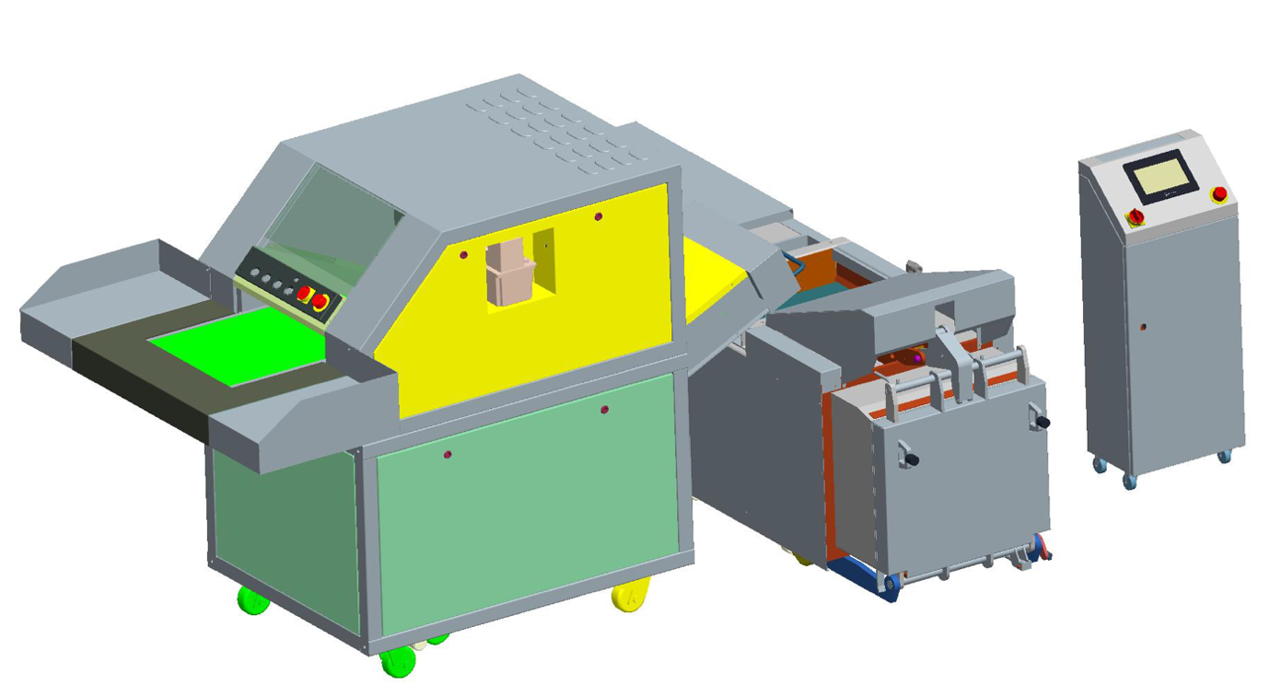
📄 YD-5001
60CM入口，每次粉碎300-500张
60 cm feed opening, shredding capacity: 300–500 sheets per pass
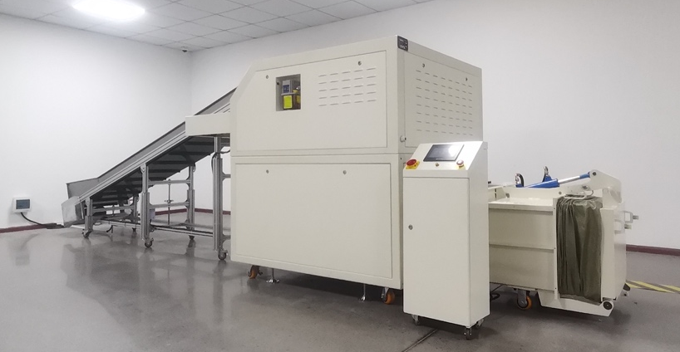 | 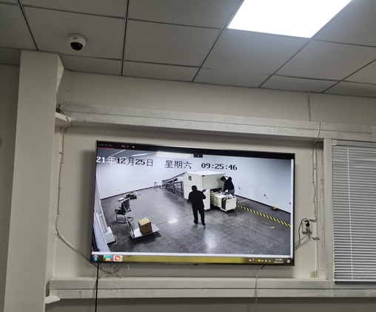
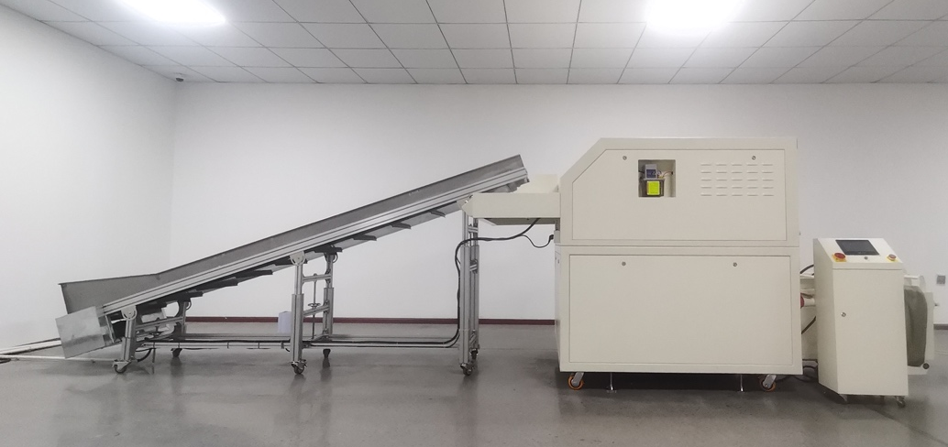 | 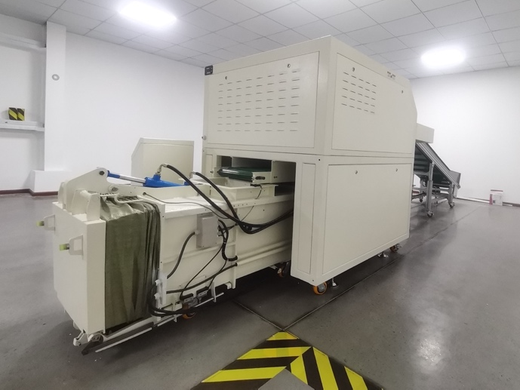
📄 YD-5002
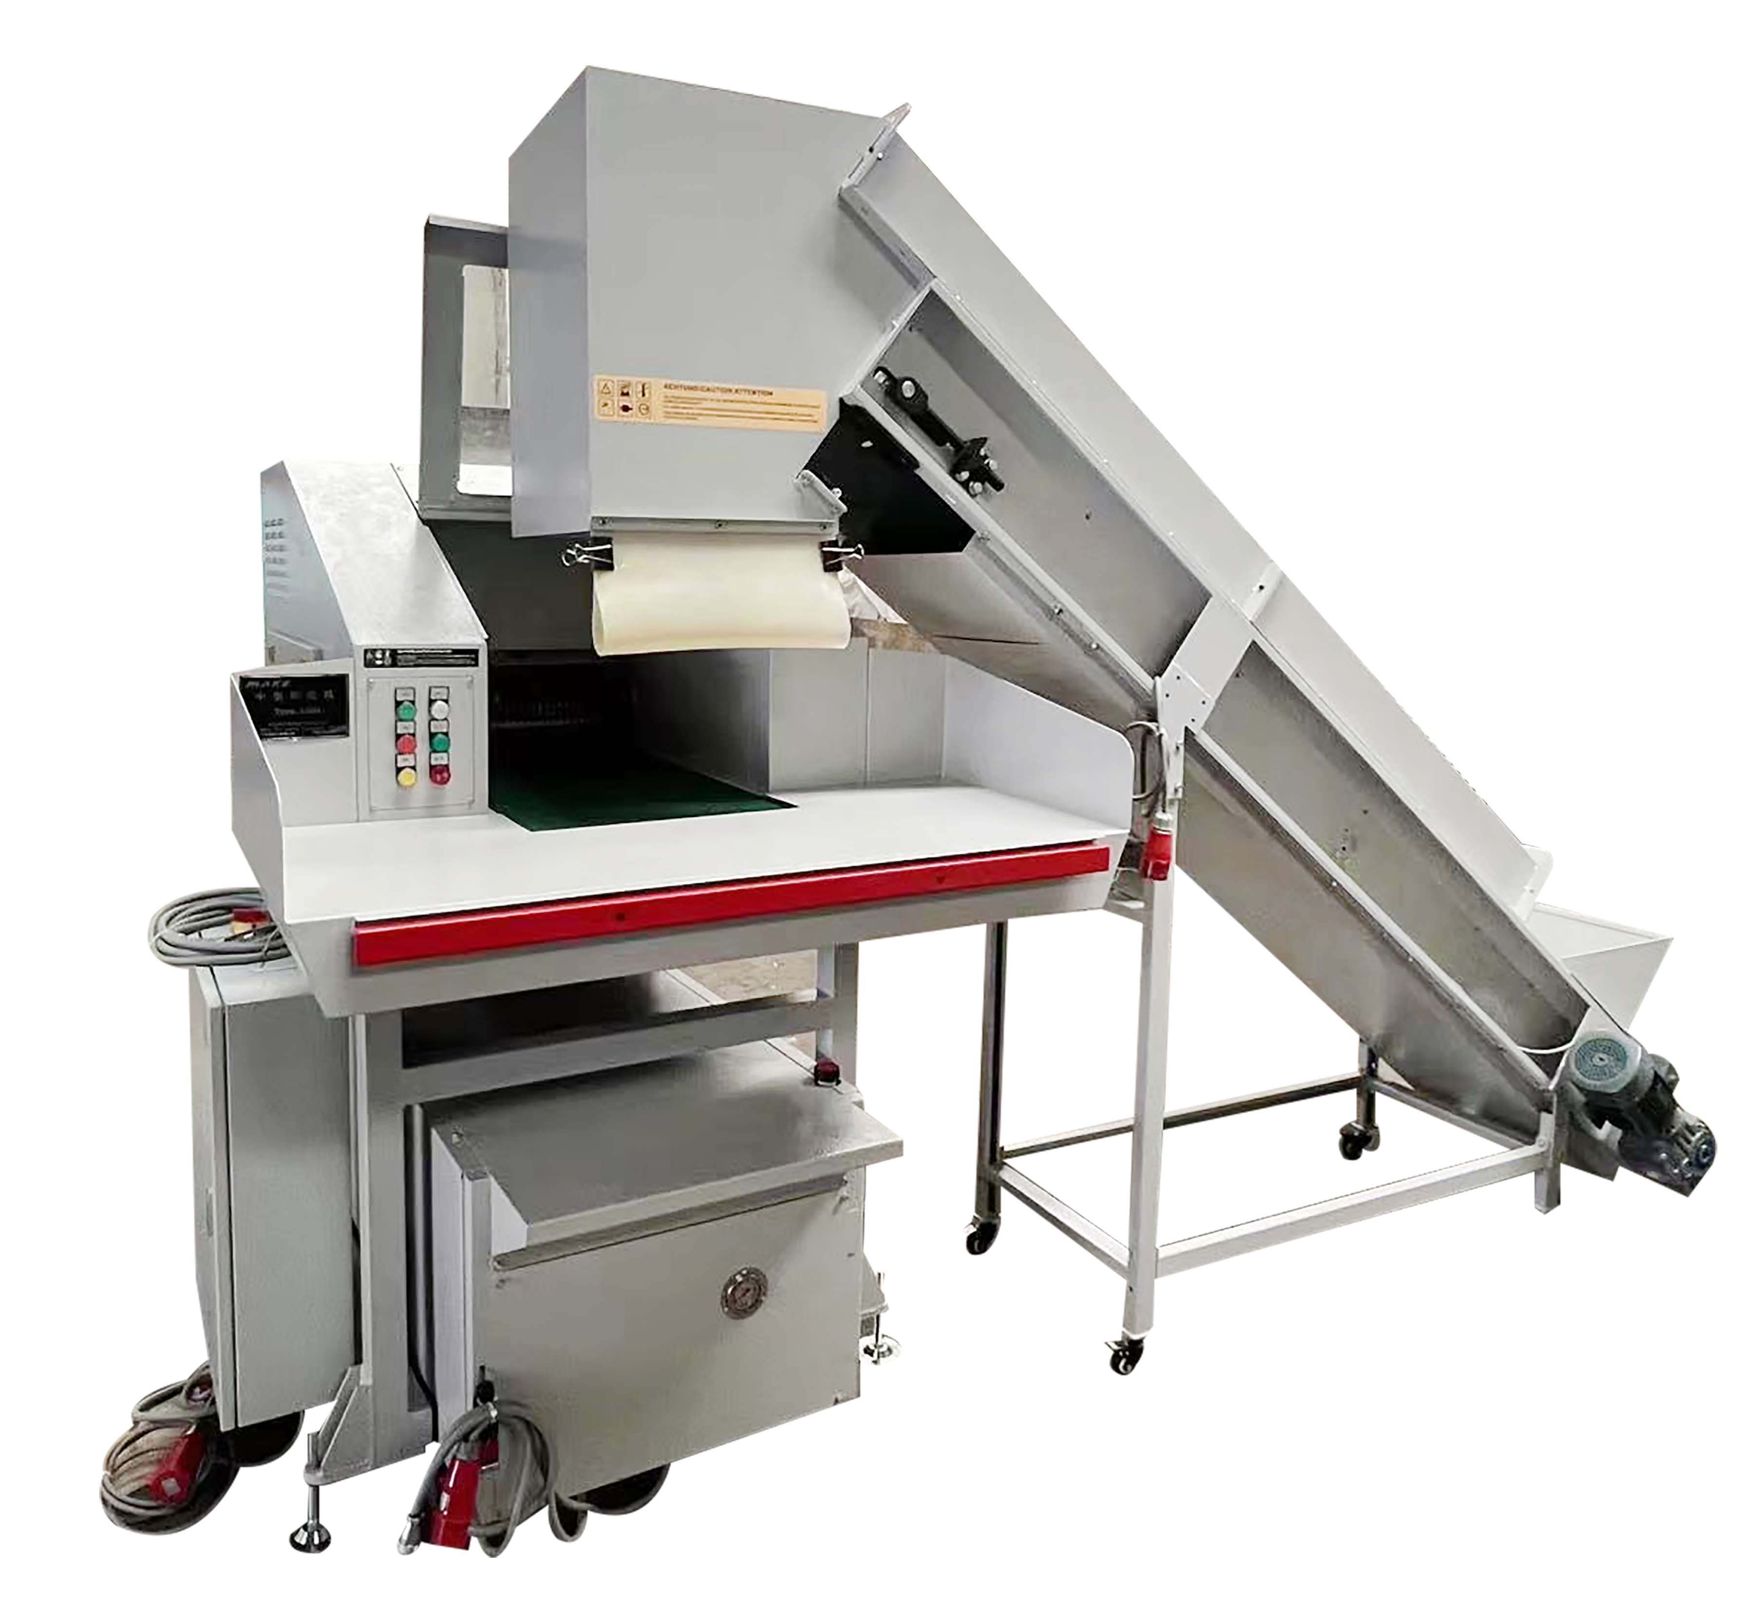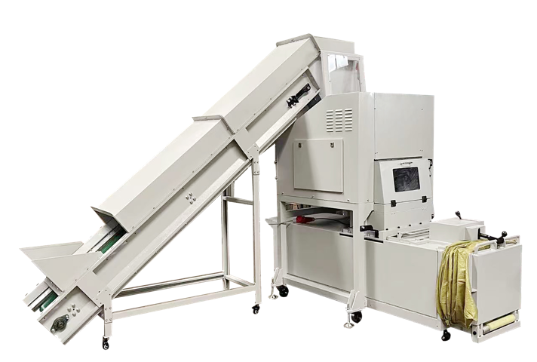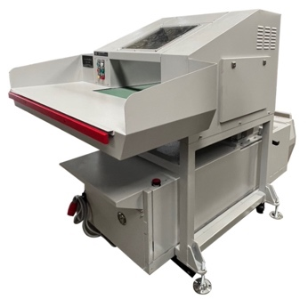

📂 货币粉碎压块一体机
货币粉碎 + 压块系统
专为纸币、现金的保密粉碎及减容处理设计，确保销毁安全可靠。
系统定位：
专为纸币、现金的高安全等级粉碎与减容处理而设计，满足金融机构的合规与安全要求。
典型特点：
- 二级粉碎结构
- 输出颗粒或粉末 + 压块
- 支持金融级安全标准
覆盖型号：
YD-BM3002P-9075

📂 Banknote Shredding & Compaction Systems
Secure shredding and volume reduction of currency and banknotes.
Included Models:
YD-BM3002P-9075
High-Security Banknote Destruction & Briquetting System

📄 Central Bank Banknote Destruction System (BDS)
High-Security Banknote Destruction & Briquetting System
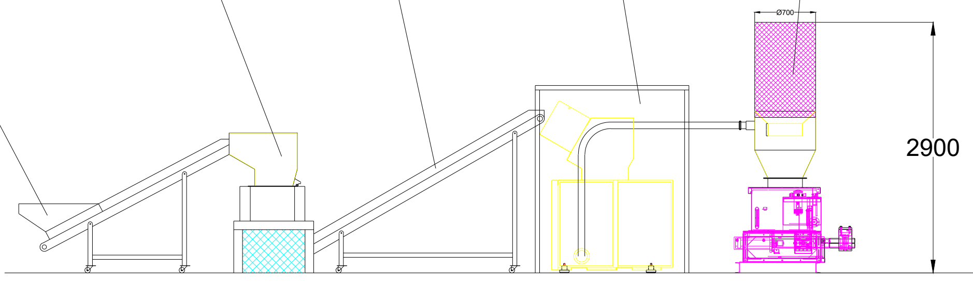
The system adopts a modular, multi-stage destruction process designed for secure and continuous banknote disposal:
Sorting Platform
→ Enclosed Conveyor Feeding
→ Primary Shredder (Dual-Shaft)
→ Conveying System
→ Secondary Fine Shredder
→ Negative Pressure Air Conveying
→ Dust Removal System
→ Buffer Silo
→ Briquetting Machine
→ Briquetted Output

Scalable & Modular Design
The system is designed with a fully modular and scalable architecture.
It can be expanded, Additional shredding lines, buffer capacity, or briquetting units can be integrated as needed.

System Capacity
- Nominal throughput: 300–500 kg/hour
- Designed for continuous operation in central bank banknote destruction facilities

📄 YD-BM3002P-9075 | Banknote Destruction Machine
Paper Shredder with Integrated Baler and Compactor
YUEDU Brand | Model: BM3002P-9075
Banknote Destruction Machine | Integrated Baler and Compactor | Output
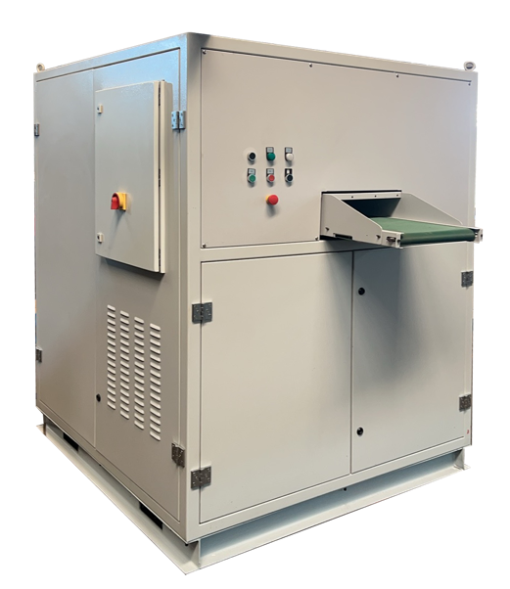 | 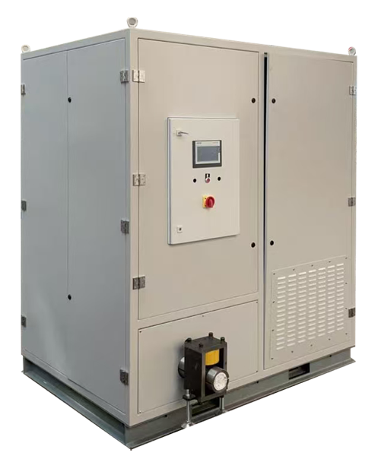 | 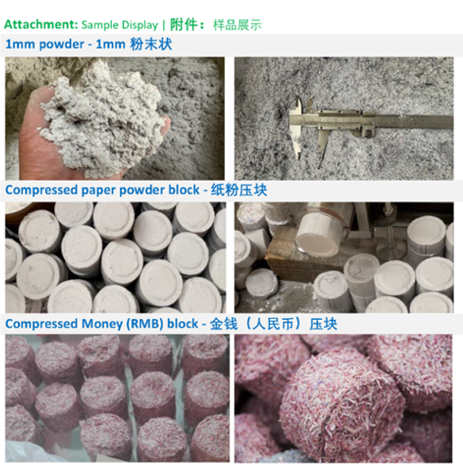
Shredder Specifications:
• Single Feed Capacity: 100 sheets; Hourly Shredding Capacity: 100-150KG/H
• Feed Width: 420mm
• Power: 22KW
• Dimensions: 3380*1440*2220mm
Shredding Process:
• Two-stage shredding with dual blade sets.
• Dimensions: 1480*1440*1850mm
• Output: 3mm particles: 100-150KG/H; 1mm particles: 75KG/H
Compacting Process:
• Compressed block diameter: 90mm*40mm; Compacting output: 75KG/H
• Dimensions: 1900*1400*2220mm

User Case: Banknote Shredder and Compactor Combo Machine
Overall Image | Compactor Section | Output | YouTube video | 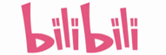bilibili video
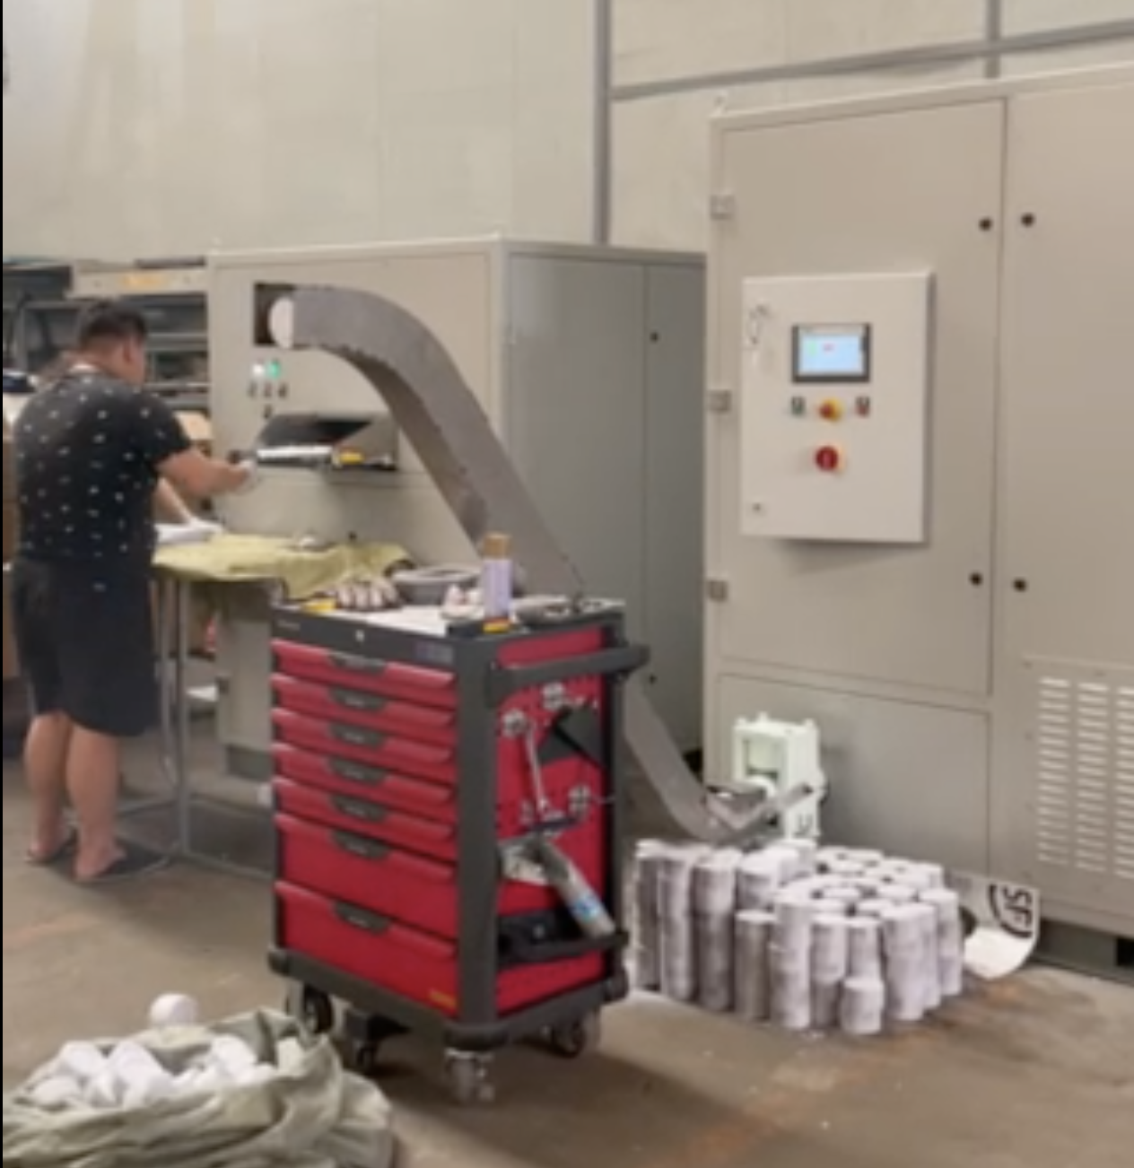 | 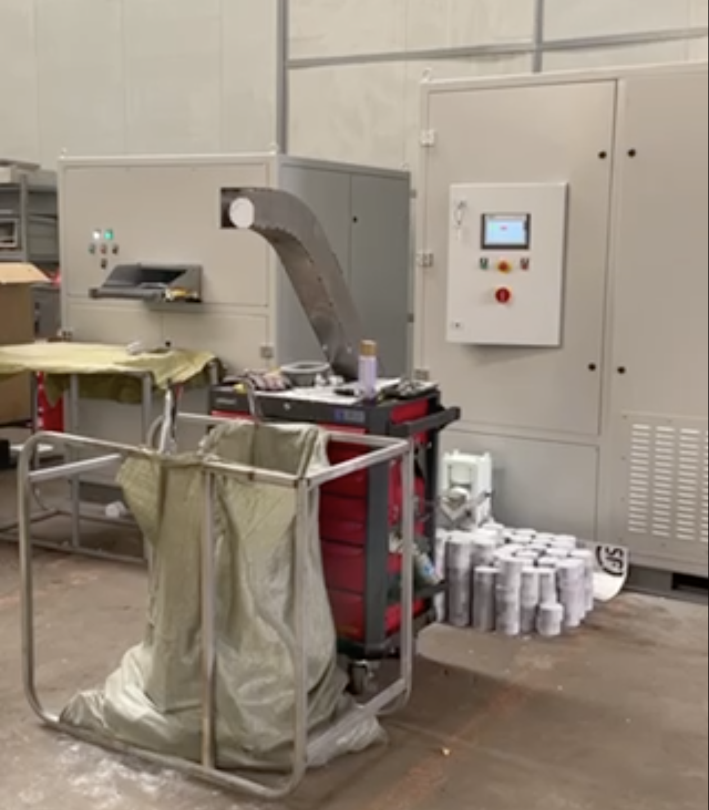 | 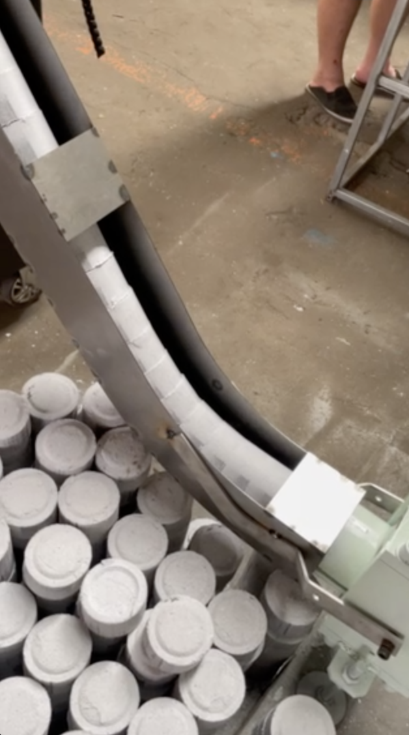 | https://youtu.be/OnOKqf-vkCA  https://youtube.com/shorts/5-dmXbM1Wpw | https://b23.tv/Go7TGFH  https://b23.tv/ToFqYLg
• Retail Price: ¥650,000 RMB (89,050.65 USD)
• Agent Price: ¥450,000 RMB (61,650.45 USD)

📄 YKJ90-75 YKJ90-250 | Compactor
Compactor Selection Table | 纸张粉碎机配套压块机选型表
 | Plan 1 | 方案1 | Plan 2 | 方案2
Model | YKJ90-75 | YKJ90-250
Image  压块机主机图 | 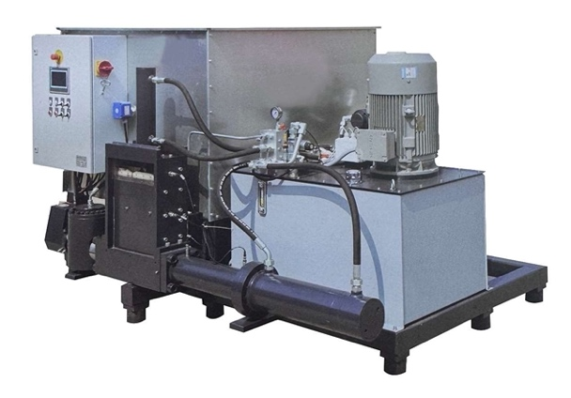 | 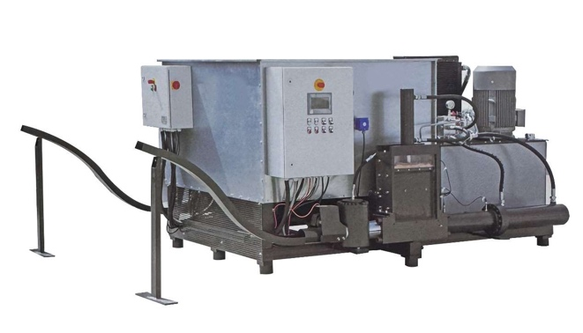
Features  特点 | Output Ports: 1  Hourly Capacity: 75 kg/hour  1个出料口  每小时产量75KG | Output Ports: 2  Hourly Capacity: 250 kg/hour  2个出料口  每小时产量250KG
Specifications  参数 | Compaction Diameter: 90mm  Compactor Output: 75 kg/hour  Motor Power: 11kW  Machine Weight: 1000kg  Dimensions: 1700mm x 2300mm x 1400mm  压块直径：90mm  产 量：75kg/H  马达功率：11kw  机器重量：1000kg  外形尺寸:1700*2300*1400 | Compaction Diameter: 90mm  Compactor Output: 250 kg/hour  Motor Power: 45kW  Machine Weight: 2200kg  Dimensions: 2700mm x 2300mm x 1400mm  压块直径：90mm  产 量：250kg/H  马达功率：45kw  机器重量：2200kg  外形尺寸:2700*2300*1400
Delivery (Working) | 30-45 | 30-45
价格RMB | 25万元 | 65万元
价格-代理  RMB | 17.5万元 | 45.5万元
Pricing USD Retail  美元零售 | 34,257 USD | 89,055 USD
Pricing USD Agent  美元代理价 | 23,977 USD | 62,337 USD

📂 三合一粉碎系统：1mm粉碎+硬盘销毁+消磁 一体机
一站式销毁解决方案，满足纸质文件、电子存储介质及磁性介质的综合销毁需求。
典型特点：
- 1mm 粉末级碎纸
- 硬盘物理破坏
- 高强度磁场消磁
覆盖型号：
YD-PZ3020 ｜ YD-PZ3025 ｜ YD-PZ4025 ｜ YD-PZ5030 ｜ YD-PZ6030

📂 Three-in-One Secure Destruction Systems (1mm Shredding + Hard Drive Crushing + Degaussing)

One-stop solution for destroying documents, hard drives, and magnetic media.
Included Models:
YD-PZ3020 ｜ YD-PZ3025 ｜ YD-PZ4025 ｜ YD-PZ5030 ｜ YD-PZ6030

📄 YD-PZ系列｜三合一保密销毁系统
✅一站式销毁解决方案：📘书本粉碎 + 💽硬盘销毁 + 🧲磁场消磁
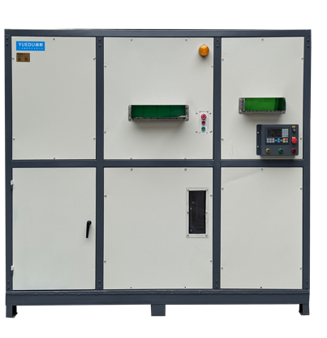 | 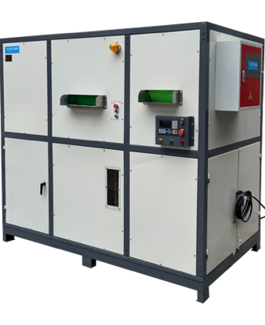 | 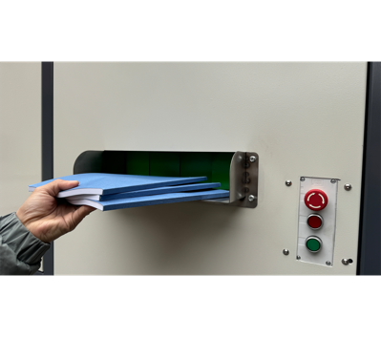 | 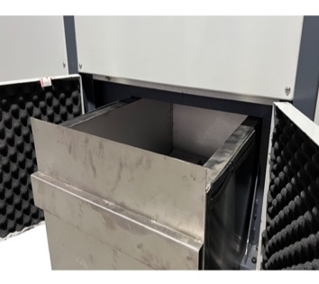
整机正面图 | 整机右侧图 | 入口1：书本 | 全封闭废料仓
🏆二十年的设计卓越 | 创新的客户应用与全球独创技术
YD-PZ系列产品凝聚了上海越都科技在粉碎与保密领域二十年的技术经验。
✅ 核心优势与技术特点
●符合保密销毁的要求：纸张1mm粉末状  ●处理极限材料：超厚、超硬材料的粉碎和  销毁，如：硬盘、硒鼓、不锈钢。  ●适应低熔点材料：采用新材料制作的信息  存储介质销毁。 | ●符合EHS标准：符合跨国企业的环境、健康与安全标准。  ●高效低耗：节省成本，提供卓越性能。  ●兼容玻纤和矿物材料：专为坚硬、磨蚀性物质设计。
🌍行业领军者的首选
广泛应用于各类单位的信息安全销毁需求，是众多世界500强企业优先采购的保密销毁设备。
🔧技术参数：
产品型号 | YD- PZ3020 | YD- PZ3025 | YD- PZ4025 | YD-PZ5030 | YD-PZ6030
碎纸张入口 | 300*130 mm | 300*130 mm | 400*200 mm | 500*300 mm | 600*500 mm
碎纸颗粒 | 1*2mm | 1*2mm | 1*2mm | 1*2mm | 1*2mm
碎纸张数 | 80-130张 | 100-150张 | 150-200张 | 200-300张 | 300-500张
碎硬盘入口 | 20cm | 25cm | 25cm | 30cm | 30cm
消磁(磁场强度) | ≥12000Gs | ≥12000Gs | ≥12000Gs | ≥12000Gs | ≥12000Gs
整机功率 | 8.2KW, 380V | 11.5KW, 380V | 13.5kw, 380V | 19KW, 380V | 26.5KW, 380V
整机尺寸 | 1.8*1.2*1.8m | 1.8*1.2*1.8m | 2*1.2*1.8m | 2.2*1.2*1.8m | 2.2*1.2*1.8m
整机重量 | 950KG | 1100KG | 1200KG | 1300KG | 1500KG
产品价格 | 19.8769万元 | 25万元 | 29.971万元 | 39.7595万元 | 49.9791万元

📄 YD-PZ Series | Three-in-One Secure Destruction System
✅ One-Stop Destruction Solution｜📘 Books + 💽 Hard Drives + 🧲 Magnetic Degaussing
 | 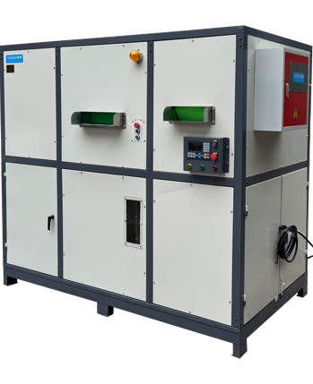
Front View | Right Side View | Safe Feeding Inlet | Fully Enclosed Waste Bin
🌍 20 Years of Engineering Excellence｜Innovative Customer-Centric Design & Proprietary Global Technology
The YD-PZ Series is the result of two decades of expertise in shredding and secure destruction. It is designed to meet the evolving needs of high-security document and media disposal.
✅ Key Features & Technical Advantages
●Meets top-tier confidentiality standards:  Shreds paper into 1mm micro-powder.  ●Handles extreme materials:  Capable of destroying ultra-thick and ultra-hard media, including hard drives, toner cartridges, and stainless steel components.  ●Compatible with low melting point materials:  Suitable for destroying modern storage media made with heat-sensitive new materials. | ●EHS-Compliant:  Fully aligned with global Environmental, Health, and Safety standards, trusted by multinational corporations.  ●Energy-efficient performance:  Reducing operational costs while maintaining performance.  ●Supports abrasive and composite materials: Specially designed to process glass fiber, mineral-based, and high-wear materials.
🔧 Technical Specifications:
Product Model | YD- PZ3020 | YD- PZ3025 | YD- PZ4025 | YD-PZ5030 | YD-PZ6030
Inlet Dimensions (mm) | 300*130 | 300*130 | 400*200 | 500*300 | 600*500
Shred Size | 1*2mm | 1*2mm | 1*2mm | 1*2mm | 1*2mm
Sheet Capacity | 80-130 | 100-150 | 150-200 | 200-300 | 300-500
Magnetic Field Strength | ≥12000Gs | ≥12000Gs | ≥12000Gs | ≥12000Gs | ≥12000Gs
Motor Power | 8.2KW, 380V | 11.5KW, 380V | 13.5kw, 380V | 19KW, 380V | 26.5KW, 380V
Dimensions (m) | 1.8*1.2*1.8m | 1.8*1.2*1.8m | 2*1.2*1.8m | 2.2*1.2*1.8m | 2.2*1.2*1.8m
Weight (kg) | 950KG | 1100KG | 1200KG | 1300KG | 1500KG
Pricing RMB | ¥198769 | ¥250000 | ¥299710 | ¥397595 | ¥499791
Pricing USD | $27,996 | $35,212 | $42,212 | $55,999 | $70,395

📂 1mm粉末状销毁系统 1mm Ultra-Fine Powder Destruction Systems
Designed for ultra-high-security destruction requirements, producing powder-like final output.
系统定位：
针对一级及绝密级信息销毁需求设计，粉碎后输出为 1×1 mm 粉末状，信息不可恢复。
典型特点：
- 粉末级输出
- 可配置集中式生产线
- 适合高等级保密单位长期运行
覆盖型号：
YD-YTJ300BM1 ｜ YD-YTJ400BM1 ｜ YD-YTJ500BM1 ｜ YD-YTJ600BM1
YD-BM4001 ｜ YD-BM4002 ｜ YD-BM6001 ｜ YD-BM6002 ｜ YD-BM6002P
YD-BM9002 ｜ YD-BM9002P

📂 1mm Ultra-Fine Powder Destruction Systems
Designed for top-secret and Level-1 confidential destruction, producing irreversible 1×1 mm powder output.
Included Models:
YD-YTJ Series ｜ YD-BM Series ｜ YD-BM-P Series

📄 Ultra-High Security - Selection 9
Selection Table 9: Ultra-High Security Confidential Destruction Equipment
(Equivalent to DIN 66399 P-7 | 1×1 mm Powder Output)– v12
 | Plan 1:  YD-YTJ400BM1  YD-YTJ500BM1  YD-YTJ600BM1 | Plan 2:  YD-BM4001 | Plan 3：  YD-BM4002 | Plan 4：  YD-BM6001 | Plan 5：  YD-BM6002 | Plan 6：  YD-BM6002P | Plan 7：  YD-BM9002  YD-BM9002P
Pricing USD | 300BM1, 17,143  400BM1, 21,150  500BM1, 25,380  600BM1, 29,610 | 21,150 | 63,450 | 54,990 | 70,500 | 141,000 | 9002, 141,000  9002P, 282,000
Entry Image | 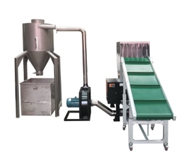 | 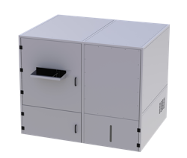 | 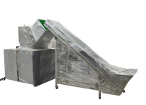 | 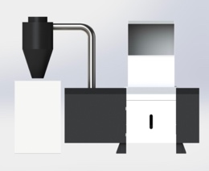 | 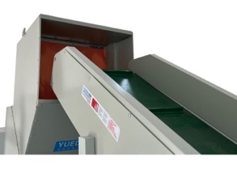 | 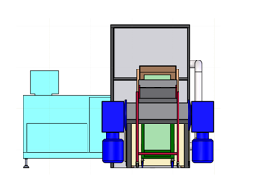 | 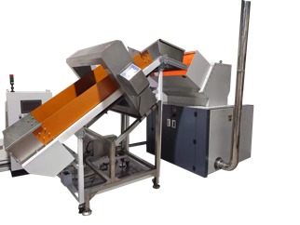
Full Machine Image | 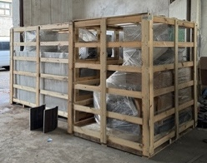 | 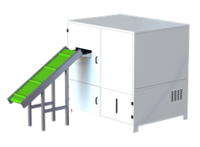 | 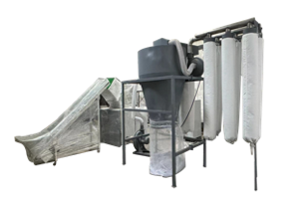 | 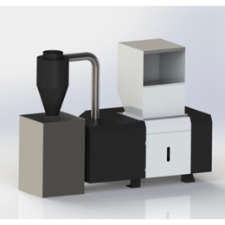 | 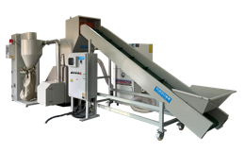 | 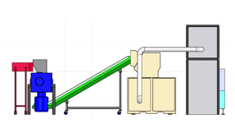 | 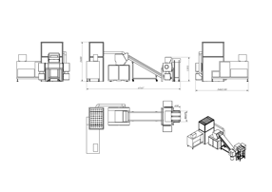
Crushing efficiency | 35 / 40 / 45KG/H | 100KG/H | 60KG/H | 50KG/H | 80KG/H | 80KG/H | 150KG/H
Shredded Size | 1*1mm  Adjustable, e.g. 2/5mm etc. | 1*1mm | 1*1mm | 1*1mm | 1*1mm | 1*1mm | 1*1mm
Sheets Shredded | 100-300 sheets | 300-500 sheets | 200-300 sheets | 300-500 sheets | 300-500 sheets | 300-500 sheets | 300-500 sheets
Entry Size | 40/ 50 / 60 CM | 60CM | 40CM | 60CM | 60CM | 60CM | 90CM
Applicable Scenarios | County-level units | Provincial and municipal units | Provincial and municipal | County-level | Provincial and municipal units | Provincial/Headquarters | Organizational Headquarters
 | https://youtu.be/q9D_uf_TdZI | https://youtu.be/RU7OpMIkUoc | https://youtube.com/shorts/KMaiAuUlj0s | https://youtu.be/i_cCRB-VJRw | https://youtu.be/v419WXU13oc | https://youtube.com/shorts/p3rOTUcy4Zg | https://youtube.com/shorts/p3rOTUcy4Zg
Attachment: Sample Display | 附件：样品展示
1mm powder - 1mm粉末状
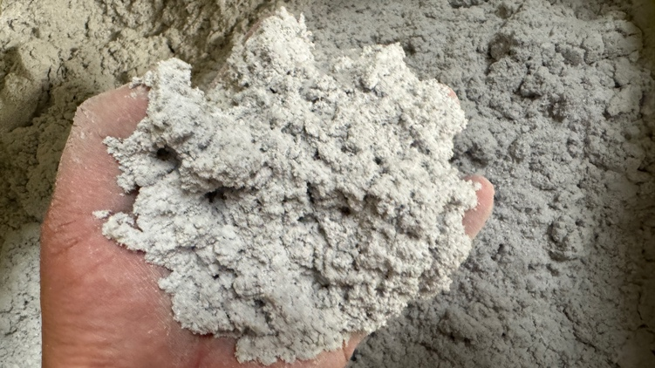 | 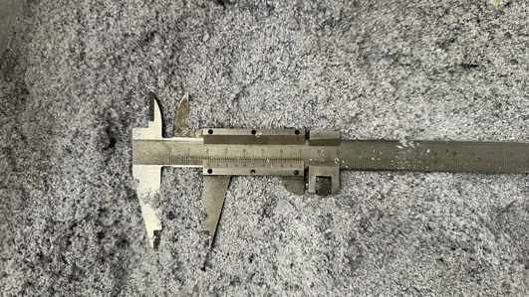 | 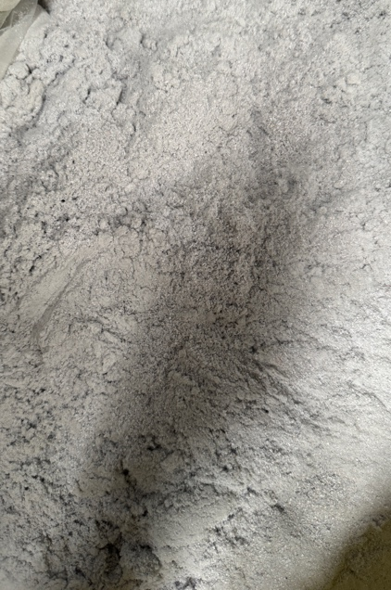
Compressed paper powder block - 纸粉压块
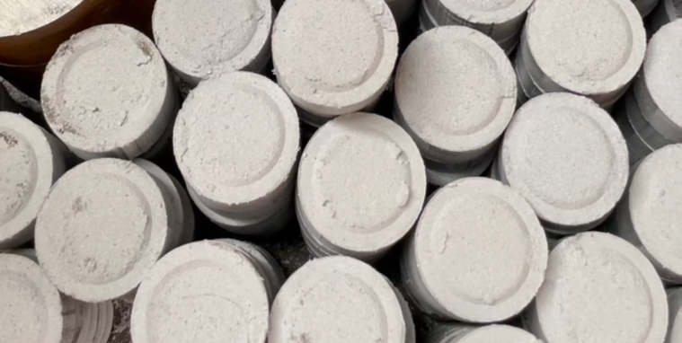 | 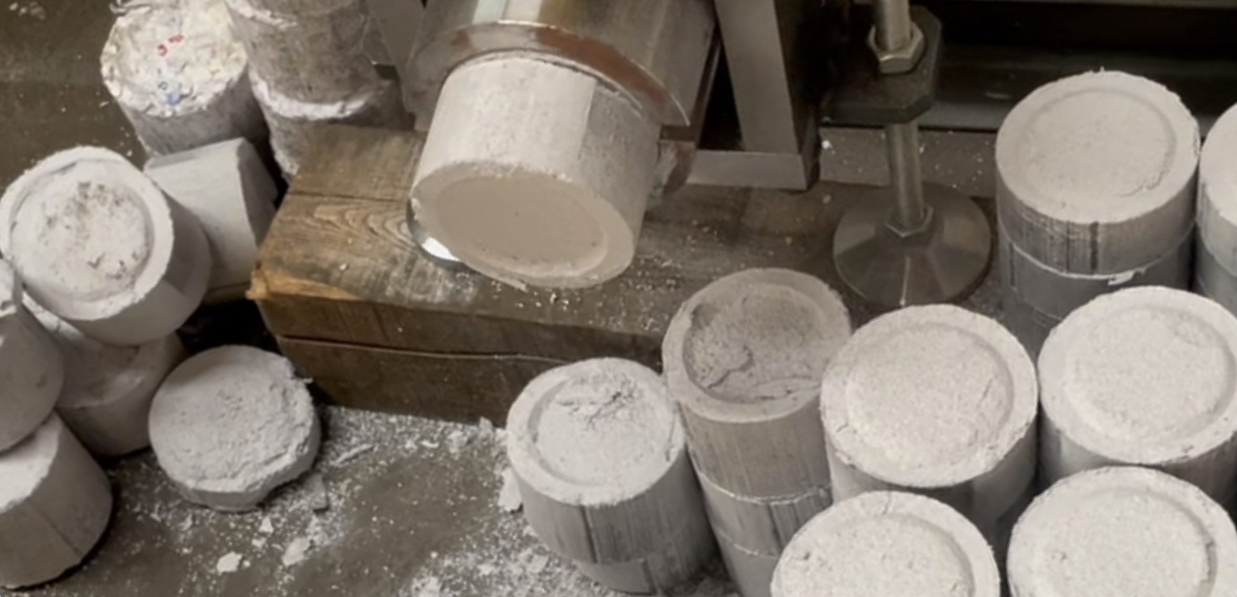 | 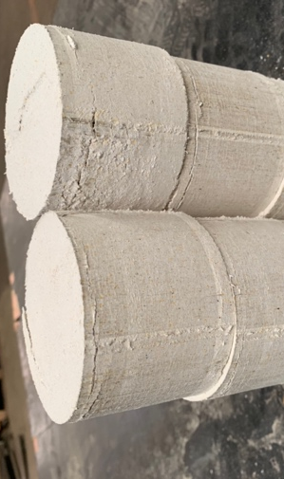
Compressed Money (RMB) block - 金钱（人民币）压块
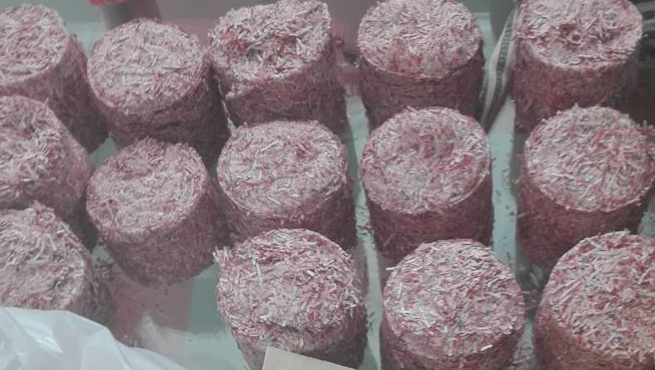 | 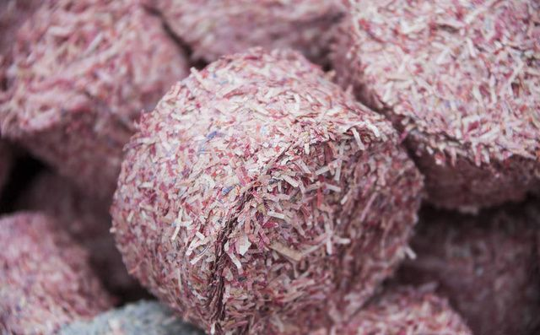 | 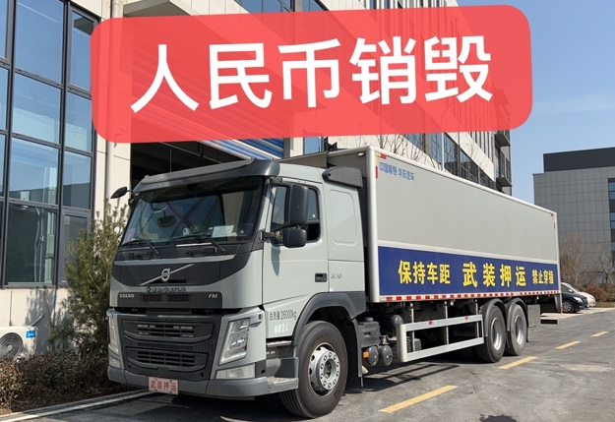

📄 YD-YTJ系列选型表600BM1 500BM1 400BM1
🖼️ Product Overview产品概览
📸用户现场  On-Site Usage | 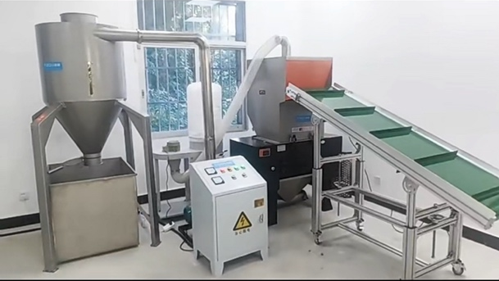
🌫️粉碎效果  Shredding Result | 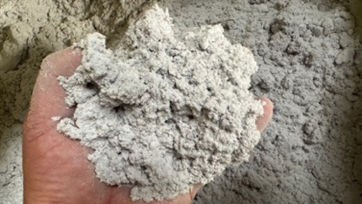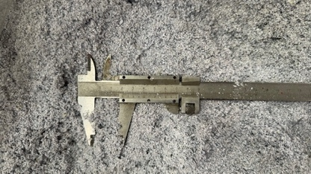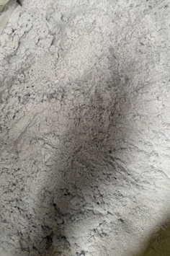
✂️ Shreddable Materials可以粉碎的物品
书本、纸张；光盘；卡；手机芯片；
PVC宣传板，塑料宣传板、KT板材、学校和单位活动展板；
其它类纸张纤维材质介质；其它类塑料材质介质
🔧 Technical Specifications主要参数
🆔型号 | YD-YTJ600BM1 | YD-YTJ500BM1 | YD-YTJ400BM1 | YD-YTJ300BM1
📥进纸宽度 | 60CM宽度、  38CM高度 | 50CM宽度、30CM高度 | 40CM宽度、26CM高度 | 30CM宽度  22CM高度
✂️碎后尺寸 | 1*1mm粉末状，可调整粉碎尺寸为1*2mm, 8mm, 3mm等
📑碎纸能力 | 300-500张 | 200-300张 | 100-200张 | 80-130张
🔌额定功率 | 19.12KW, 三相380V | 15KW, 三相380V | 10KW, 三相380V | 7.5KW, 三相380V
💰价格(¥) | 21万元 | 18万元 | 15万元 | 12万元
➕ Custom Case定制方案
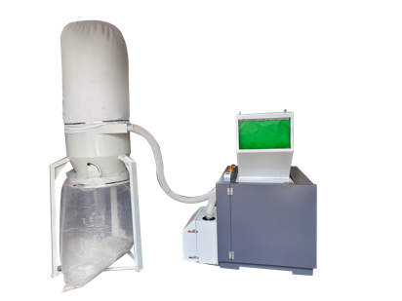 | 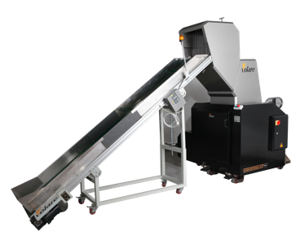 | 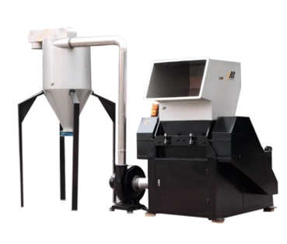 | 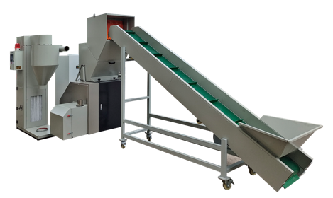

📄 YD-YTJ600BM1 500 400 300
🖼️ Product Overview
📸On-Site Usage
🌫️Shredding Result
✂️ Shreddable Materials
Books and paper documents, CDs/DVDs
Cards and chip-based items (e.g. SIM cards, mobile chips)
PVC advertising boards, plastic display panels, KT boards, school and institutional event panels
Other paper- or fiber-based media
Other plastic-based materials

🔧 Technical Specifications
🆔Model | YD-YTJ600BM1 | YD-YTJ500BM1 | YD-YTJ400BM1 | YD-YTJ300BM1
📥Feed Width | 60CM*38CM | 50CM*30CM | 40CM*26CM | 30CM*22CM
✂️ Cut Size | 1*1mm粉末状，可调整粉碎尺寸为1*2mm, 8mm, 3mm等
📑 Max Sheets | 300-500 | 200-300 | 100-200 | 80-130
🔌Power | 19.12KW,3 phase 380V | 15KW,3 phase 380V | 10KW,3 phase 380V | 7.5KW, 3 phase 380V
💰Price (USD) | 29,610 | 21,150 | 21,150 | 17,143
➕ Custom Case

📄 YD-BM4001
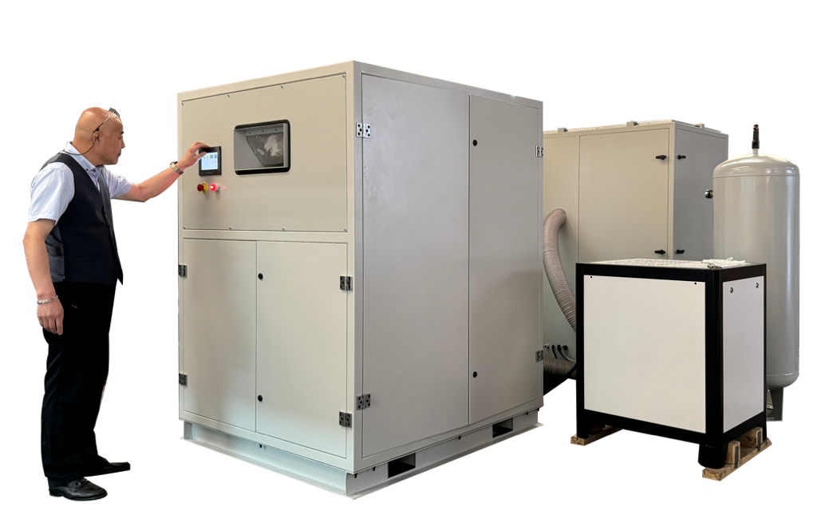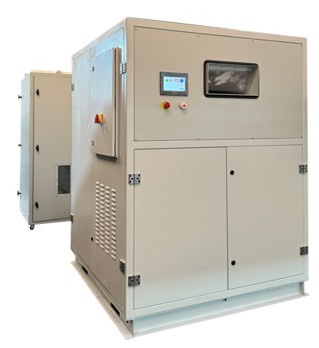

1mm powder - 1mm粉末状
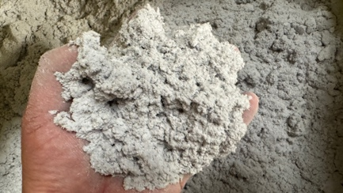 | 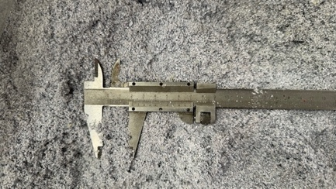 | 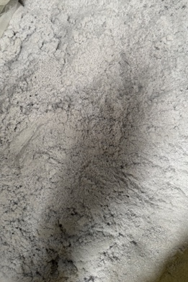
Shredder Specifications:
• Single Feed Capacity: 100 sheets; Hourly Shredding Capacity: 100-150KG/H
• Output: 3mm particles: 100-150KG/H; 1mm particles: 75KG/H
https://www.youtube.com/watch?v=Kc4YdBsiQKo
➕ Custom Case定制案例
Banknote Destruction Machine | Integrated Baler and Compactor | Output
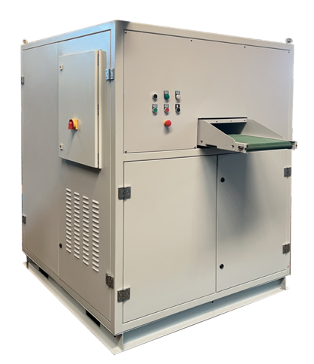 | 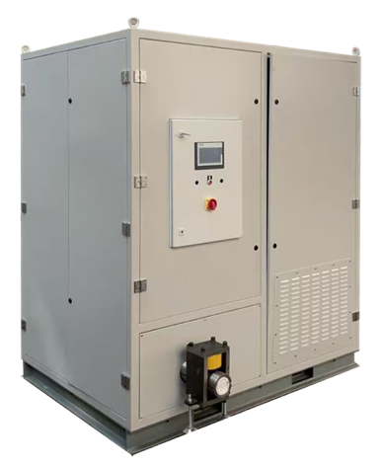 | 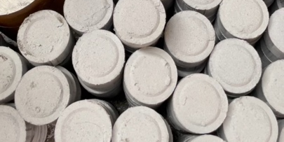

Video1: https://youtu.be/OnOKqf-vkCA Video2: https://youtube.com/shorts/5-dmXbM1Wpw

📄 YD-BM6002
🖼️ Product Overview产品概览
越都YD-BM6002机型（1*1mm粉末状）
适合场景 | 绝密销毁，保密1级销毁室，集中大批量粉碎涉密书本资料  案例：  某战区 保密室、某政府涉密销毁车间、某企业保密销毁中心
推荐原因 | A 保密程度高，可达到1*1mm粉末状（棉絮状）  B 粉碎效率高，速度快，有效的粉碎涉密单位的大量保密介质材料  C 可调整粉碎尺寸，适合多种销毁工况  D 可粉碎多种涉密介质，性价比高
型号 | YD-BM6002
价格 | 49.7731元
视频链接 | 【书本纸张絮状粉末效果：越都保密涉密销毁系统1mm粉末状效果】 https://b23.tv/Qqb6qwC
入口 | 1个
入口尺寸 | 60CM宽度、28CM高度
粉碎形状 | 1*2mm粉末状，80-100kg/hour  4~5mm粉末状，500 – 650kg/hour  8mm粉末状，1200-1600kg/hour  粉碎尺寸可调整
每次碎纸 | 300-500张
电压 | 380V
功率 | 27KW
可碎材料 | 光盘介质、卡片、芯片、存储介质、线路板、半导体介质
整机图  用户现场 | 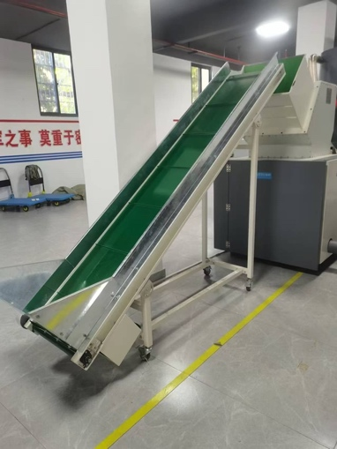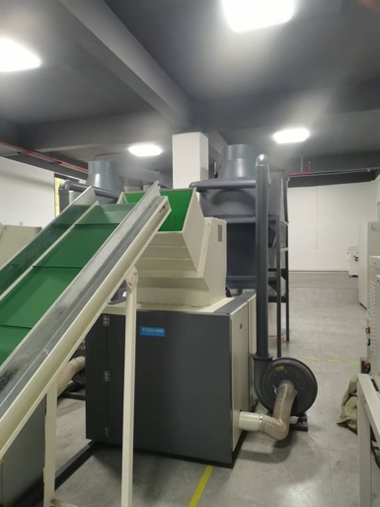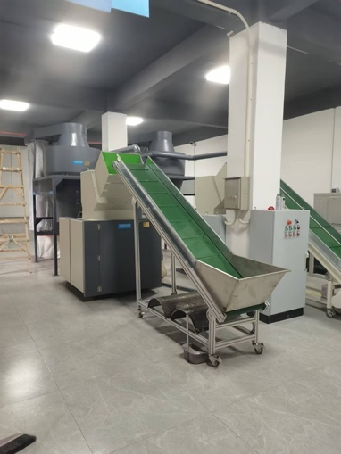

输送带进料。最小尺寸可以达到1mm粉末状。配套大吸力出料除尘系统，有效提升效率。

📄 YD-BM6002
1mm 粉末级高效率保密碎纸系统（1×1 mm 粉末级）
🖼️ Product Overview产品概览
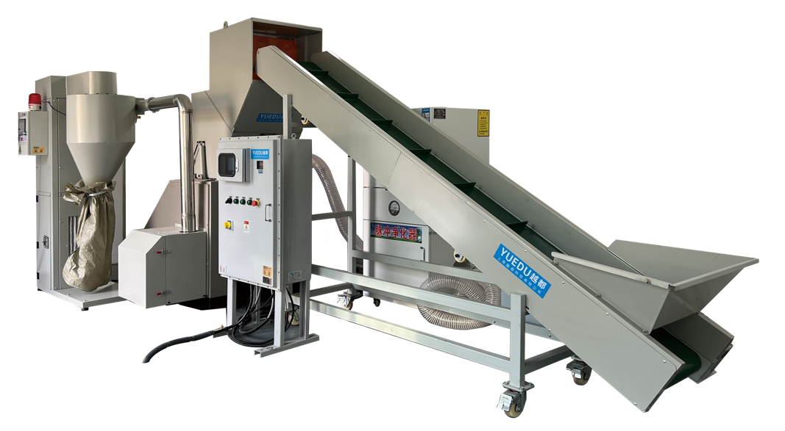 | 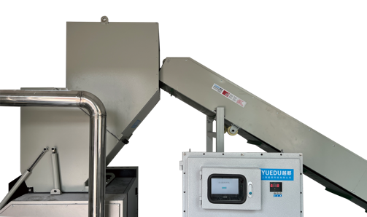
 | 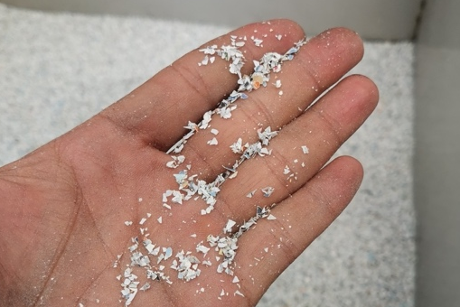
🧩 Application Scenarios 应用场景
🔒🛡️ Secure / Confidential Room / Secure Destruction Center
💰产品价格：碎纸机部分YD-BM6002机型，价格：49.7731万元

🔧技术参数
Model | YD-BM6002 | 📏整体方案三视图：
入口尺寸 | 600 mm (W) × 280 mm (H) | 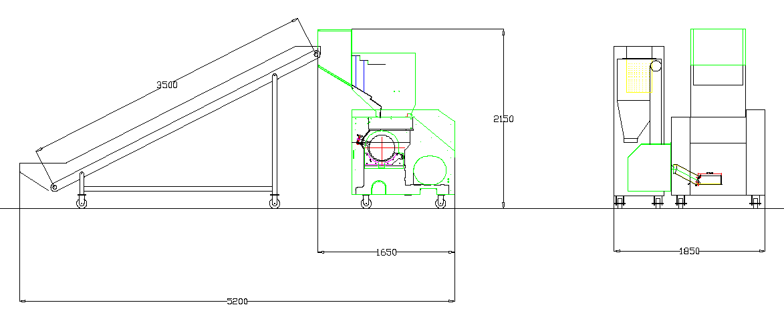
粉碎样式 | Powder (adjustable)
粉碎尺寸 | 1 × 1 mm
粉碎效率 | 1×2 mm: 80–100 kg/hour  4–5 mm: 500–650 kg/hour  8 mm: 1200–1600 kg/hour
单次进纸量 | 300–500 sheets
电压 | 380 V / 3-phase
功率 | 27 kW

➕ Custom Case定制案例
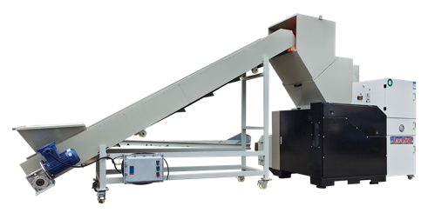 | 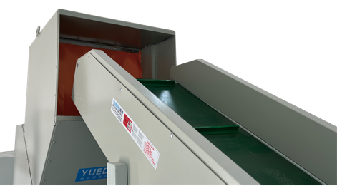 | 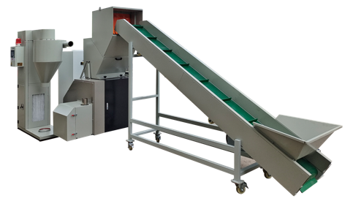
注：以上方案仅供参考，以用户要求的实际交付为准。

📄 YD-BM6002
Flagship 1mm Powder-Level Security Shredding System
🖼️ Product Overview
🧩 Application Scenarios
🔒🛡️ Secure / Confidential Room / Secure Destruction Center

💰 Price: RMB 497,731
🔧 Technical Specifications
Model | YD-BM6002 | 📏整体方案三视图：
Feed Opening Size | 600 mm (W) × 280 mm (H)
Shredding Output Form | Powder (adjustable)
Minimum Particle Size | 1 × 1 mm
Shredding Capacity | 1×2 mm: 80–100 kg/hour  4–5 mm: 500–650 kg/hour  8 mm: 1200–1600 kg/hour
Sheets per Batch | 300–500 sheets
Power Supply | 380 V / 3-phase
Installed Power | 27 kW

➕ Case
📌 Note:The above solution is for reference only. Final delivery is subject to the user’s confirmed requirements.

📄 YD-BM6002P粉碎系统
全功能粉碎、除尘、打包一体化系统
一次粉碎 + 二次粉碎 + 除尘 + 打包压块的一体化系统解决方案
🖼️产品概览Product Overview
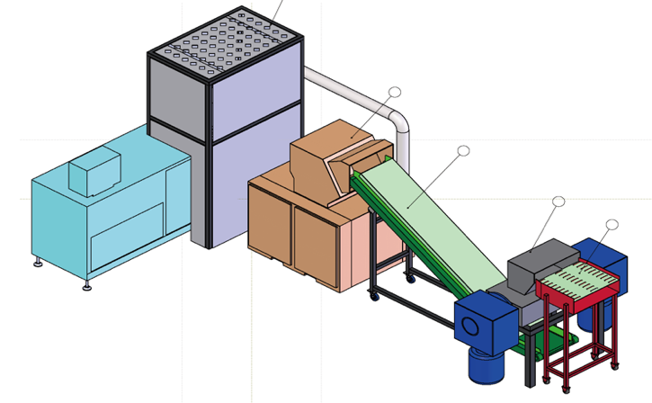 | 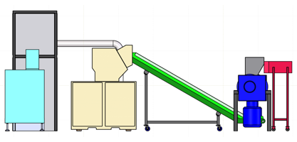
 | 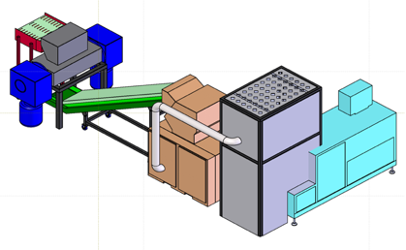
🧩 应用场景Application Scenarios
🔒🛡️保密室/ Secure Confidential Room 保密销毁中心 / Secure Destruction Center

💰产品价格：
碎纸机部分YD-BM6002机型，价格：49.7731万元
打包压块机 YD-DBJ6002P机型，价格：49.75万元
📏整体方案三视图：
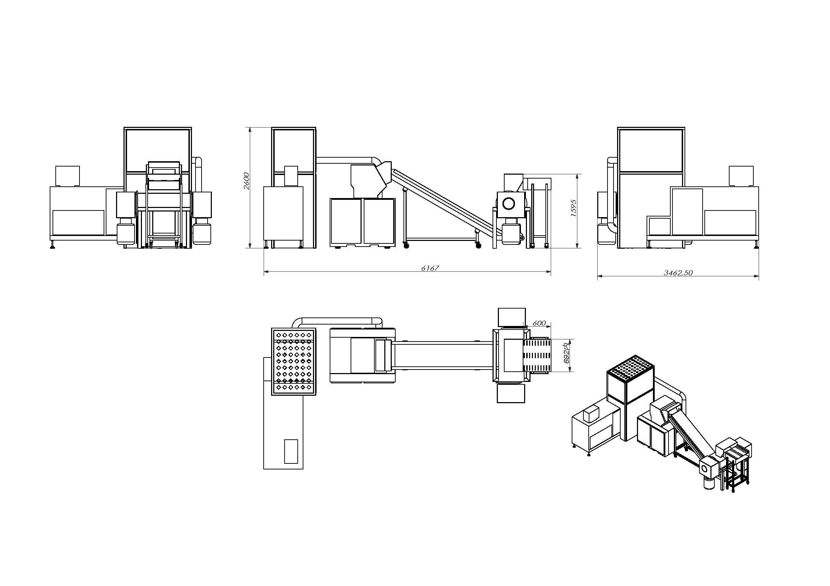
注：以上方案仅供参考，以用户要求的实际交付为准。

📄 YD-BM6002P Integrated Shredding System
All-in-One Shredding, Dust Collection & Baling System
Integrated system solutions for shredding, secondary processing, dust removal, and baling.
🖼️ Product Overview
🧩 Application Scenarios
🔒🛡️Secure / Confidential Room / Secure Destruction Center
💰 Product Pricing:
Shredder Unit – Model: YD-BM6002 → ¥497,731
Baler & Compactor Unit – Model: YD-DBJ6002P → ¥497,500
📏 System Overview: Three-View Diagram
(Front / Side / Top Views of the Integrated System)
📌 Note:The above solution is for reference only. Final delivery is subject to the user’s confirmed requirements.

可定制尺寸：提供2毫米、3毫米和5毫米规格。若需其他选项，请联系我们。
长期运行：请均匀投料，并在粉碎室内材料完全处理后再加入新的材料。对于连续投料，每批次的投料量不得超过表格中规定值的三分之一。
Customizable Sizes: Available in 1mm, 3mm, and 5mm specifications. For additional options, please contact customer service.
For Long-Term Operation: Feed materials evenly and wait until the materials in the shredding chamber are fully processed before adding more. For continuous feeding, ensure each batch is no more than one-third of the value specified in the table.

