🧑‍💼 CEO致辞
页面路径： /about/ceo-message
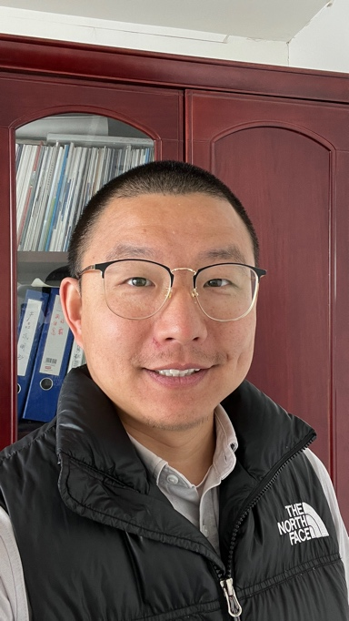

亲爱的合作伙伴们：
👋 欢迎来到 越都科技（YUEDU）！
🧭 自公司创立以来，我们始终坚持一个使命：
提供安全、高效、可定制的粉碎解决方案，真正解决客户在销毁环节中的核心问题。
💬 我们始终专注于客户的真实需求，正是这种**“以客户为中心”**的理念，支撑了越都不断的发展与壮大。
📚 我们从沃伦·巴菲特、查理·芒格、段永平等企业家的思想中汲取灵感，致力于打造一个：
- 🎯 以需求为驱动 的企业
- 🌱 长期主义 为导向的战略
- 🧠 常识和实效 导向的运营体系
- 🫱‍🫲 本分做人做事 的文化基础
🛠 我始终相信，
真正的好企业，不只是卖出产品，而是：
✅ 建立信任
✅ 维护合作关系
✅ 持续为客户创造真实可感的价值
🔐 每一套解决方案，背后承载的，不只是技术，更是我们对客户安全、隐私和未来保障的庄严承诺。
🙏 在此，我谨向所有信任越都的客户与合作伙伴表示由衷感谢。
正因为有你们，我们才能坚定地前行、持续地创新。
🤝 未来，我们将继续携手并进，不断突破，共创更大的价值！

敬礼，
✍️ 邓浩
创始人 & CEO
上海越都科技有限公司

🧑‍💼 CEO Message
Page URL: /about/ceo-message

Dear Partners,
👋 Welcome to YUEDU!
🧭 Since our founding, YUEDU has had a singular mission:
To deliver secure, efficient, and customized shredding solutions that truly solve the challenges our clients face.
💬 We’ve always placed our focus on solving real customer problems, and this unwavering commitment to understanding their needs and delivering value has been key to our success.
📚 As a company, we draw inspiration from business legends like Warren Buffett, Charlie Munger, and Duan Yongping.
We are building a demand-driven organization grounded in:
- 🎯 Long-term thinking
- 🤝 Integrity
- 🧠 Practical wisdom
🛠 I firmly believe that good business is not just about selling products —
it’s about fostering trust, nurturing partnerships, and consistently delivering real value.
🔐 Every solution we offer is designed to have a profound impact on our clients’ security, privacy, and long-term sustainability.
🙏 I want to take this opportunity to express my deep gratitude to all our partners and clients for the trust you’ve placed in us.
Together, we will continue to grow, innovate, and stay true to our mission of delivering excellence.
🤝 Thank you for being a part of YUEDU’s journey.
We’re excited to continue working with you — pushing the boundaries of what we can achieve together.

Warm regards,
✍️ Hao Deng
CEO & Founder
Shanghai YUEDU Technology Co., Ltd.

