🧑‍💼 CEO Message
Page URL: /about/ceo-message
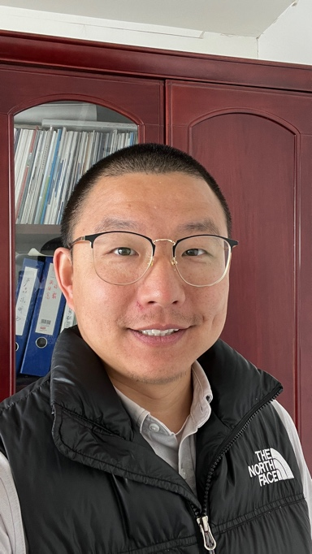
Dear Partners,
👋 Welcome to YUEDU!
🧭 Since our founding, YUEDU has had a singular mission:
To deliver secure, efficient, and customized shredding solutions that truly solve the challenges our clients face.
💬 We’ve always placed our focus on solving real customer problems, and this unwavering commitment to understanding their needs and delivering value has been key to our success.
📚 As a company, we draw inspiration from business legends like Warren Buffett, Charlie Munger, and Duan Yongping.
We are building a demand-driven organization grounded in:
- 🎯 Long-term thinking
- 🤝 Integrity
- 🧠 Practical wisdom
🛠 I firmly believe that good business is not just about selling products —
it’s about fostering trust, nurturing partnerships, and consistently delivering real value.
🔐 Every solution we offer is designed to have a profound impact on our clients’ security, privacy, and long-term sustainability.
🙏 I want to take this opportunity to express my deep gratitude to all our partners and clients for the trust you’ve placed in us.
Together, we will continue to grow, innovate, and stay true to our mission of delivering excellence.
🤝 Thank you for being a part of YUEDU’s journey.
We’re excited to continue working with you — pushing the boundaries of what we can achieve together.

Warm regards,
✍️ Hao Deng
CEO & Founder
Shanghai YUEDU Technology Co., Ltd.

