📄 资质与认证 | Certifications
我们致力于为全球客户提供安全、合规、高标准的产品与服务，并获得了以下资质与认证：
We are committed to providing safe, compliant, and high-standard products and services to our global clients. The following certifications have been obtained:

✅ 企业资质 | Company Qualifications

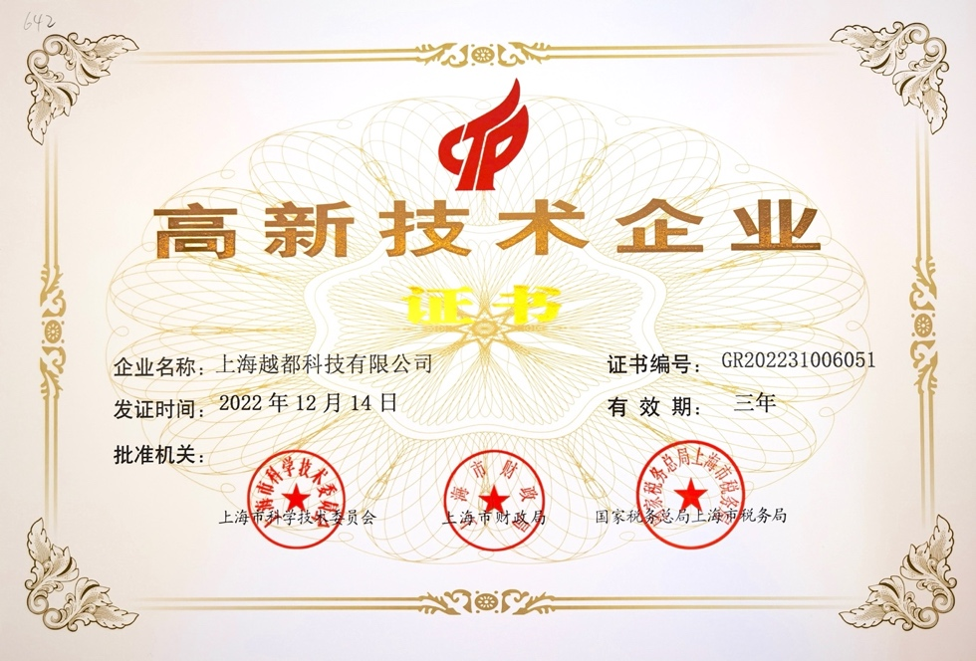
- 📄 企业营业执照（中英文）
Business License (in Chinese and English)
公司依法在中国注册并运营，具备合法生产与贸易资格。
Official business registration approved by Chinese authorities, validating our legal status for manufacturing and international trade.
- 🏆 高新技术企业认定
Certificate of High and New Technology Enterprise
由中国科技和财政部门联合认定，标志着公司在研发和创新方面的持续投入与成果。
Recognized by Chinese science and finance departments for sustained investment in R&D and technological innovation.

✅ 国际认证 | International Certifications
- ✅ 欧盟CE认证
EU CE Certification
产品符合欧盟健康、安全、环保等标准，允许进入欧洲市场。
Complies with EU safety, health, and environmental protection standards, allowing distribution within the European market.
- 📋 ISO质量管理体系认证
ISO Quality Management System Certification
体现公司管理流程、产品质量与客户服务的系统化规范。
Demonstrates standardized management, consistent product quality, and customer service excellence.

✅ 出口与行业资质 | Export & Industry Certifications
- 🌐 出口报关资格 / 进出口权证明
Customs Export Qualification / Import-Export License
表明公司具备合法的国际贸易资质，可进行出口业务。
Confirms legal qualification for international trade and customs clearance.
- 🛡 政府采购 / 军队供货证明
Government Procurement / Military Approved Supplier Certificate
体现公司为跨国公司、各国政府及军队部门提供专业设备的合规能力与项目履历。
Validates our compliance and experience in supplying secure equipment to government and military agencies.

📎 附件下载 / Downloads (可选)
- 营业执照 PDF（中文版 & 英文版）
- CE 证书副本
- 高新技术企业证书副本
- ISO 体系认证
