💵 Central Bank & Banknote Printing Industry Solution

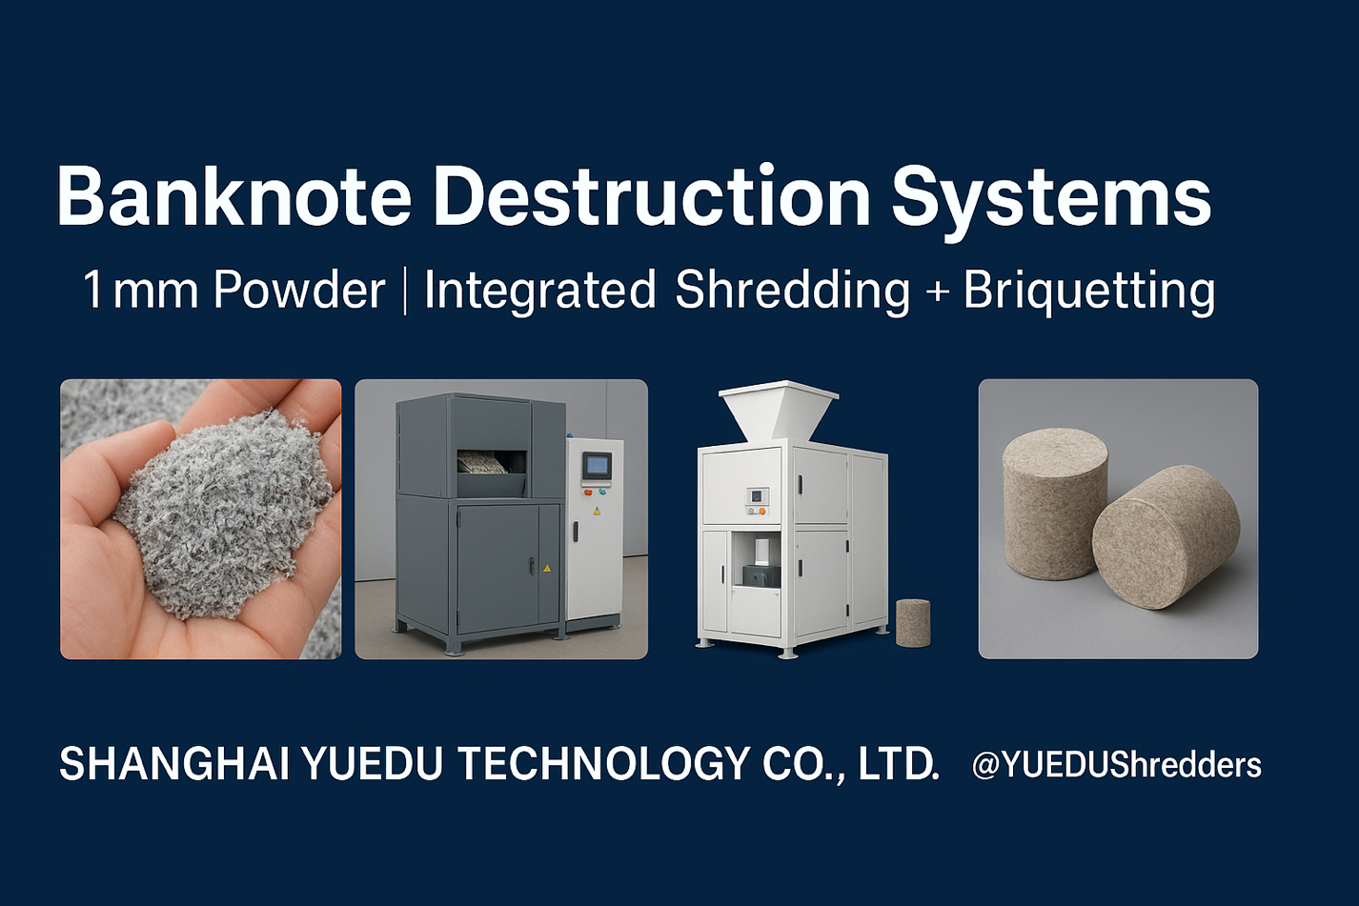
Secure. Efficient. Compliant.

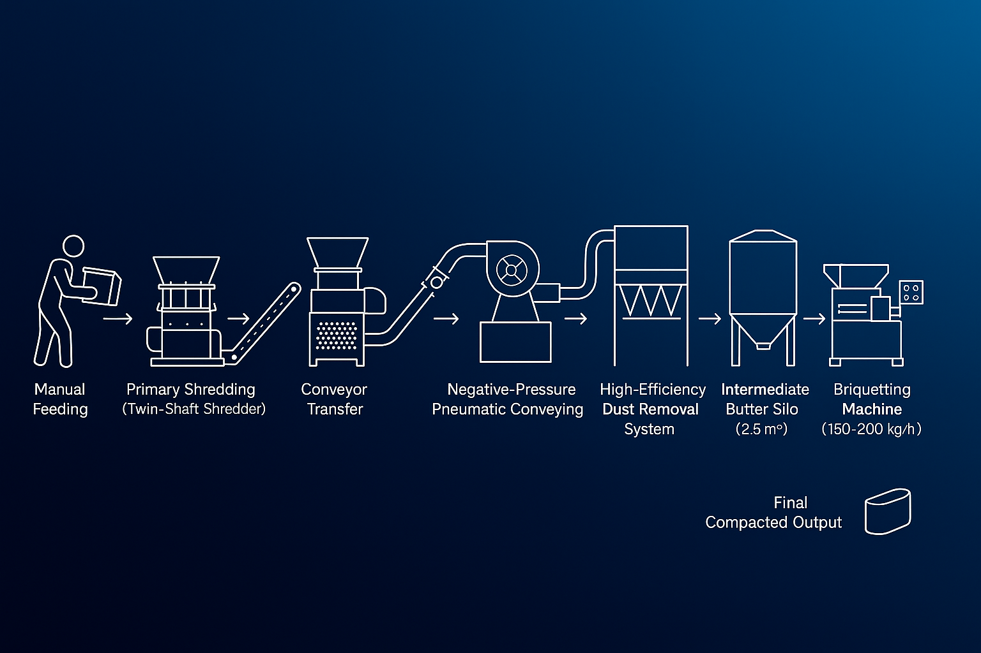
BDS for Central-bank-level:
Two-Stage Shredding / Dust Extraction & Filtration / Briquetting

Case study • Client A
Banknote Destruction Machine | Integrated Baler and Compactor | Output
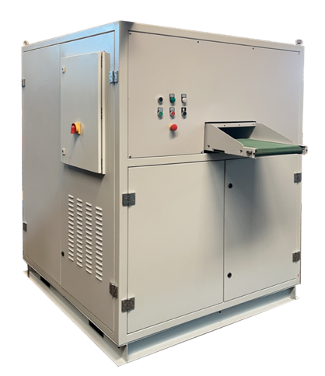 | 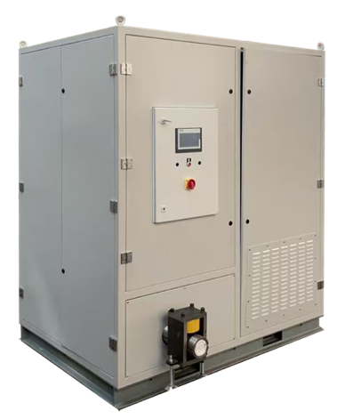 | 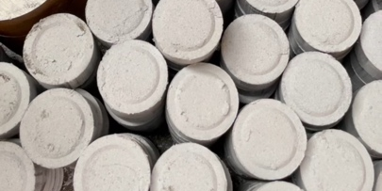 | 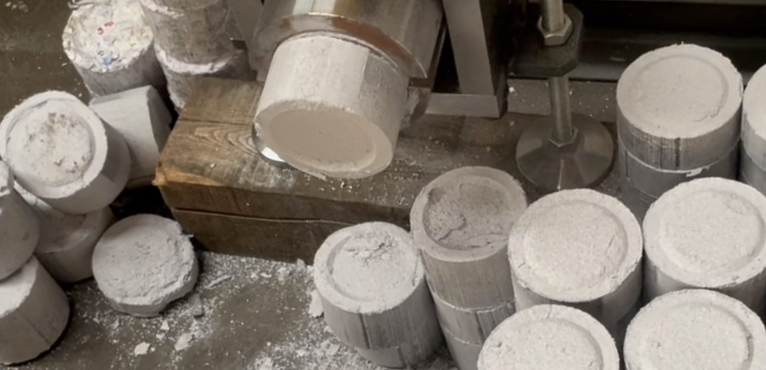
 |  | 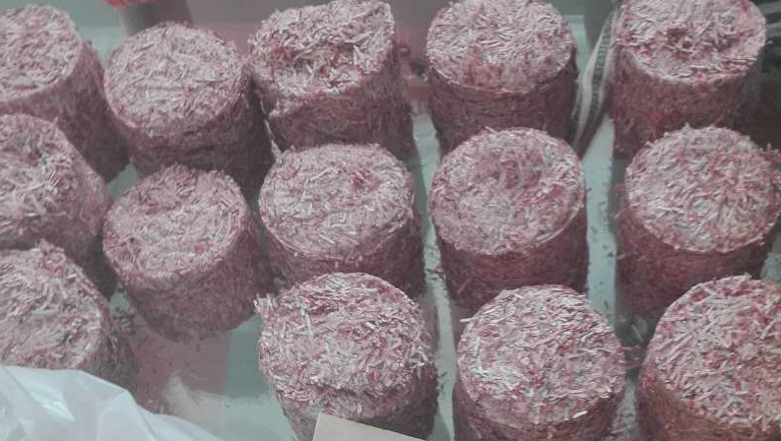 | 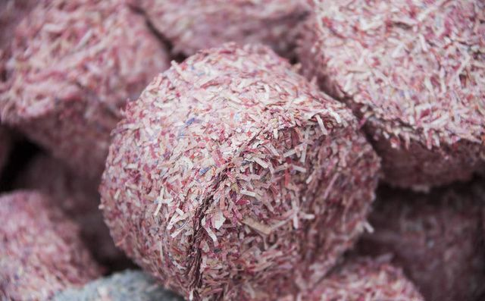

🔒 Industry Background
Banknotes, securities, and confidential financial materials require strict, centralized destruction under national regulations.
In most countries, the Central Bank or Security Printing Corporation mandates that obsolete or damaged banknotes be shredded and compacted before final disposal — ensuring both security and traceability throughout the process.

💡 YUEDU Solution Overview
Goal: Provide a secure, reliable, and scalable destruction line from in-feed to briquette, with full process traceability and low TCO.
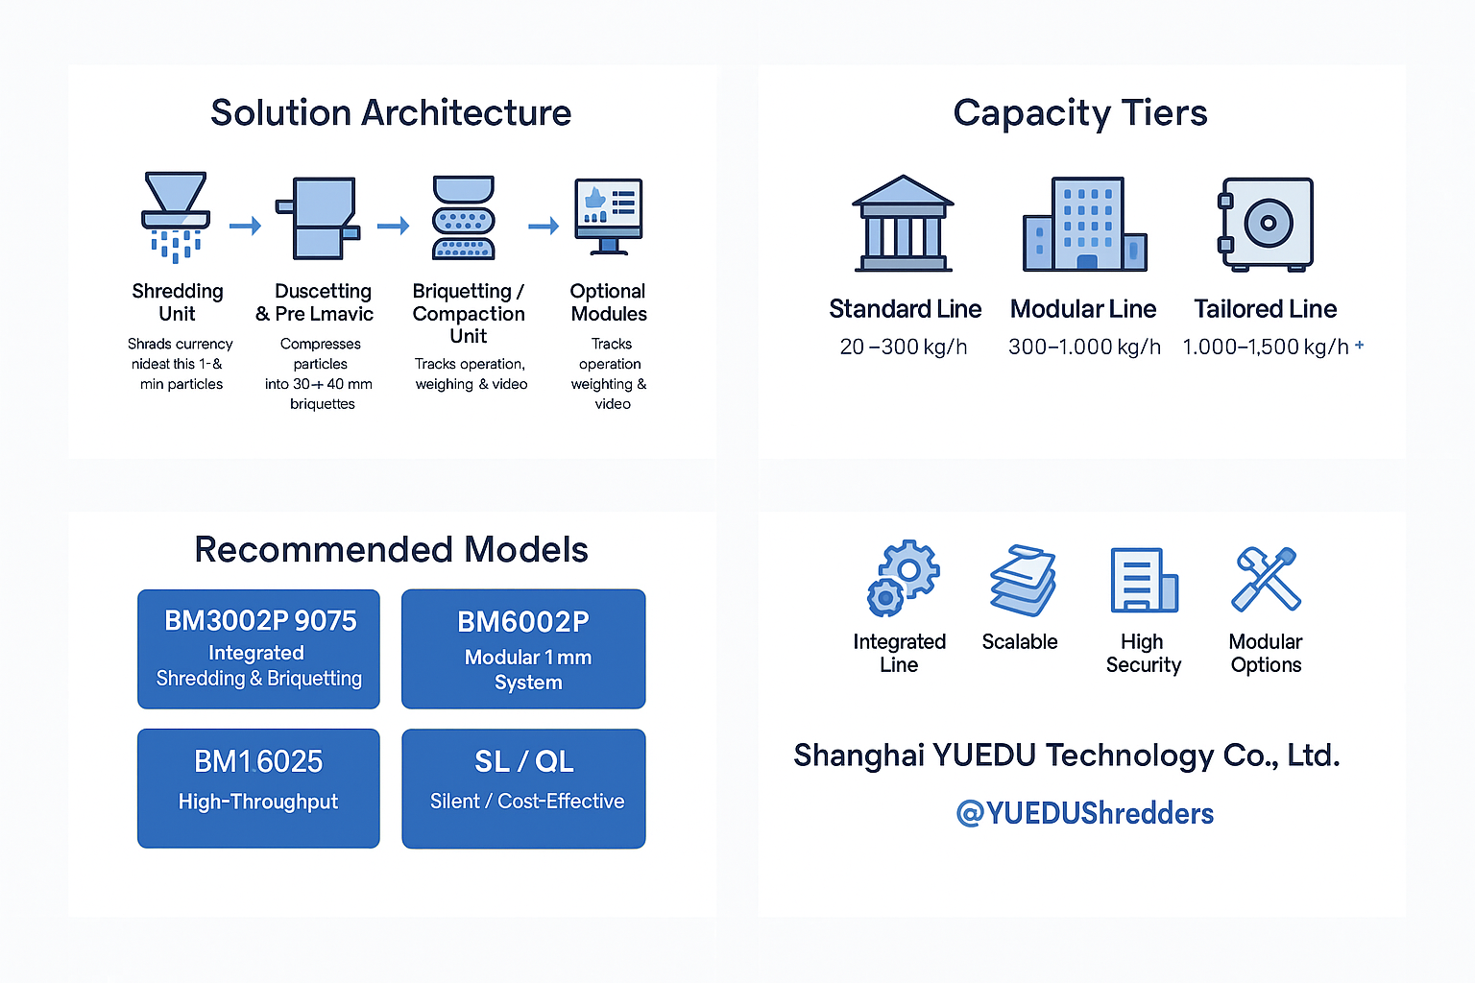
Structure solutions as Standard / Modular / Tailored Lines, all modular & scalable to site constraints and capacities.
Capacity spans 20–1,000 kg/h (standard) and can be customized up to 1,500 kg/h; shredding, suction, dust filtration and briquetting are delivered as one coherent solution.

🧩 Solution Architecture

⚙️ System Workflow
Feeding → Shredding → Dust Dust Extraction & Pneumatic Conveying→ Briquetting / Bagging → Monitoring & Control → Storage/Dispatch
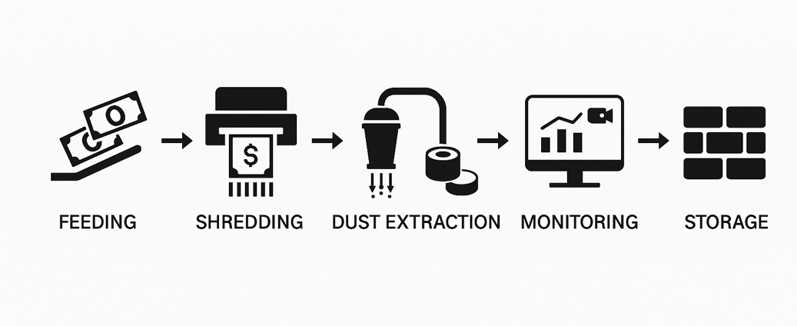
Each stage works seamlessly through modular design and centralized PLC control, ensuring continuous operation, data traceability, and high-level security for national banks, mints, and document destruction centers.

🔧 System Composition
No. | Module 模块 | Description (English)
1️ | Feeding & Preparation Unit | Handles the intake of obsolete banknotes or securities. Designed with safety covers and anti-jam protection to ensure stable feeding.
2️ | Shredding Unit | High-torque industrial shredder reduces banknotes into fine particles of 1–3 mm (up to 1 mm powder for top-security applications).
3️ | Dust Extraction Unit | Multi-stage dust collection and filtration system maintains a clean, dust-free working environment and protects operators.
4️ | Briquetting / Compaction Unit  / Bagging | Briquetting / Compaction Unit  Compress shredded particles into Ø90×40 mm briquettes for easy weighing, storage, and traceable disposal.  Bagging / Boxing  More economical and easier to handle and ship for small volumes or polymer notes.
5️ | PLC & Monitoring with Traceability | Central control with touch-screen interface integrates all modules, providing real-time operation data, weighing records, and video traceability.  Lockable hoppers and the two-person rule ensure secure batch operations with full auditability.
6️ | Optional Modules | Customizable extensions such as conveyor auto-feeding, magnetic separation units, weighing platforms, Remote diagnostics, Reports & dashboards.

Capacity Tiers & Line Types
Reference Line | Typical Capacity | Usage Scenarios | Models
Standard Line | 20–300 kg/h | Security Rooms / Municipal Destruction Room | Solution C: Cost-Effective 1–3mm Shredding  ✔ (6/7) QL300 – QL600 Series – Budget-friendly shredders from $2,000  ✔ (7/7) SL500 – SL700 Series – Silent, high-security shredding for offices
Modular Line | 300–1,000 kg/h | Provincial / National Treasury Large-Scale Center | Solution B: Ultra-Fine 1mm Shredding System  ✔ (4/7) 300BM1 – 600BM1 Series – Ultra-fine shredding (1mm) for P-6 compliance  ✔ (5/7) Modular Systems 6002 & 4001 – Customizable with briquetting/baling
Tailored Line | 1,000–1,500 kg/h+ | National Cash Center / Banknote Printing Plant / Central Banks | Solution A: Integrated Shredding & Briquetting  ✔ (1/7) BM3002P-9075 – High-security integrated shredding & briquetting  ✔ (2/7) BM6002P – Dual-stage shredding for high-capacity destruction  ✔ (3/7) Models 5002 & 5001 – Shredding + baling combo

Case study • Client B
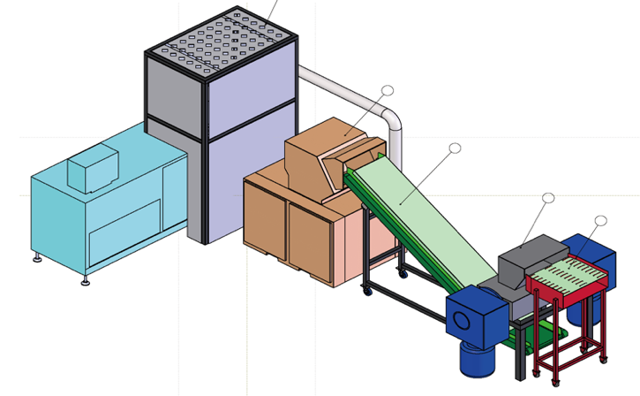 | 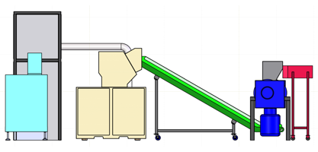
 | 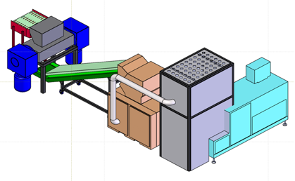

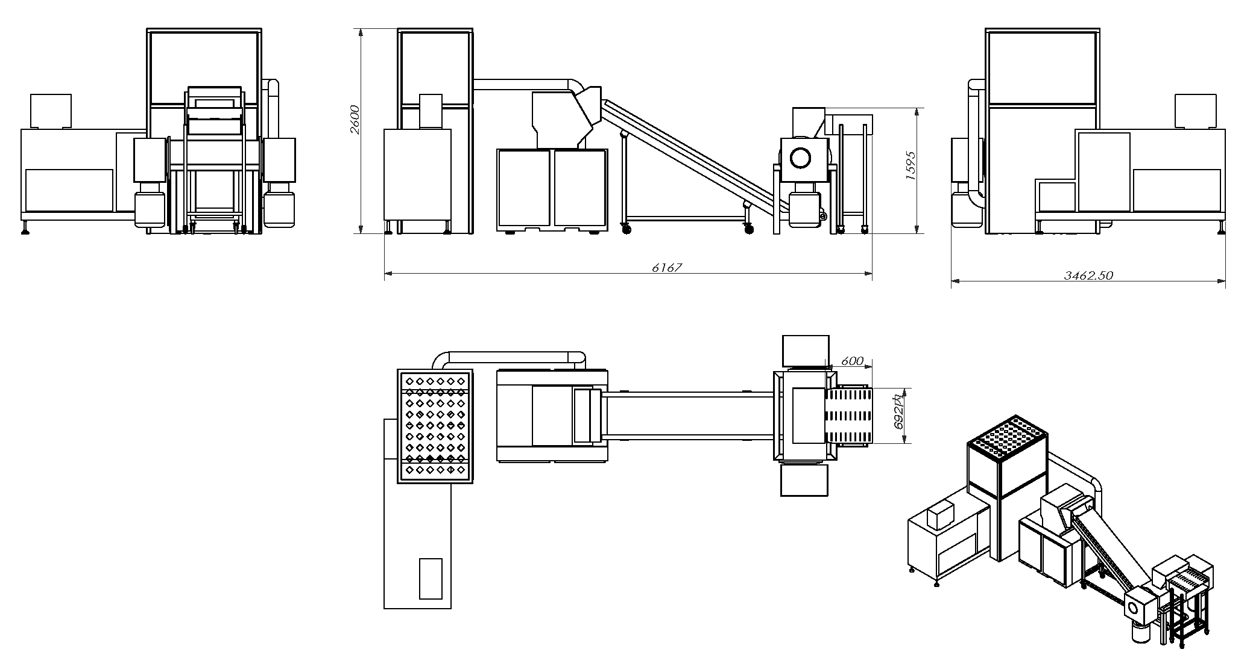

📦 Recommended Models
Model | Type & Positioning | Target Scenario | Capacity / Throughput | Briquette / Baler | Key Highlights
BM3002P-9075 | Integrated shredding + briquetting | Provincial / Municipal Destruction Room | 100–150 kg/h @ 3 mm；~75 kg/h @ 1 mm | Ø90×40 mm paper briquette 纸砖 | Closed feeding, dual-control, PLC HMI, video & weighing traceability
BM6002P | Modular 1 mm mainline | Provincial Bank / Treasury Center | 300–700 kg/h（scalable | Briquetter / Baler | Multi-point suction, long-run ducting, cross-room/floor
BM6002P (Parallel) + YKJ90-75 / 90-250 | High-throughput parallel line | National Cash Center / Banknote Printer | 1000 kg/h+ | YKJ90-75 (single port) / YKJ90-250 (dual port) | Scalable, low TCO, high uptime
BM4001 | Compact 1 mm upgrade | Small rooms / retrofit | 250 kg/h+ | YKJ90-75 (single port) / YKJ90-250 (dual port) | Quick fit-in; integrate with existing suction & briquetter
5002 (or 5001/500CC2024) | Pre-shred + baling | Pre-shred to offload main line | 500–600 kg/h（single line ） | Bale 50–75 kg | Reduces main load & raises stability
YTJ-BM1 Series (300/400/500/600BM1) | Ultra-fine 1×1 mm | Classified room / Military / Finance | 80–500 pages per put | — | Belt-feed; handles thick bound files
SL500 / SL600 / SL700 | Silent high-security | Office / Voucher Room | — | — | Low noise, compact footprint
QL300–QL600 | Cost-effective line | Small / Mid volume | — | — | Budget-friendly；prefer bagging/boxing
PSJ300 / 350 / 500 / 468 | Industrial pre-shred | Books/archives pre-shred | 100–1000+ kg/h | — | Dual-inlet, continuous duty

🏛 Case Studies
- People’s Bank of China (PBOC) – Provincial Destruction Centers
- Shanghai Mint & Nanjing Mint – Banknote printing & recycling
- National Security Printing Plant – Integrated shredding + briquetting
- African & Asian Central Banks – YD-BM3002P customized destruction line
- Classified/confidential entity – YD-BM6002 ultra-fine (powder-grade) shredding system.

Case study • client C

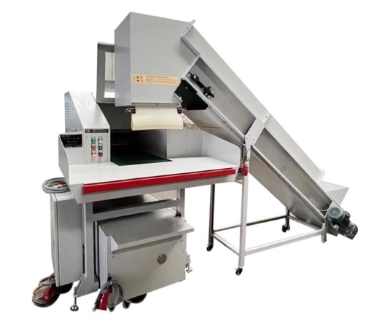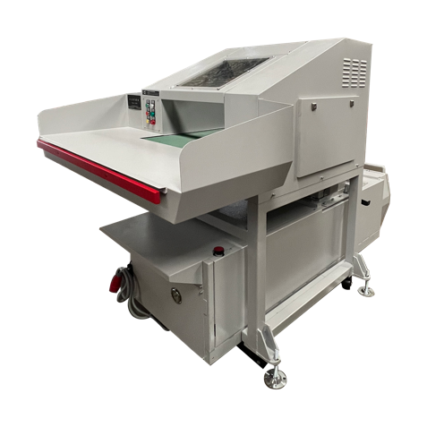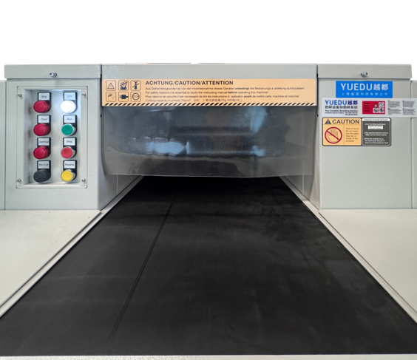
Case study • client D
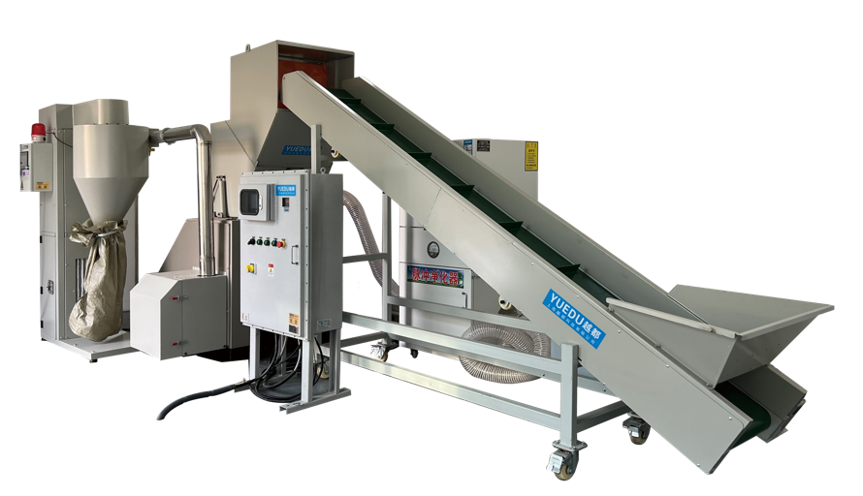
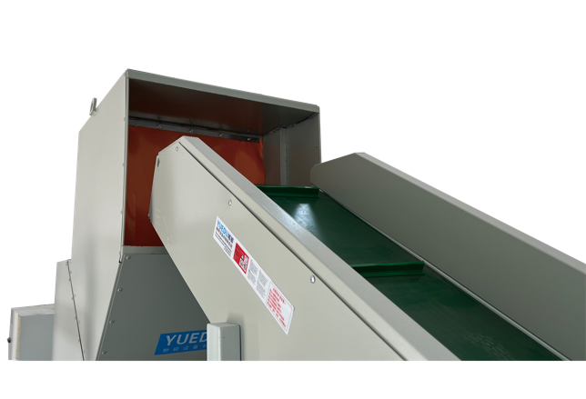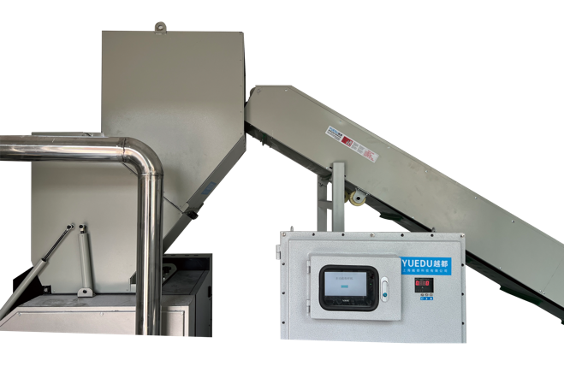
Case study • client E
A Central Bank in the Russian Region
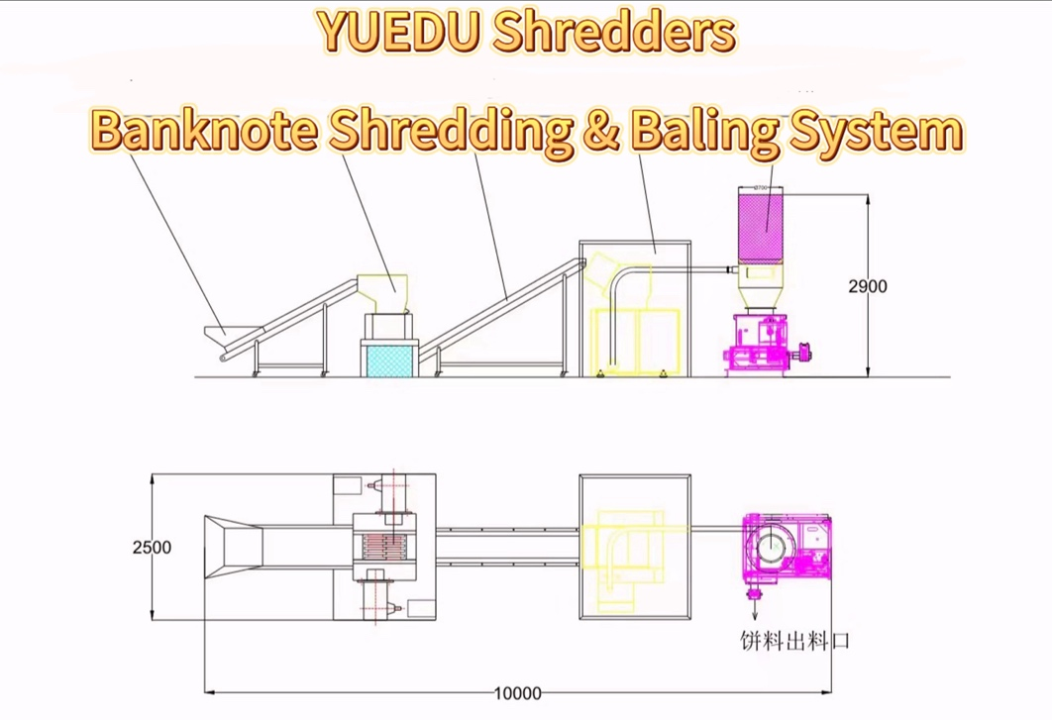

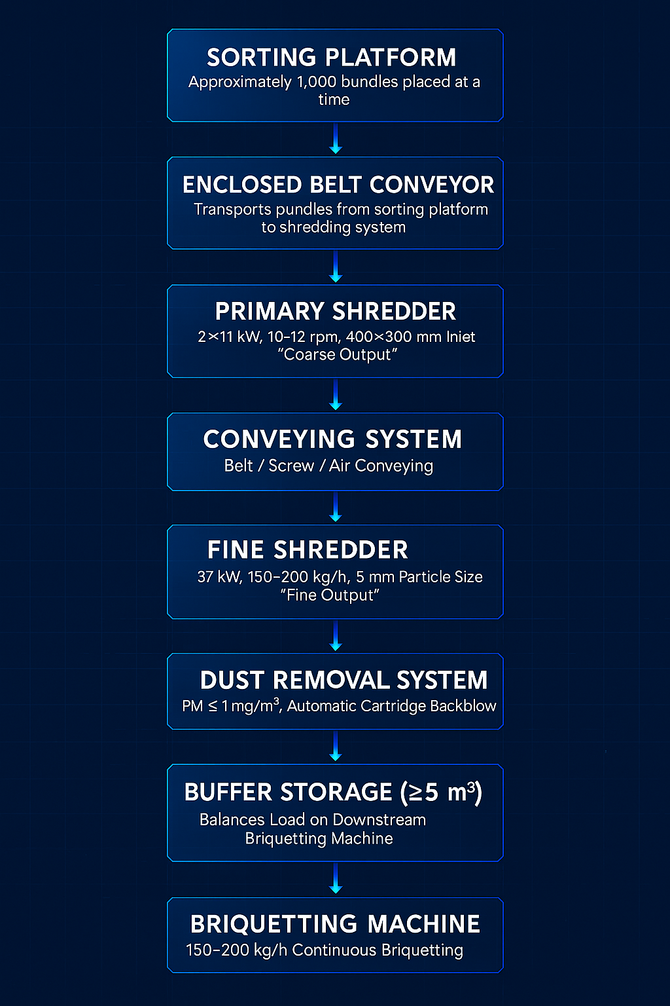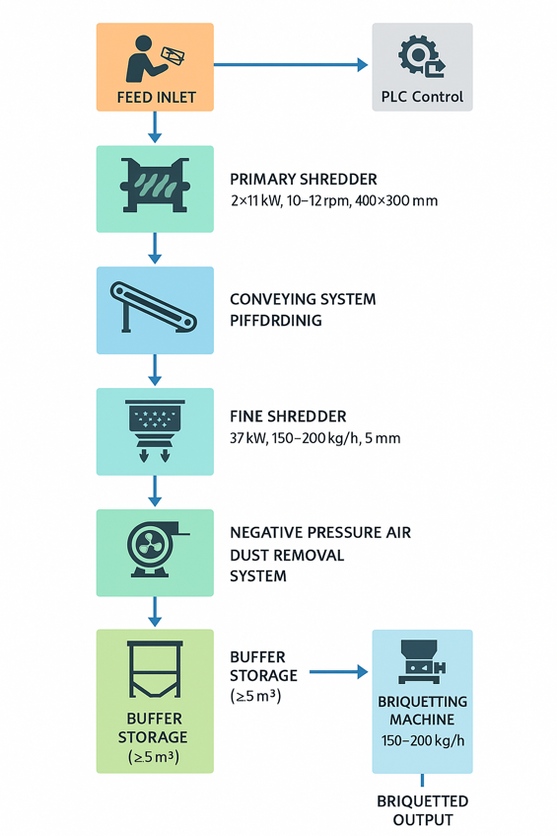

🌍 Compliance & Certification
✔ DIN 66399 P-6 / P-7
✔ China National Level 1 Confidentiality Standard

Why YUEDU
- Aligned with international architectures (Standard / Modular / Tailored) covering the full process—feeding, shredding, suction, briquetting, and monitoring—while delivering lower cost and faster lead times.
- Integrated + modular approach: from small destruction rooms to national cash centers, with optional briquetting or bagging configurations.
✓ Proven technical capability in multi-stage shredding systems
✓ Compliance with central bank destruction standards
✓ Stable, durable, and safety-certified industrial machinery
✓ Experience integrating complete destruction lines
(coarse shredding → fine shredding → air conveying → dust removal → briquetting)
YUEDU is fully qualified to deliver:
- Safe
- Reliable
- International-standard
- Long-term maintainable
banknote destruction systems for the Central Bank.

🌐 Contact Us
Shanghai YUEDU Technology Co., Ltd.
🌐 Website: www.yuedushredders.com
📧 Email: yuedushredders@gmail.com / denghao8410@gmail.com
☎️ Sales Supervisor: +86 159 0178 2779 (WhatsApp / WeChat / Facebook / Telegram)
📍 Company Headquarters: No. 555 Chengyin Road, Baoshan City Industrial Park, Shanghai, China
@YUEDUShredders – Empowering Global Industries with Intelligent Destruction Systems.
Specifications subject to change without prior notice.

