🏦 YUEDU 银行现钞冲孔机 YD-BC01
Banknote Canceller YD-BC01 — Central Bank Currency Cancellation System
（上海越都科技有限公司）
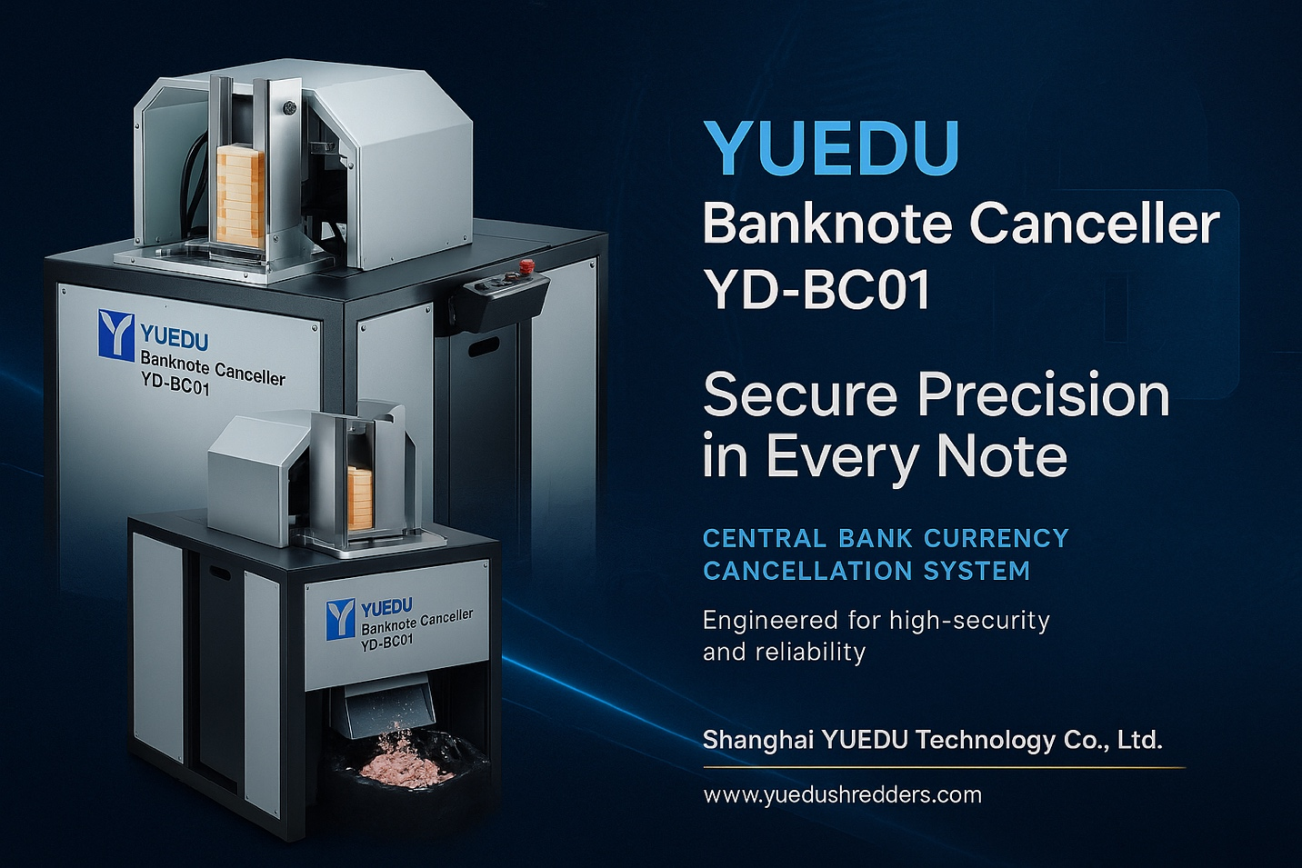

🧠 产品简介
YD-BC01 是一款专为中央银行及金融监管机构设计的高安全级纸币冲孔作废设备。
系统采用模块化液压驱动结构和智能检测控制技术，能够在分拣后对纸币进行快速、精准的作废冲孔处理，
有效降低运输及存储风险，确保废钞流向安全可控。
该设备基于越都公司在金融载体销毁、精密液压控制及安全防护领域的多年经验研发，
适用于银行、造币厂、印钞厂、保密销毁中心等专业机构。

🧩 设计特点
- 高安全性冲孔结构：模具设计符合各国央行安全标准，支持多种孔型与编码模式；
可根据用户监管规范定制冲孔图案，实现唯一性识别。
- 模块化液压系统：采用独立液压驱动与智能稳压回路，冲孔动作平稳、噪音低、寿命长。
- 人机工程优化：进钞高度适中，操作界面简洁直观，长时间作业仍保持舒适与安全。
- 即分即作废流程：支持分拣机后端直接接入，实现“分拣–冲孔–封包”一体化处理，
减少中间环节与风险。

⚙️ 主要特点
- 每小时可自动处理 最高 2,500 捆纸币；
- 适合 单人或双人协同操作，满足多级安全管理要求；
- 年度维护简单，仅需定期更换液压油与刀具打磨；
长期高强度运行时，每 2–3 个月进行润滑保养即可；
- 采用 工业级元件 与优化结构布置，运行稳定、寿命长；
- 配备 电气联锁安全防护罩 与紧急停机功能，符合 EHS 安全标准；
- 可与越都系列销毁系统（粉碎机、压块机）联机形成完整销毁线。

🧭 操作流程
- 启动设备，系统自动进入待机状态；
- 将待作废纸币捆放入自动进钞装置；
- 系统自动分离、定位至冲孔模具下方并执行冲孔；
- 完成的纸币捆被自动推送至出料托盘；
- 废屑由下方独立收集箱集中存储；
- 整个流程自动循环，直至送料装置为空。

🔧 机器配置
- 电动液压驱动系统（智能稳压）
- 自动分币送料机构
- 多模式安全操作面板（带负载监控）
- 可更换式冲孔模具组件
- 废屑收集系统（可选真空回收型）
- 维护工具与备件包（可选）
- 操作与保养说明书

📏 技术参数
项目 | 参数
外形尺寸（长×宽×高） | 900 × 770 × 1,370 mm
整机重量 | 约 260 kg
冲孔模具 | 标配 6 孔 Ø12 mm（可选定制孔型）
处理速度 | 每分钟最高 25 捆
适用钞票尺寸 | 200 × 100 mm（可根据客户需求调整）
电源 | 380V 50Hz（三相） / 可定制 220V 单相
控制方式 | PLC 智能控制 + 传感检测保护
噪音等级 | ≤72 dB(A)
安全标准 | CE / GB/T 5226.1 / 越都内部安全规范

🏢 制造商信息
上海越都科技有限公司
Shanghai YUEDU Technology Co., Ltd.
📍 地址：上海市宝山城市工业园区城银路555弄
📞 电话：+86-159 0178 2779
📧 邮箱：yuedushredders@gmail.com
🌐 网站：www.yuedushredders.com
© 2025 Shanghai YUEDU Technology Co., Ltd.
保留技术更新与设计修改权。

🏦 YUEDU Banknote Canceller YD-BC01
Central Bank Currency Cancellation System
Shanghai YUEDU Technology Co., Ltd.

🧠 Product Overview
The YD-BC01 is a high-security banknote cancellation machine designed for central banks, national mints, and financial supervision agencies.
It adopts a modular electro-hydraulic system with intelligent control and precision detection to perforate banknotes immediately after sorting —
reducing transportation risks and ensuring full traceability and destruction integrity.
Developed from YUEDU’s extensive experience in secure destruction, hydraulic control, and EHS-compliant safety design,
the system is ideal for central banks, security printing plants, banknote processing centers, and confidential destruction facilities.

🧩 Design Features
- High-Security Punching Structure –
The perforation die meets strict central-bank standards and supports various hole patterns or coded shapes.
Each pattern can be customized for regulatory or identification purposes.
- Modular Hydraulic Drive –
Independent power module with smart pressure stabilization delivers smooth punching, low noise, and extended lifetime.
- Ergonomic Human-Machine Interface –
Optimized working height, simple control layout, and comfortable operation even during continuous use.
- Immediate “Sort-and-Cancel” Workflow –
Can be linked directly to banknote sorting lines to realize “Sorting → Cancellation → Bundling” in one automated sequence,
minimizing manual handling and security exposure.

⚙️ Key Advantages
- Processes up to 2,500 bundles per hour automatically.
- Configurable for single- or dual-operator modes to meet different security levels.
- Easy annual maintenance: hydraulic oil replacement and blade sharpening only;
light lubrication every 2–3 months under heavy duty.
- Industrial-grade components and simplified mechanical layout ensure reliability and long service life.
- Equipped with electrical interlock safety cover and emergency-stop system compliant with EHS standards.
- Can be integrated with YUEDU shredders or briquetting presses to form a complete destruction line.

🧭 Operation Sequence
- Power on — system enters standby mode.
- Place the sorted banknote bundles into the automatic feeder.
- Notes are automatically separated, positioned beneath the die, and perforated.
- Each processed bundle is pushed to the delivery tray.
- Waste chads are collected in a sealed container below the punching area.
- The cycle repeats automatically until the feeder is empty.

🔧 Machine Configuration
- Electro-hydraulic drive system (smart pressure control)
- Automatic banknote feeding unit
- Multi-mode operator panel with load monitoring
- Replaceable punching die assembly
- Waste-collection container (optional vacuum system)
- Maintenance tool & spare-parts kit (optional)
- Operation / maintenance manual

📏 Technical Specifications
Item | Specification
Dimensions (L×W×H) | 900 × 770 × 1 370 mm
Net Weight | ≈ 260 kg
Punch Die | Standard 6-hole Ø12 mm (custom patterns optional)
Processing Speed | Up to 25 bundles / min
Banknote Size | 200 × 100 mm (adjustable upon request)
Power Supply | 380 V / 50 Hz (3 Phase) or 220 V / 50 Hz option
Rated Power | 3.5 kW
Control System | PLC intelligent control + sensor protection
Noise Level | ≤ 72 dB(A)
Safety Compliance | CE / GB-T 5226.1 / YUEDU internal EHS standard

🏢 Manufacturer
Shanghai YUEDU Technology Co., Ltd.
📍 Address: No. 555 Chengyin Road, Baoshan Industrial Park, Shanghai, China
📞 Tel: +86 159 0178 2779
📧 Email: yuedushredders@gmail.com
🌐 Website: www.yuedushredders.com
© 2025 Shanghai YUEDU Technology Co., Ltd.
Specifications subject to change without prior notice.

