🏦 YUEDU Banknote Canceller YD-BC01
Central Bank Currency Cancellation System
Shanghai YUEDU Technology Co., Ltd.
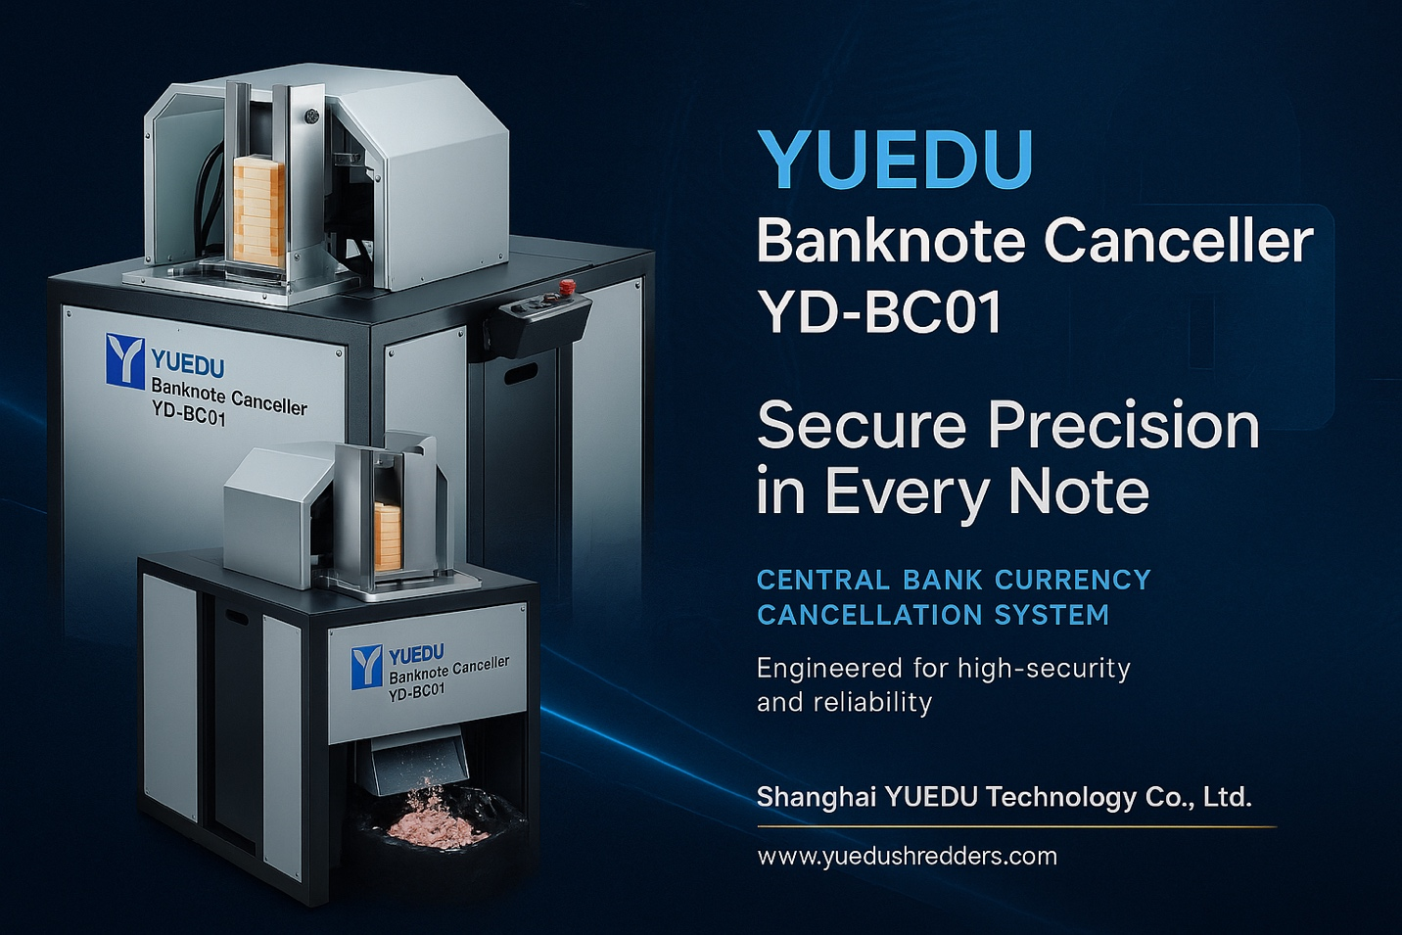

🧠 Product Overview
The YD-BC01 is a high-security banknote cancellation machine designed for central banks, national mints, and financial supervision agencies.
It adopts a modular electro-hydraulic system with intelligent control and precision detection to perforate banknotes immediately after sorting —
reducing transportation risks and ensuring full traceability and destruction integrity.
Developed from YUEDU’s extensive experience in secure destruction, hydraulic control, and EHS-compliant safety design,
the system is ideal for central banks, security printing plants, banknote processing centers, and confidential destruction facilities.

🧩 Design Features
- High-Security Punching Structure –
The perforation die meets strict central-bank standards and supports various hole patterns or coded shapes.
Each pattern can be customized for regulatory or identification purposes.
- Modular Hydraulic Drive –
Independent power module with smart pressure stabilization delivers smooth punching, low noise, and extended lifetime.
- Ergonomic Human-Machine Interface –
Optimized working height, simple control layout, and comfortable operation even during continuous use.
- Immediate “Sort-and-Cancel” Workflow –
Can be linked directly to banknote sorting lines to realize “Sorting → Cancellation → Bundling” in one automated sequence,
minimizing manual handling and security exposure.

⚙️ Key Advantages
- Processes up to 2,500 bundles per hour automatically.
- Configurable for single- or dual-operator modes to meet different security levels.
- Easy annual maintenance: hydraulic oil replacement and blade sharpening only;
light lubrication every 2–3 months under heavy duty.
- Industrial-grade components and simplified mechanical layout ensure reliability and long service life.
- Equipped with electrical interlock safety cover and emergency-stop system compliant with EHS standards.
- Can be integrated with YUEDU shredders or briquetting presses to form a complete destruction line.

🧭 Operation Sequence
- Power on — system enters standby mode.
- Place the sorted banknote bundles into the automatic feeder.
- Notes are automatically separated, positioned beneath the die, and perforated.
- Each processed bundle is pushed to the delivery tray.
- Waste chads are collected in a sealed container below the punching area.
- The cycle repeats automatically until the feeder is empty.

🔧 Machine Configuration
- Electro-hydraulic drive system (smart pressure control)
- Automatic banknote feeding unit
- Multi-mode operator panel with load monitoring
- Replaceable punching die assembly
- Waste-collection container (optional vacuum system)
- Maintenance tool & spare-parts kit (optional)
- Operation / maintenance manual

📏 Technical Specifications
Item | Specification
Dimensions (L×W×H) | 900 × 770 × 1 370 mm
Net Weight | ≈ 260 kg
Punch Die | Standard 6-hole Ø12 mm (custom patterns optional)
Processing Speed | Up to 25 bundles / min
Banknote Size | 200 × 100 mm (adjustable upon request)
Power Supply | 380 V / 50 Hz (3 Phase) or 220 V / 50 Hz option
Rated Power | 3.5 kW
Control System | PLC intelligent control + sensor protection
Noise Level | ≤ 72 dB(A)
Safety Compliance | CE / GB-T 5226.1 / YUEDU internal EHS standard

🌐 Contact Us
Shanghai YUEDU Technology Co., Ltd.
🌐 Website: www.yuedushredders.com
📧 Email: yuedushredders@gmail.com / denghao8410@gmail.com
☎️ Sales Supervisor: +86 159 0178 2779 (WhatsApp / WeChat / Facebook / Telegram)
📍 Company Headquarters: No. 555 Chengyin Road, Baoshan City Industrial Park, Shanghai, China
@YUEDUShredders – Empowering Global Industries with Intelligent Destruction Systems.
Specifications subject to change without prior notice.

