Looking for complete solutions for banknote destruction?
This comprehensive video covers 3 major strategies and 7 specialized models trusted by central banks:

Solution A: Integrated Shredding & Briquetting
✔ (1/7) BM3002P-9075 – High-security integrated shredding & briquetting
✔ (2/7) BM6002P – Dual-stage shredding for high-capacity destruction
✔ (3/7) Models 5002 & 5001 – Shredding + baling combo
Solution B: Ultra-Fine 1mm Shredding System
✔ (4/7) 300BM1 – 600BM1 Series – Ultra-fine shredding (1mm) for P-6 compliance
✔ (5/7) Modular Systems 6002 & 4001 – Customizable with briquetting/baling
Solution C: Cost-Effective 1–3mm Shredding
✔ (6/7) QL300 – QL600 Series – Budget-friendly shredders from $2,000
✔ (7/7) SL500 – SL700 Series – Silent, high-security shredding for offices
👉 Learn more: www.yuedushredders.com

📄 （1/7）BM3002P-9075 Banknote Shredding & Briquetting System
Paper Shredder with Integrated Baler and Compactor
YUEDU Brand | Model: BM3002P-9075
Banknote Destruction Machine | Integrated Baler and Compactor | Output
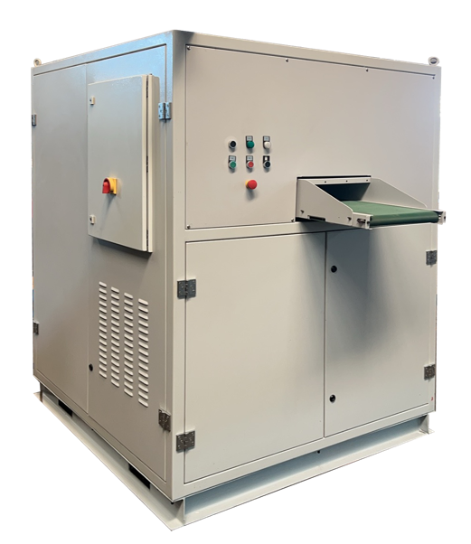 | 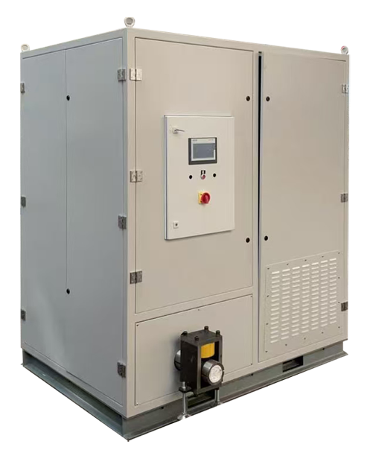 | 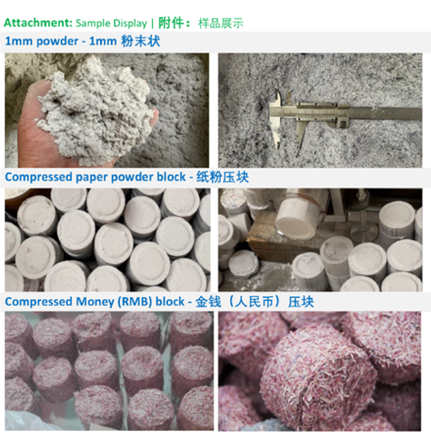
Shredder Specifications
• Single Feed Capacity: 100 sheets; Hourly Shredding Capacity: 100-150KG/H
• Feed Width: 420mm • Power: 22KW
• Dimensions: 3380*1440*2220mm
Shredding Process:
• Two-stage shredding with dual blade sets.• Dimensions: 1480*1440*1850mm
• Output: 3mm particles: 100-150KG/H; 1mm particles: 75KG/H
Compacting Process:
• Compressed block diameter: 90mm*40mm; Compacting output: 75KG/H
• Dimensions: 1900*1400*2220mm

User Case: Banknote Shredder and Compactor Combo Machine
Overall Image | Compactor Section | Output | YouTube video | 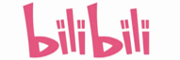bilibili video
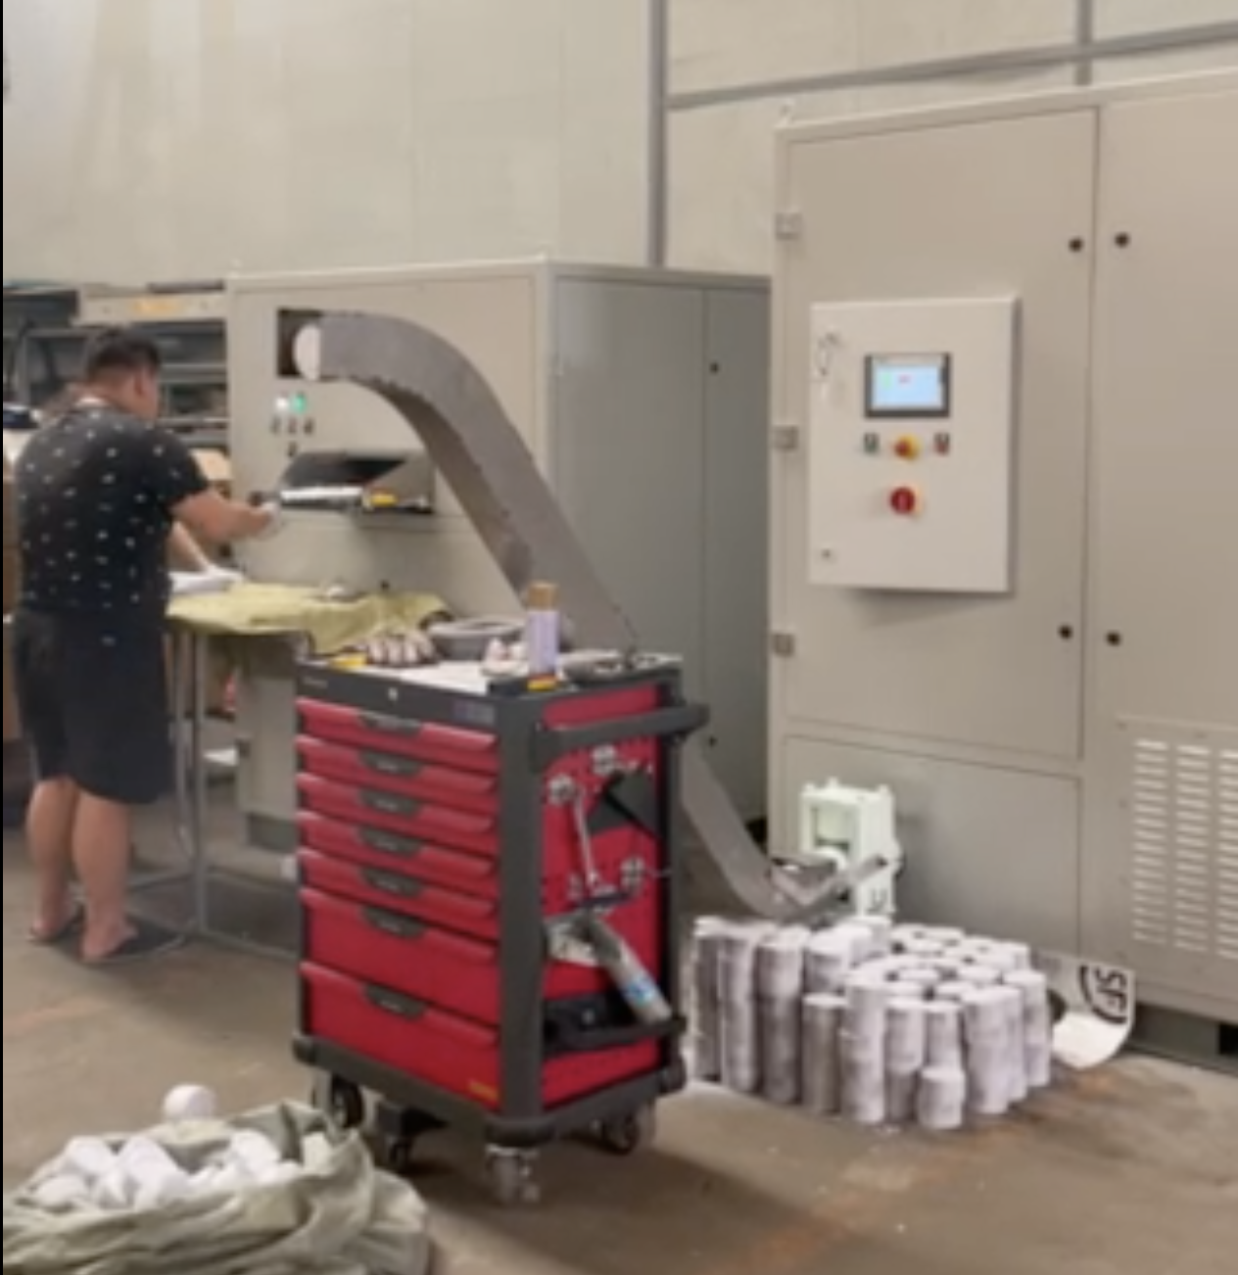 | 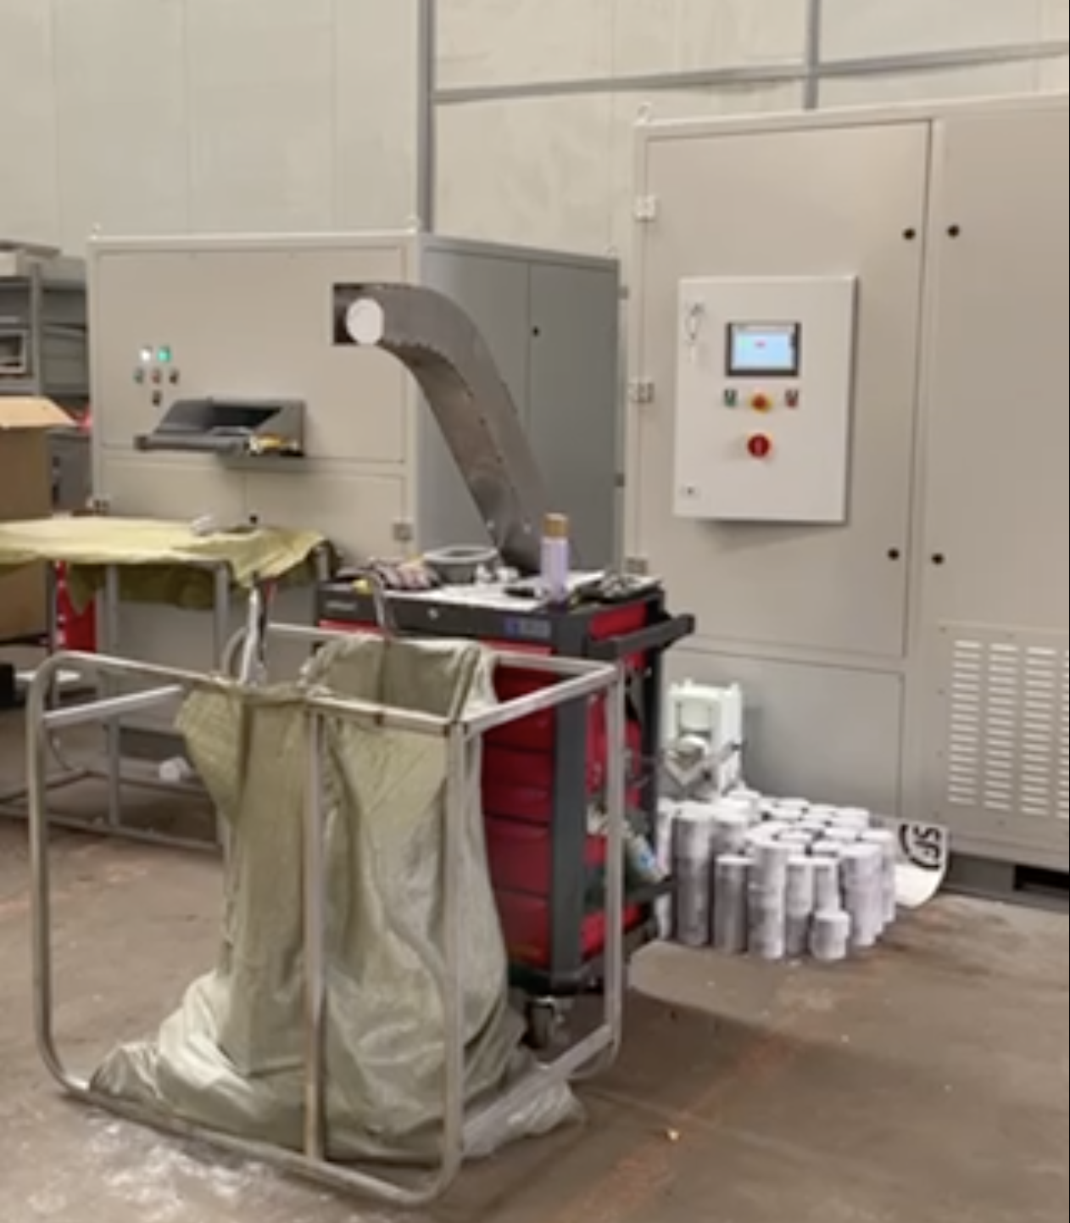 | 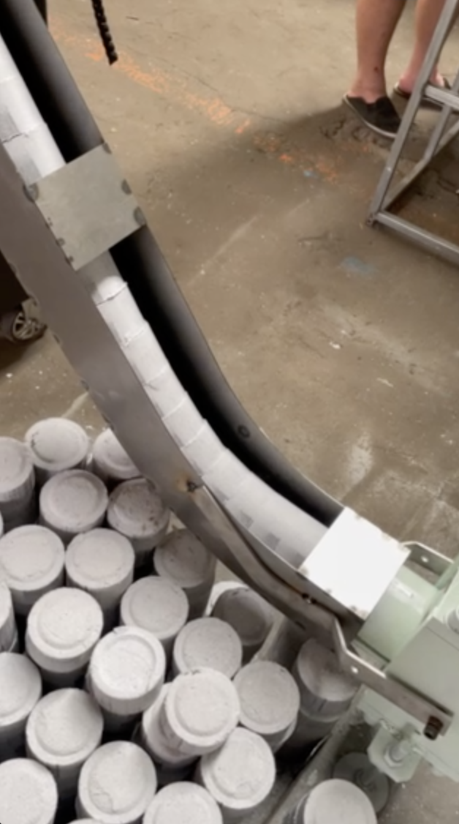 | https://youtu.be/OnOKqf-vkCA  https://youtube.com/shorts/5-dmXbM1Wpw | https://b23.tv/Go7TGFH  https://b23.tv/ToFqYLg

📄（2/7）YD-BM6002P Integrated Shredding System
All-in-One Shredding, Dust Collection & Baling System
Integrated system solutions for shredding, secondary processing, dust removal, and baling.
🖼️ Product Overview
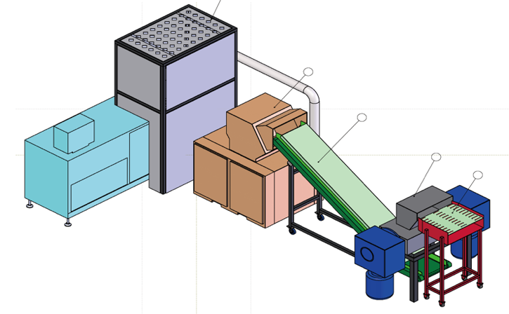 | 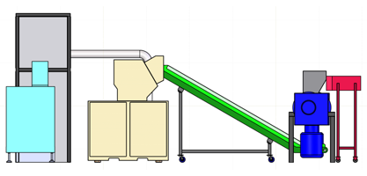
 | 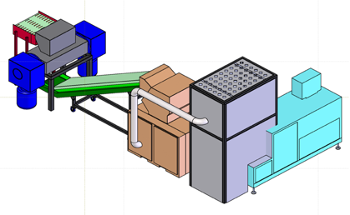
🧩 Application Scenarios
🔒🛡️Secure / Confidential Room
🔒🏭 Secure Destruction Center
💰 Product Pricing:
Shredder Unit – Model: YD-BM6002 → ¥497,731
Baler & Compactor Unit – Model: YD-DBJ6002P → ¥497,500
📏 System Overview: Three-View Diagram
(Front / Side / Top Views of the Integrated System)
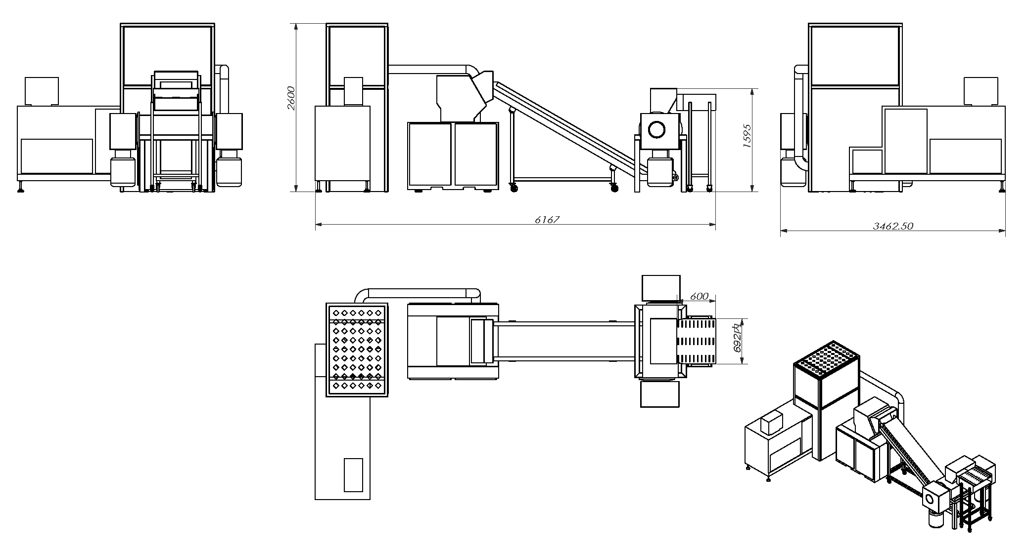
📌 Note:The above solution is for reference only. Final delivery is subject to the user’s confirmed requirements.

📄（3.1/7） YD-500CC2024 (500 pages)
🖼️ Product Overview
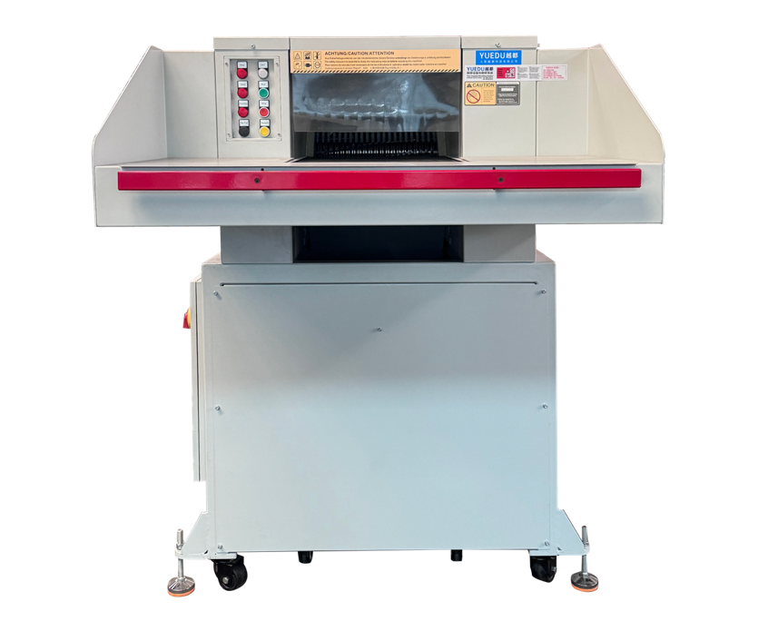
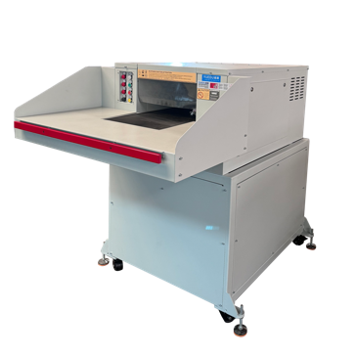 | 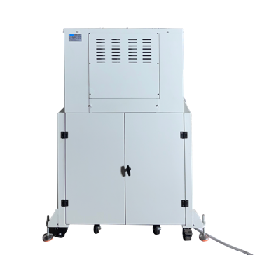 | 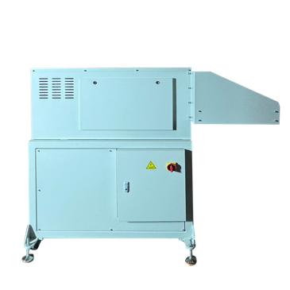 | 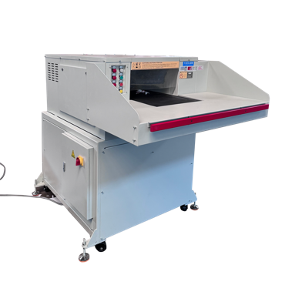
🔧 Technical Specifications：
🔒Security Level (DIN 66399) | P-2/O-2/T-2/E-2 | P-3/O-2/T-3/E-2 | P-4/O-3/T4/E-3 | P-5/O-4/T5/E-4/F-2
📥Feed Width (mm) | 500 | 500 | 500 | 500
✂️ Cut Size(mm) | 10.5x40-75 | 6x50 | 3.8x40 | 1.9x15
📑 Max Sheets | 500-550 | 340-380 | 180-200 | 90-100
⚖️Weight (kg) | 1200 | 1200 | 1200 | 1200
🔌Power | 7.5KW  3 x 400 V/50 Hz | 7.5KW  3 x 400 V/50 Hz | 7.5KW  3 x 400 V/50 Hz | 9.5KW  3 x 400 V/50 Hz
📏 L×W×H (mm) | 1318×1843×1638 | 1318×1843×1638 | 1318×1843×1638 | 1318×1843×1638
🗑️Bin(L) | 550L | 550L | 550L | 550L
💰Price (USD)
➕ Optional Add-ons:
Floor-mounted conveyor and rear baling system for efficient shredding and compact waste handling.

📄（3.2/7）YD-5002 Book Shredding & Baling Systems
🖼️ Product Overview
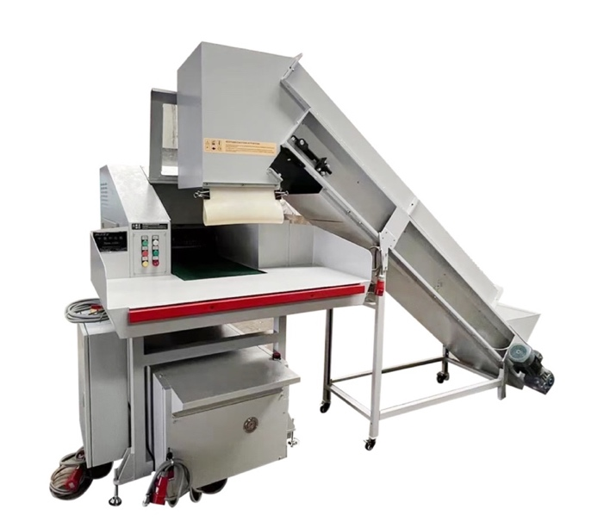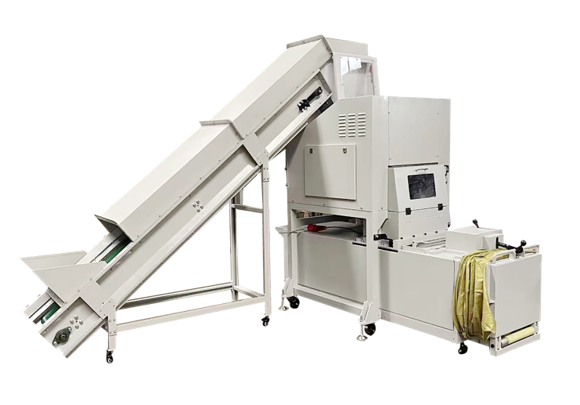
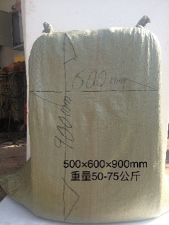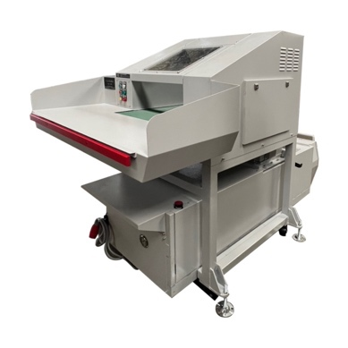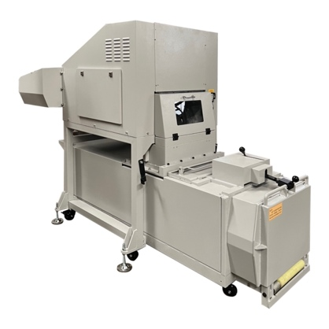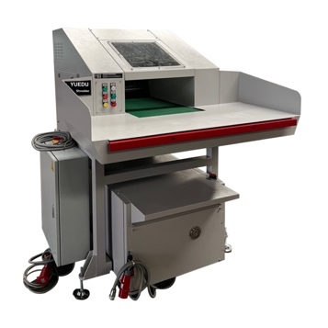
500CC shredder + 10T baler combo, ideal for secure rooms and archives.
Shreds up to 500 kg/h, compresses into 50–75 kg paper bales.
🔧 Technical Specifications：
⚙️Output/h: 500–600 kg
⚖️ Bale Weight: 50–75 kg
🧱Baling Pressure: 85 kN
🔌Power: 11.5 kW, 3 phase 400 V / 50 HZ
📏 L×W×H (mm): 3257*2588*2284
📐 System Overview: Three-View Diagram
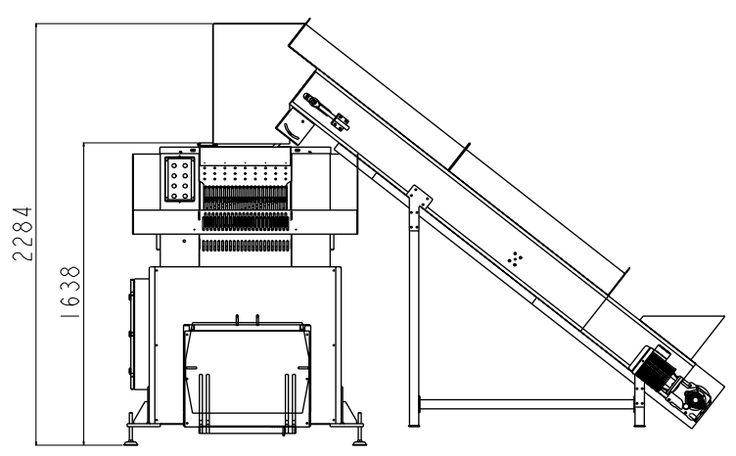 | 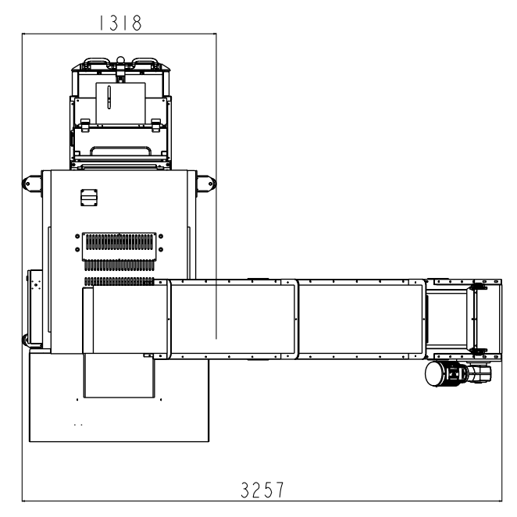 | 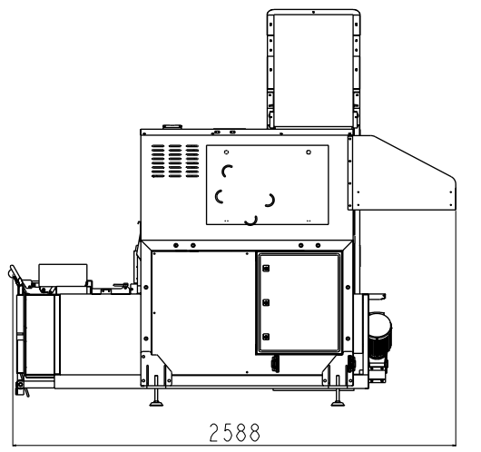

📄（4/7）YD-YTJ600BM1 500 400 300 – 1mm Ultra-Fine Shredders
🖼️ Product Overview
📸On-Site Usage | 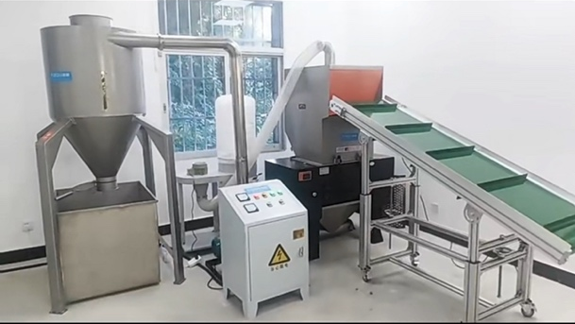
🌫️Shredding Result | 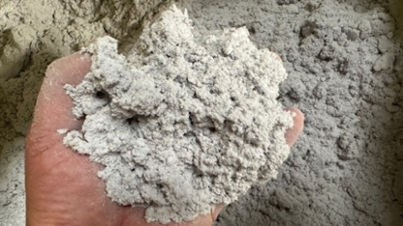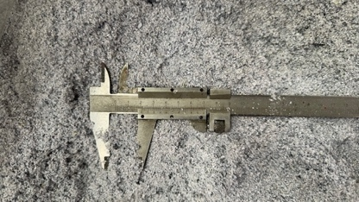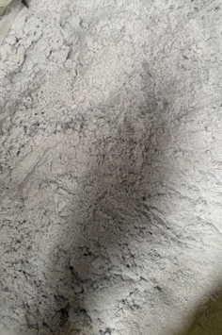
✂️ Shreddable Materials
Books and paper documents, CDs/DVDs
Cards and chip-based items (e.g. SIM cards, mobile chips)
PVC advertising boards, plastic display panels, KT boards, school and institutional event panels
Other paper- or fiber-based media
Other plastic-based materials
🔧 Technical Specifications
🆔Model | YD-YTJ600BM1 | YD-YTJ500BM1 | YD-YTJ400BM1 | YD-YTJ300BM1
📥Feed Width | 60CM*38CM | 50CM*30CM | 40CM*26CM | 30CM*22CM
✂️ Cut Size | 1*1mm粉末状，可调整粉碎尺寸为1*2mm, 8mm, 3mm等
📑 Max Sheets | 300-500 | 200-300 | 100-200 | 80-130
🔌Power | 19.12KW,3 phase 380V | 15KW,3 phase 380V | 10KW,3 phase 380V | 7.5KW, 3 phase 380V
💰Price (USD) | 29,610 | 21,150 | 21,150 | 17,143
➕ Custom Case
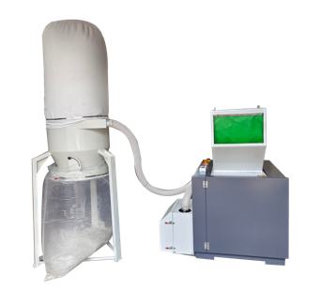 | 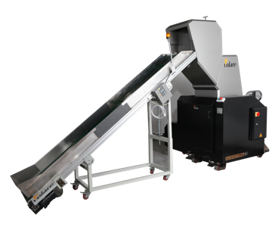 | 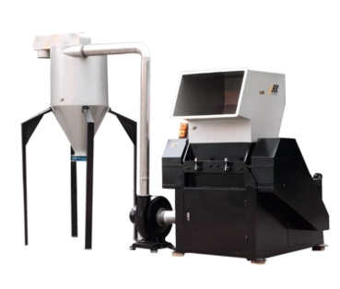 | 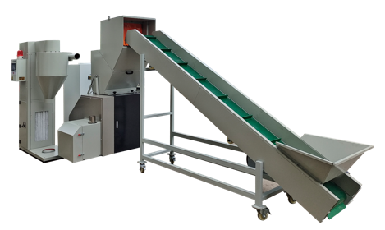

📄（5.1/7）YD-BM6002– Modular 1mm Shredding Solutions
Flagship 1mm Powder-Level Security Shredding System
🖼️ Product Overview
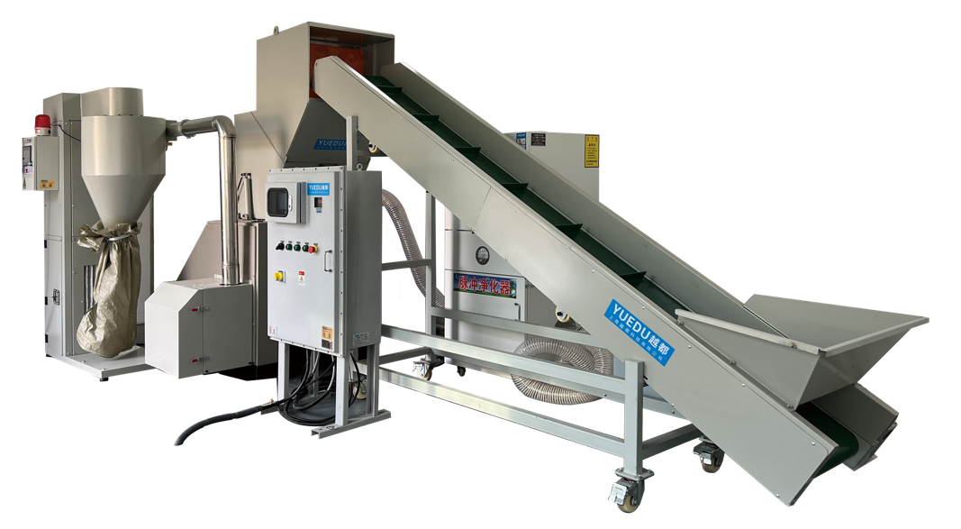 | 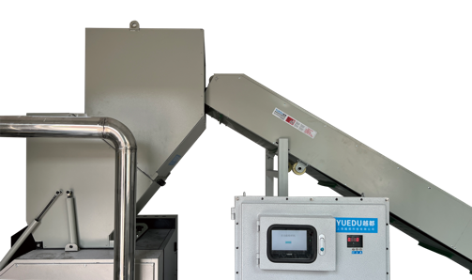
 | 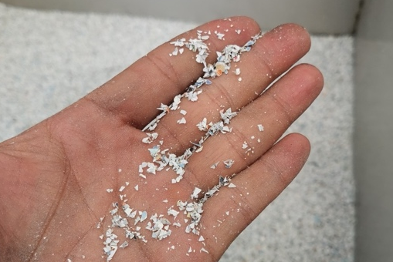
🧩 Application Scenarios
🔒🛡️ Secure / Confidential Room / Secure Destruction Center

💰 Price: RMB 497,731
🔧 Technical Specifications
Model | YD-BM6002 | 📏整体方案三视图：
Feed Opening Size | 600 mm (W) × 280 mm (H) | 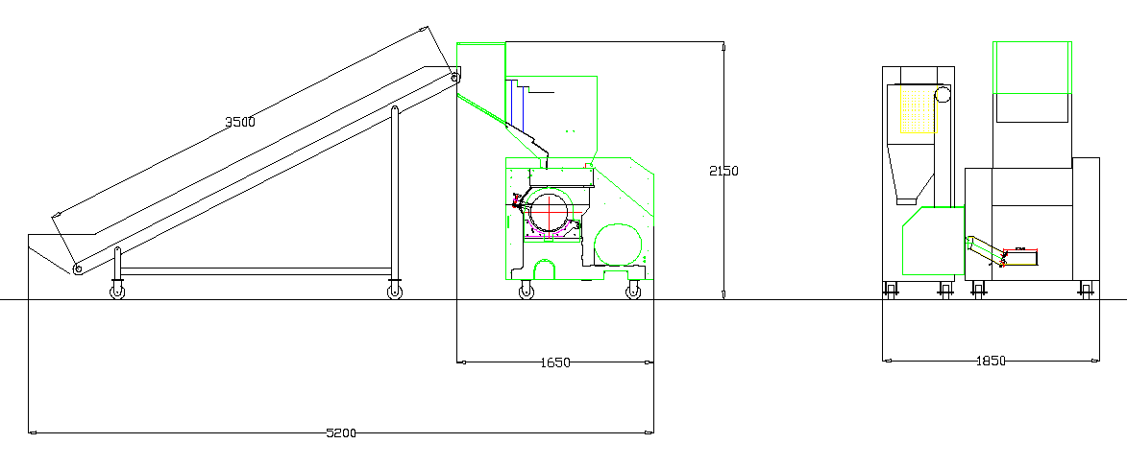
Shredding Output Form | Powder (adjustable)
Minimum Particle Size | 1 × 1 mm
Shredding Capacity | 1×2 mm: 80–100 kg/hour  4–5 mm: 500–650 kg/hour  8 mm: 1200–1600 kg/hour
Sheets per Batch | 300–500 sheets
Power Supply | 380 V / 3-phase
Installed Power | 27 kW

➕ Case
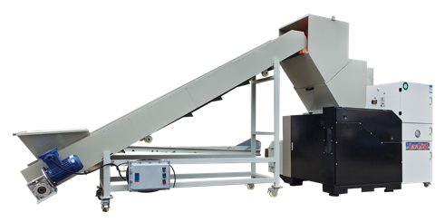 | 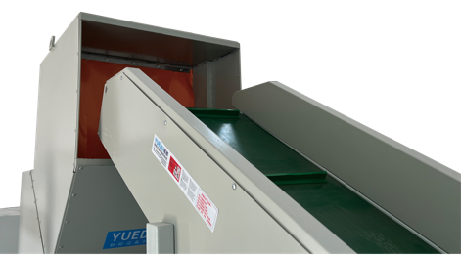 | 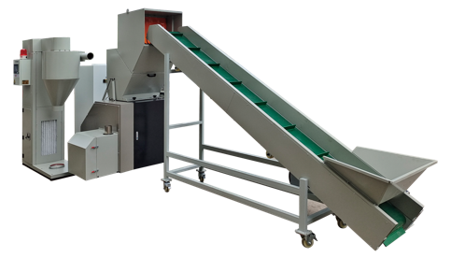
📌 Note:The above solution is for reference only. Final delivery is subject to the user’s confirmed requirements.

📄（5.2/7）YD-BM4001 – Modular 1mm Shredding Solutions
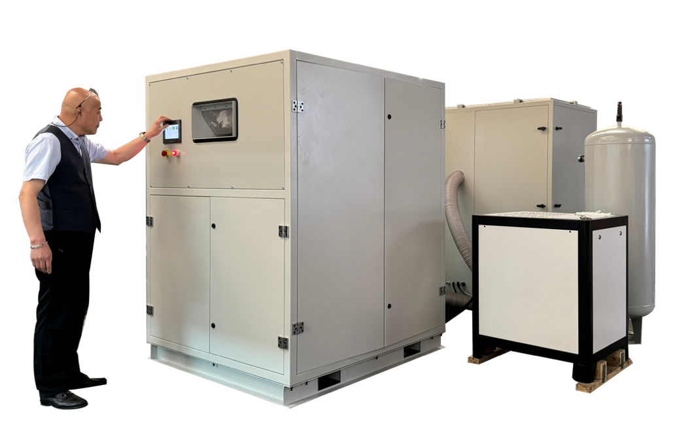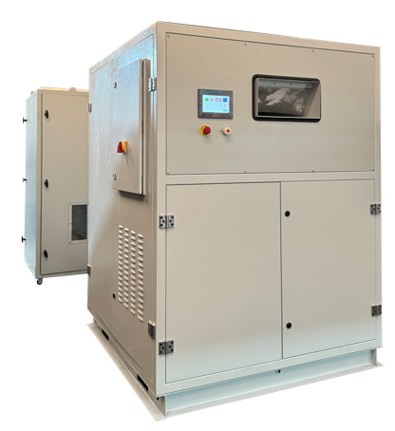
1mm powder - 1mm粉末状
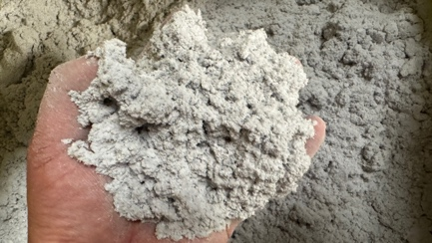 | 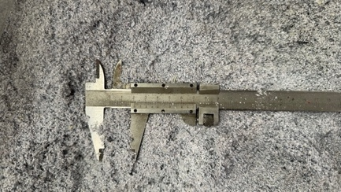 | 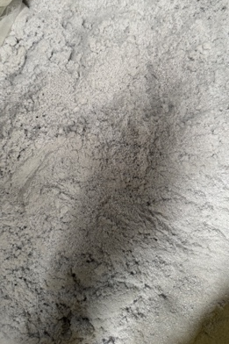
Shredder Specifications:
• Single Feed Capacity: 100 sheets; Hourly Shredding Capacity: 100-150KG/H
• Output: 3mm particles: 100-150KG/H; 1mm particles: 75KG/H
 https://www.youtube.com/watch?v=Kc4YdBsiQKo
➕ Custom Case定制案例
Banknote Destruction Machine | Integrated Baler and Compactor | Output
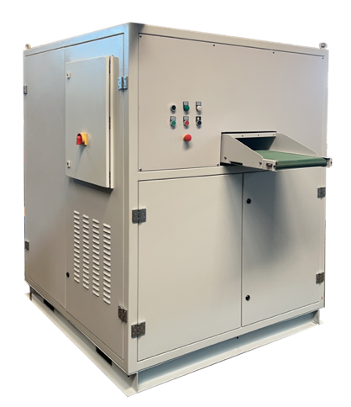 | 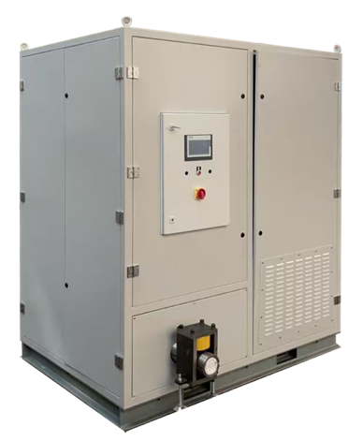 | 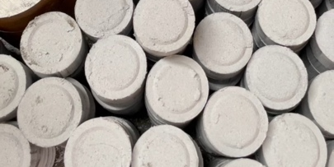 | 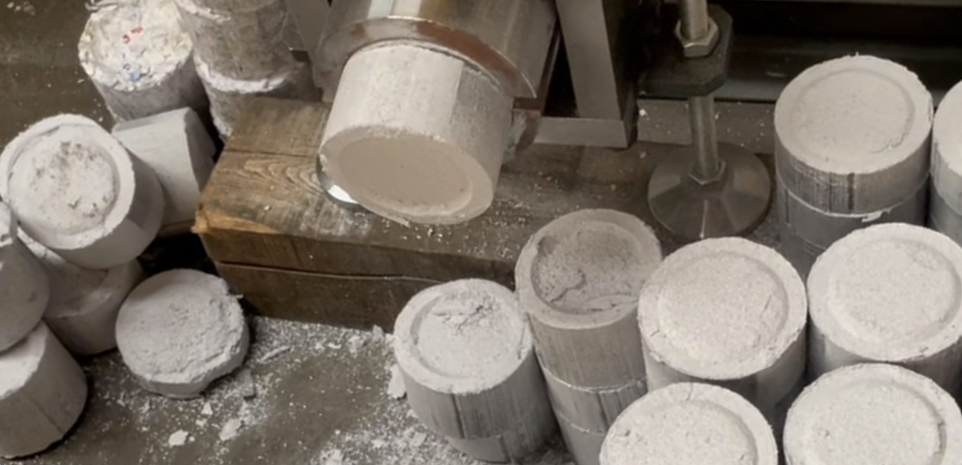
 |  | 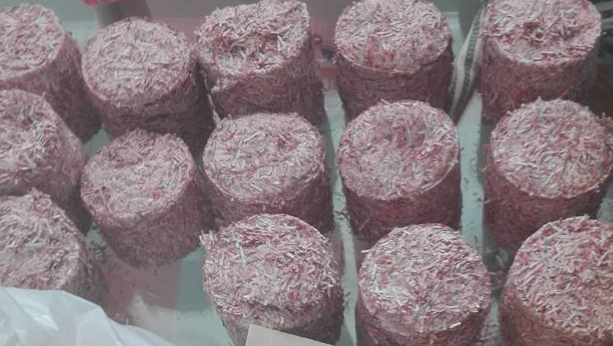 | 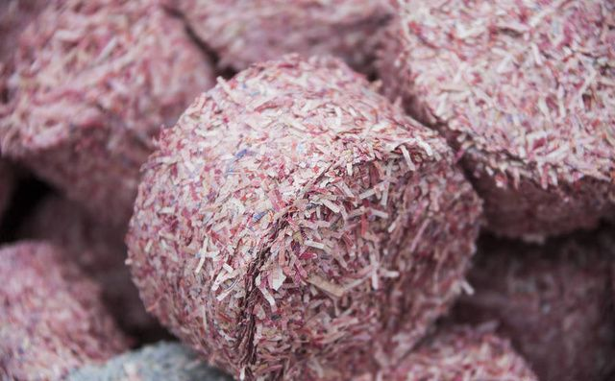

Video1: https://youtu.be/OnOKqf-vkCA Video2: https://youtube.com/shorts/5-dmXbM1Wpw

📄（6/7）YD-FSJQL系列 300-800型漏斗大功率机型
🖼️ Product Overview
YD-FSJQL300 | YD-FSJQL400 | YD-FSJQL500 | YD-FSJQL600
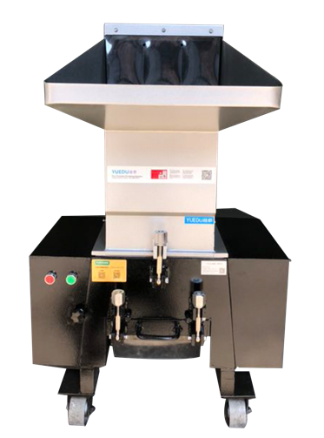 | 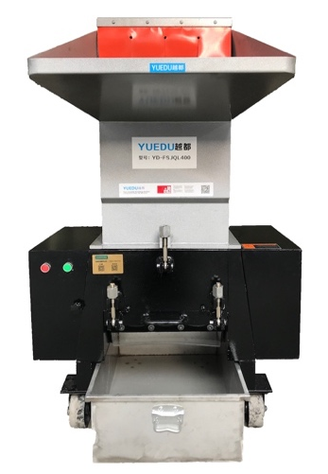 | 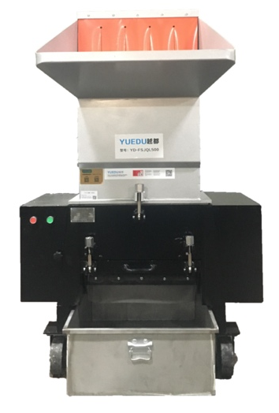 | 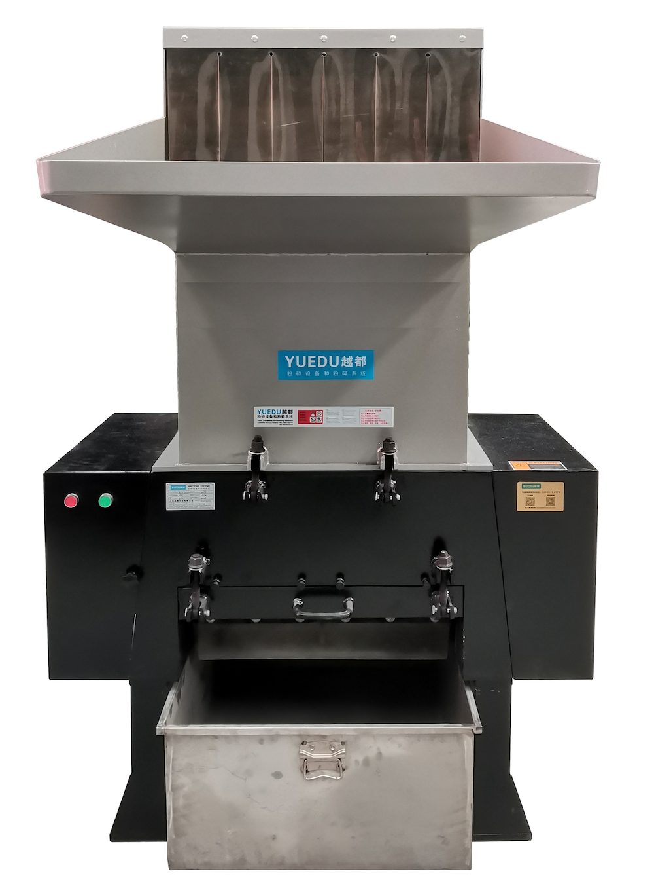
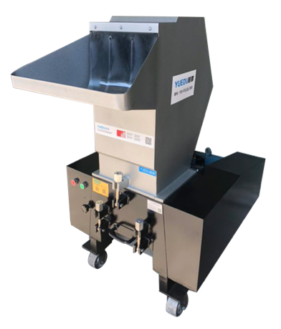 | 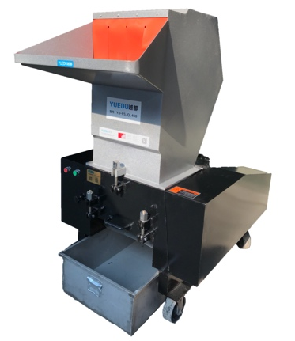 | 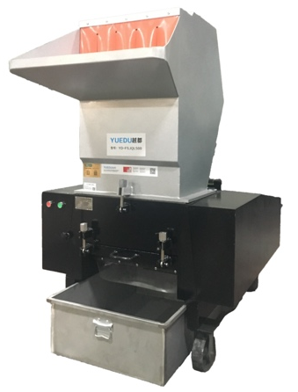 | 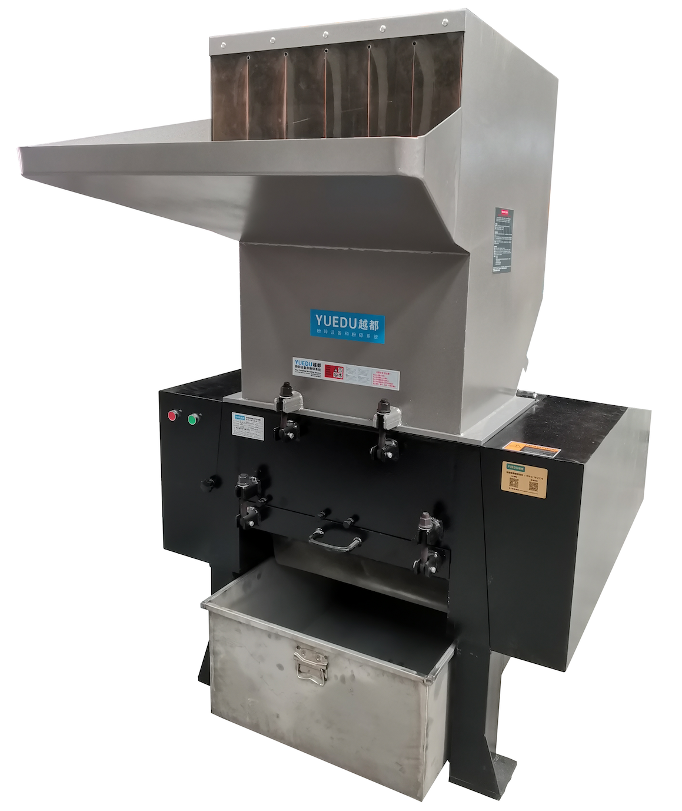
Constructed with specialized wear-resistant steel, this innovative design guarantees unmatched bite force, exceptional durability, and an extended service life. The oversized inertia wheel amplifies torque and maximizes capacity, ensuring peak performance under demanding conditions.

Technical Specifications:
Product Model | YD-FSJQL300 | YD-FSJQL400 | YD-FSJQL500 | YD-FSJQL600 | YD-FSJQL800
Inlet Dimensions (mm) | 310*260 | 410*260 | 510*260 | 610*310 | 810*410
Number of Sheets Shredded | 30-50 | 70-80 | 100-150 | 200-300 | 400-800
Shredding Capacity（kg/h） | 100-200 | 150-250 | 200-350 | 300-600 | 500-800
Motor Power | 5.5KW, 380V | 7.5KW, 380V | 11KW, 380V | 15KW, 380V | 30KW, 380V
Shredded Size(Customizable) | 8mm | 8mm | 8mm | 8mm | 8mm
Dimensions (m) | 1.22x0.72x1.16 | 1.32x0.86x1.46 | 1.45x1.00x1.54 | 1.70x1.15x1.88 | 2.22x1.38x2.38
Weight (kg) | 450 | 550 | 750 | 850 | 2000
Pricing RMB | 11765 | 15261 | 19792 | 31423 | 79618

📄（7/7）YD-SL500 | 600 | 700 Silent High-Power Shredder
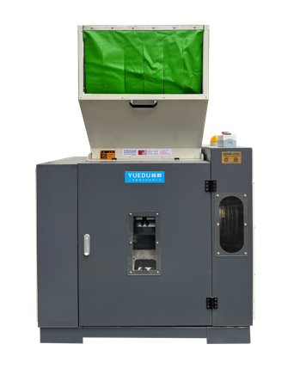 | 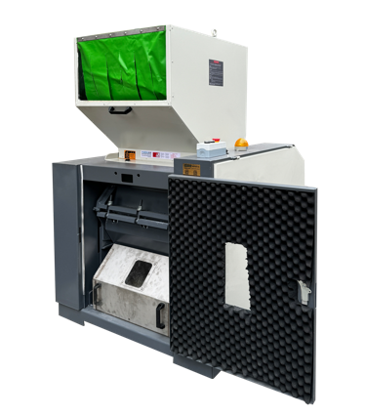 | 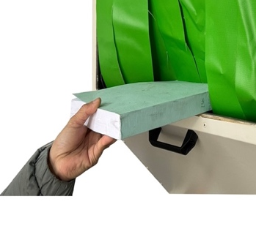 | 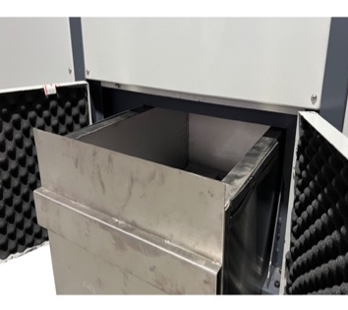
Front View | Internal View | Safe Feeding Inlet | Fully Enclosed Waste Bin
🏆Twenty Years of Design Expertise, Proven Client Applications, and Innovative Global Technologies
As a pioneering new product, it integrates two decades of engineering excellence, extensive client application cases, and globally innovative technology. Features include but are not limited to:
● EHS-Compliant: Fully aligned with global Environmental, Health, and Safety standards, trusted by multinational corporations.  ● High Efficiency, Low Energy Consumption: Saves costs while delivering exceptional performance.  ● Zero Leakage: No material leakage, no dust emissions, and no material return during operation. | ● Handles Extreme Materials: Suitable for ultra-thick and super-hard materials.  ● Adaptable to Low-Melting Plastics and Rubber: Ideal for processing heat-sensitive materials.  ● Compatible with Glass Fiber and Mineral Materials: Designed for tough, abrasive substances.
🌍Preferred by Industry Leaders
The first choice for multinational corporations, industry leaders, and Fortune Global 500 enterprises.
🔧Technical Specifications:
Product Model | YD-SL500 | YD-SL600 | YD-SL700 | YD-SL800
Inlet Dimensions (mm) | 400*250 | 500*260 | 600*300 | 700*500
Number of Sheets Shredded | 150-250 | 300-500 | 400-600 | 500-700
Shredding Capacity | 200-350 kg/h | 300-600 kg/h | 400-600kg/h | 500-700kg/h
Motor Power | 7.5KW, 380V | 11KW, 380V | 15kw, 380V | 30kw
Shredded Size(Customizable) | 8mm | 8mm | 8mm | 8mm
Dimensions (mm) | 840*1000*1563 | 994*1160*1689 | 1260*1200*1950 | 1300*1250*2400
Weight (kg) | 450 | 700 | 900 | 1200
Pricing RMB | 67669 | 82715 | 97761 | 119837
Pricing USD | 9,667 | 11,817 | 13,966 | 17,120

📄 YD-FSJQL800 Industrial High-Performance Strong Cutter Shredder
🖼️ High-performance shredding unit for heavy-duty, multi-material applications.
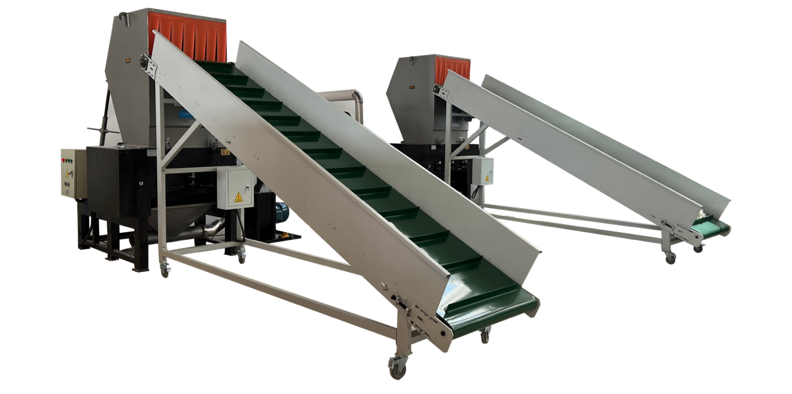
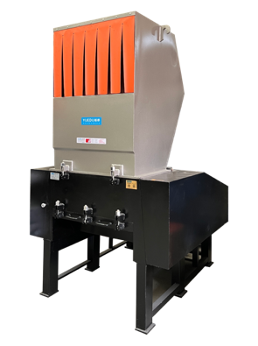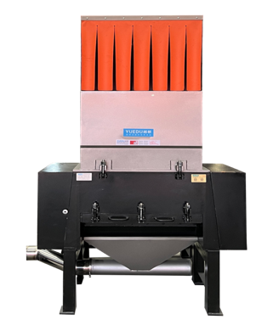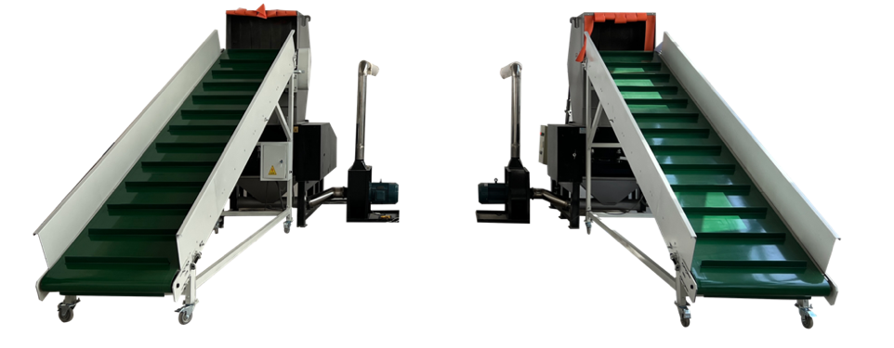 It is capable of processing bulk paper but also excels at shredding large, thick, and hard engineering plastics and other diverse materials.
Its unique modular design allows it to operate as a high-efficiency standalone unit or integrate seamlessly into large-scale automated destruction or recycling production lines.
🌟 Key Advantages
- Powerful Shredding Performance / Integrated Conveying Structure
- Flexible Modular Design / Industrial-Grade Throughput
🔧 Technical Specifications
Model | YD-FSJQL800
Feed Opening | 810 * 410 mm (Ideal for bulk/boxed feeding)
Motor Power | 30 KW, 380 V (High-torque drive)
Throughput | 500 - 800 kg/h
Max Sheets | 400 - 800 sheets (For paper-based materials)
Discharge Structure | Integrated Fan (Easy connection to suction systems)
Output Size | 8 mm (Customizable upon request)
Dimensions | 2.22 x 1.38 x 2.38 m

📄 Ultra-High Security - Selection 9
Equivalent to DIN 66399 P-7 | 1×1 mm Powder Output– v12
 | Plan 1:  YD-YTJ400BM1  YD-YTJ500BM1  YD-YTJ600BM1 | Plan 2:  YD-BM4001 | Plan 3：  YD-BM4002 | Plan 4：  YD-BM6001 | Plan 5：  YD-BM6002 | Plan 6：  YD-BM6002P | Plan 7：  YD-BM9002  YD-BM9002P
Pricing USD | 300BM1, 17,143  400BM1, 21,150  500BM1, 25,380  600BM1, 29,610 | 21,150 | 63,450 | 54,990 | 70,500 | 141,000 | 9002, 141,000  9002P, 282,000
Entry Image | 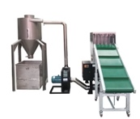 | 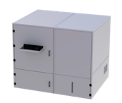 | 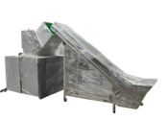 | 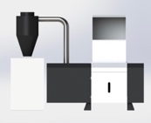 | 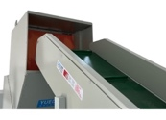 | 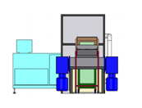 | 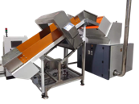
Full Machine Image | 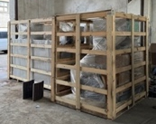 | 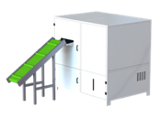 | 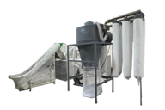 | 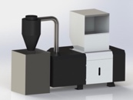 | 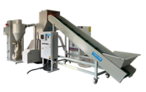 | 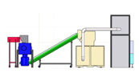 | 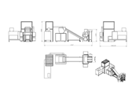
Crushing efficiency | 35 / 40 / 45KG/H | 100KG/H | 60KG/H | 50KG/H | 80KG/H | 80KG/H | 150KG/H
Shredded Size | 1*1mm  Adjustable, e.g. 2/5mm etc. | 1*1mm | 1*1mm | 1*1mm | 1*1mm | 1*1mm | 1*1mm
Sheets Shredded | 100-300 sheets | 300-500 sheets | 200-300 sheets | 300-500 sheets | 300-500 sheets | 300-500 sheets | 300-500 sheets
Entry Size | 40/ 50 / 60 CM | 60CM | 40CM | 60CM | 60CM | 60CM | 90CM
Applicable Scenarios | County-level units | Provincial and municipal units | Provincial and municipal | County-level | Provincial and municipal units | Provincial/Headquarters | Organizational Headquarters
 | https://youtu.be/q9D_uf_TdZI | https://youtu.be/RU7OpMIkUoc | https://youtube.com/shorts/KMaiAuUlj0s | https://youtu.be/i_cCRB-VJRw | https://youtu.be/v419WXU13oc | https://youtube.com/shorts/p3rOTUcy4Zg | https://youtube.com/shorts/p3rOTUcy4Zg
Attachment: Sample Display | 附件：样品展示
1mm powder - 1mm粉末状
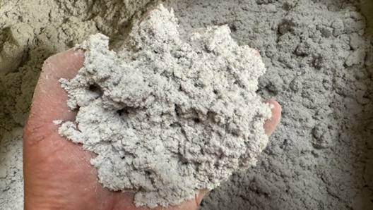 | 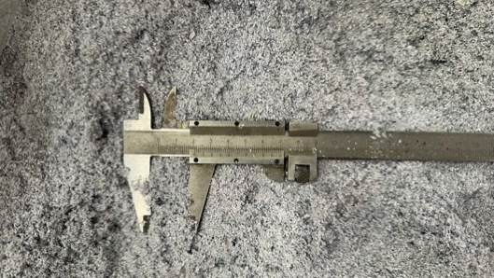 | 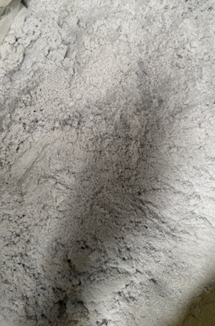
Compressed paper powder block - 纸粉压块
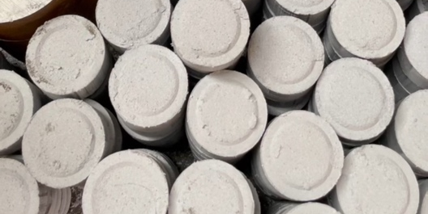 |  | 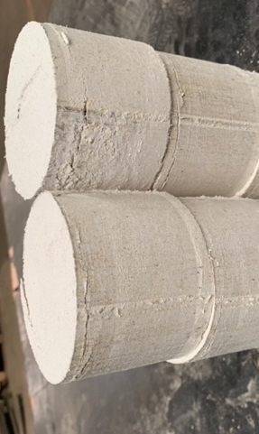
Compressed Money (RMB) block - 金钱（人民币）压块
 |  | 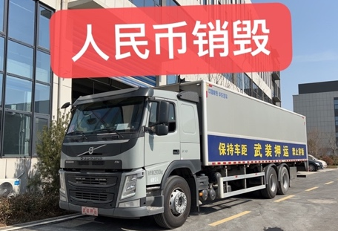

📞 Contact Us

Johnny Deng, Managing Director
☎️ Phone: +86 159 0178 2779 (WhatsApp / WeChat / Facebook / Telegram)
📧Email: denghao8410@gmail.com

Shanghai YUEDU Technology Co., Ltd. (YUEDU Shredders)
🌐 Website(Global): www.yuedushredders.com (note: VPN required for China access, as the server is hosted by Google.)
📧 Email: yuedushredders@gmail.com / denghao8410@gmail.com
☎️ Sales Supervisor: +86 159 0178 2779 (WhatsApp / WeChat / Facebook / Telegram) ☎️ Administrative Supervisor: +86 137 6138 5116
☎️ Head Office Main Line: +86 21 519 000 20
📍 Company Headquarters: Building 12, No. 555 Chengyin Road, Baoshan City Industrial Park, Shanghai, China

与我们联系（中文普通话）

上海越都科技有限公司
📍公司总部：上海市宝山城市工业园区城银路555弄12号楼
☎️ 中文电话: 138 1115 0898（同微信）, 137 1700 3125（同微信）, 188 1682 6112（同微信）
☎️ 公司总机：021 - 519 000 20
☎️ 行政总裁：137 6138 5116
☎️ 投诉电话：159 0178 2779
📧 Email邮箱: denghao8410@gmail.com
🌐 Website(中文网站): www.91suizhiji.com
🌐 文档下载站： www.daxingsuizhiji.com

For Long-Term Operation: Feed materials evenly and wait until the materials in the shredding chamber are fully processed before adding more. For continuous feeding, ensure each batch is no more than one-third of the value specified in the table.
Shredding Capacity: The listed capacity is the maximum, applicable to hard plastics. For materials like paper, the shredding capacity decreases and depends on the output size (larger sizes process faster). For shredding paper, a 3 cm output size is recommended for faster processing.
Customizable Sizes: Available in 1mm, 3mm, and 5mm specifications. For additional options, please contact customer service.
For Long-Term Operation: Feed materials evenly and wait until the materials in the shredding chamber are fully processed before adding more. For continuous feeding, ensure each batch is no more than one-third of the value specified in the table.
Shredding Capacity: The listed capacity is the maximum, applicable to hard plastics. For materials like paper, the shredding capacity decreases and depends on the output size (larger sizes process faster). For shredding paper, a 3 cm output size is recommended for faster processing.
Customizable Sizes: Available in 1mm, 3mm, and 5mm specifications. For additional options, please contact customer service.

