📄 Secure Document Destruction Solution - for Professional Operators

Integrated Shredding Lines - 2,000 Tons / Year

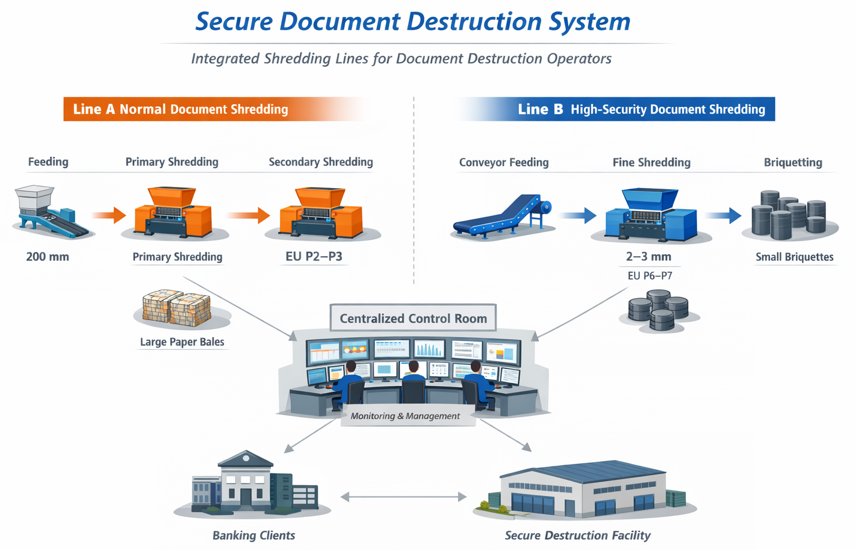

1. Project Overview
This solution is designed for professional document destruction operators providing outsourced services to banks and financial institutions.
The system focuses on long-term operational stability, security compliance, and cost efficiency, which are critical for service providers managing continuous workloads from multiple banking clients.
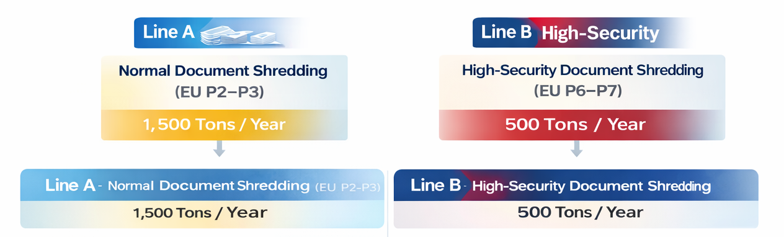
- Total annual volume: approx. 2,000 tons
  - Normal documents: 1,500 tons / year
  - High-security documents (EU P6–P7): 500 tons / year
- Operational assumption:
  - 200 working days per year
  - 6 operating hours per day
- Site condition:
  - Centralized operation at one facility
  - Available area ≥ 500 m², height approx. 6 m
- Design objective:
  - Stable, scalable operation for outsourced destruction services
  - Clear separation of security levels for different banking requirements

2. Overall System Concept
The proposed system is designed specifically for operators, not for one-time or internal bank use.
- Normal and high-security documents are processed on separate, dedicated lines
- Parallel line architecture ensures:
  - Continuous operation
  - Easy maintenance without full shutdown
  - Lower operational risk for service providers
- The system is suitable for multi-client, long-term service contracts

3. Line A – Normal Document Shredding (EU P2–P3)
Annual volume: approx. 1,500 tons
- Required throughput: 1.2–1.3 tons/hour
- Configuration: 2 parallel shredding lines
Each line includes:
- Primary shredder
  - Motor power: 15 kW
- Secondary shredder
  - Motor power: 10 kW
  - Security level: EU P2–P3
- Single-line capacity: 600–700 kg/hour
Discharge & baling:
- Shredded paper is sent directly to the customer’s existing baler
- Large paper bales for easy handling and resale
- No additional baler investment required

4. Line B – High-Security Document Shredding (EU P6–P7)
Annual volume: approx. 500 tons
- Required throughput: approx. 400–420 kg/hour
- Configuration: 2 parallel high-security shredding lines
Each line includes:
- Conveyor feeding system
- Primary shredder
  - Motor power: 11 kW
- High-security fine shredder
  - Motor power: 22 kW
  - Output size: 1–2 mm particles
  - Security level: EU P6–P7
- Single-line capacity: 150–200 kg/hour
Final treatment:
- Shredded paper powder is processed by a hydraulic briquetting system
- Compressed into small cylindrical briquettes

5. Key Advantages for Operators
- ✔ Designed for outsourced document destruction services
- ✔ Parallel production lines ensure high uptime and operational flexibility
- ✔ Separation of security levels improves workflow efficiency
- ✔ Industrial-grade design suitable for continuous daily operation
- ✔ Optimized investment structure and long-term ROI for operators

This solution concept is intended for professional operators serving banks, central banks, and financial institutions.

🌐 Contact Us 联系我们
Shanghai YUEDU Technology Co., Ltd. | 上海越都科技有限公司
📧 Email: yuedushredders@gmail.com | denghao8410@gmail.com
📱 WhatsApp / WeChat: +86 159 0178 2779
🌐 Website: www.yuedushredders.com
@YUEDUShredders – Empowering Global Industries with Intelligent Destruction Systems.

📄 银行档案文件保密销毁整体解决方案
面向专业运营方的集成式粉碎生产线方案
处理能力：2,000 吨 / 年

1. 项目概述（Project Overview）
本解决方案专为专业文件销毁运营方（Document Destruction Operators）设计，用于为银行及金融机构提供外包式档案销毁服务。
系统设计重点放在长期运行稳定性、保密合规性以及整体成本效率上，适用于需要同时服务多家银行客户、长期连续运行的运营场景。
- 年总处理量：约 2,000 吨
  - 普通文件：1,500 吨 / 年
  - 高保密文件（EU P6–P7）：500 吨 / 年
- 运行假设：
  - 每年 200 个工作日
  - 每天 6 小时 实际运行时间
- 场地条件：
  - 单一厂区集中运营
  - 可用面积 ≥ 500 平方米
  - 厂房高度约 6 米
- 设计目标：
  - 适用于外包销毁服务的稳定、可扩展运营
  - 不同保密资料对应不同保密等级，清晰分线处理

2. 整体系统设计理念（Overall System Concept）
该系统是从运营方视角出发设计的工业级方案，并非一次性项目或银行内部自用系统。
- 普通文件与高保密文件 分别在独立生产线上处理
- 并行生产线架构可实现：
  - 连续稳定运行
  - 单线维护时无需全线停机
  - 降低运营方整体运行风险
- 系统非常适合：
  - 多客户并行
  - 长期服务合同
  - 规模化档案销毁运营

3. Line A —— 普通文件粉碎线（EU P2–P3）
年处理量：约 1,500 吨
- 目标产能：约 1.2–1.3 吨 / 小时
- 配置方式：2 条并行粉碎生产线

每条生产线配置包括：
- 一级粉碎机（Primary Shredder）
  - 电机功率：15 kW
- 二级粉碎机（Secondary Shredder）
  - 电机功率：10 kW
  - 保密等级：EU P2–P3
- 单线产能：约 600–700 kg / 小时

出料与打包方式：
- 粉碎后的纸张 直接进入客户现有打包机
- 打包成大尺寸纸包，便于搬运、存储及再销售
- 无需额外投资新的打包设备

4. Line B —— 高保密文件粉碎线（EU P6–P7）
年处理量：约 500 吨
- 目标产能：约 400–420 kg / 小时
- 配置方式：2 条并行高保密粉碎生产线

每条生产线配置包括：
- 输送带自动上料系统
- 一级粉碎机
  - 电机功率：11 kW
- 高保密细碎机
  - 电机功率：22 kW
  - 出料尺寸：1–2 mm 粉末颗粒
  - 保密等级：EU P6–P7
- 单线产能：约 150–200 kg / 小时

末端收集和压块：
- 粉碎后的纸粉进入液压式纸粉压块系统
- 压缩成小型圆柱状压块

5. 运营方核心优势总结（Key Advantages for Operators）
- ✔ 专为外包式文件销毁运营模式设计
- ✔ 并行生产线保障高开机率与运营灵活性
- ✔ 不同保密等级分线处理，提升整体流程效率
- ✔ 工业级设计，适合长期、连续日常运行
- ✔ 投资结构合理，有利于运营方长期 ROI

本方案适用于为银行、中央银行及金融机构提供服务的专业运营方。

📞 Contact Us

Johnny Deng, Managing Director
☎️ Phone: +86 159 0178 2779 (WhatsApp / WeChat / Facebook / Telegram)
📧Email: denghao8410@gmail.com

Shanghai YUEDU Technology Co., Ltd. (YUEDU Shredders)
🌐 Website(Global): www.yuedushredders.com (note: VPN required for China access, as the server is hosted by Google.)
📧 Email: yuedushredders@gmail.com / denghao8410@gmail.com
☎️ Sales Supervisor: +86 159 0178 2779 (WhatsApp / WeChat / Facebook / Telegram) ☎️ Administrative Supervisor: +86 137 6138 5116
☎️ Head Office Main Line: +86 21 519 000 20
📍 Company Headquarters: Building 12, No. 555 Chengyin Road, Baoshan City Industrial Park, Shanghai, China

与我们联系（中文普通话）

上海越都科技有限公司
📍公司总部：上海市宝山城市工业园区城银路555弄12号楼
☎️ 中文电话: 138 1115 0898（同微信）, 137 1700 3125（同微信）, 188 1682 6112（同微信）
☎️ 公司总机：021 - 519 000 20
☎️ 行政总裁：137 6138 5116
☎️ 投诉电话：159 0178 2779
📧 Email邮箱: denghao8410@gmail.com
🌐 Website(中文网站): www.91suizhiji.com
🌐 文档下载站： www.daxingsuizhiji.com

