📄 Secure Document Destruction Solution – Normal & High-Security

Integrated Shredding Lines – 2,000 Tons / Year

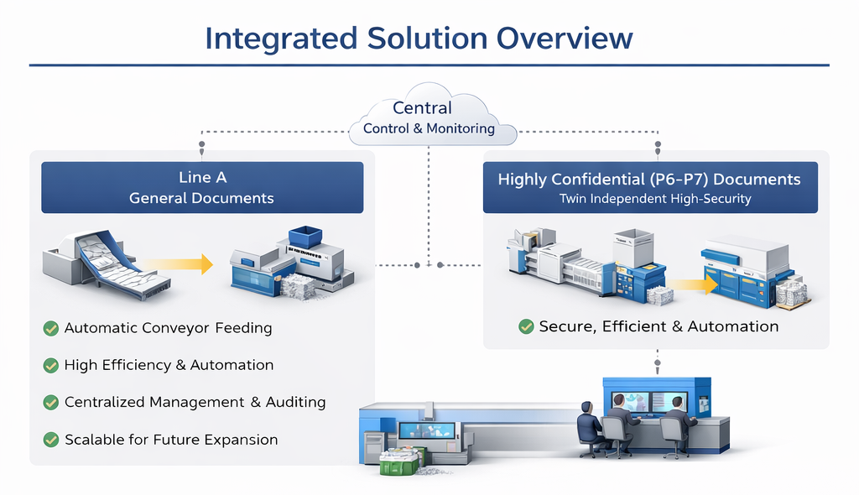

1. Project Overview
This project is designed for bank-related archival document destruction, combining operational efficiency and high security compliance.
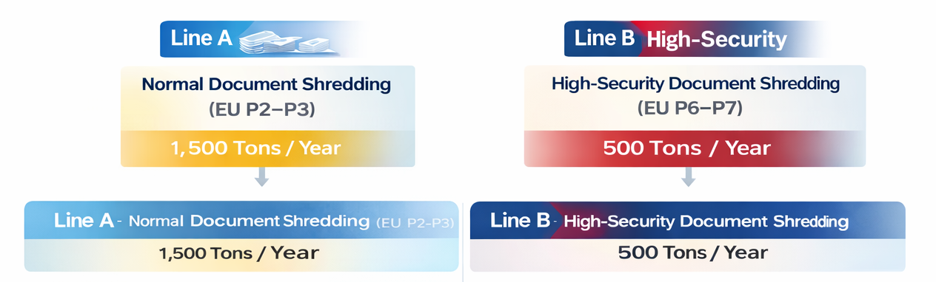
- Total volume: approx. 2,000 tons / year
  - Normal documents: 1,500 tons / year
  - High-security documents (P6–P7): 500 tons / year
- Operation assumption:
  - 200 working days / year
  - 6 operating hours / day
- Site condition:
  - Single centralized location
  - Area ≥ 500 m², height approx. 6 m
- Design objective:
  - Stable, long-term industrial operation
  - Modular & parallel production lines
  - Clear separation of security levels

2. Overall System Concept
We recommend an integrated solution with separated security levels and parallel production lines:
- Normal documents and high-security documents are processed on independent lines
- Multiple parallel lines ensure:
  - Operational stability
  - Maintenance flexibility
  - No single-point failure risk
- All systems are centrally managed within one facility

3. Line A – Normal Document Shredding (EU P2–P3)
Annual volume: approx. 1,500 tons
- Required throughput: 1.2–1.3 tons/hour
- Configuration: 2 parallel shredding lines
Each line includes:
- Primary shredder
  - Motor power: 15 kW
  - Output size: approx. 20 mm
- Secondary shredder
  - Motor power: 10 kW
  - Security level: EU P2–P3
- Single-line capacity: 600–700 kg/hour
Discharge & baling:
- Shredded paper is sent directly to the customer’s existing baler
- Large paper bales for easy handling and resale
- No additional baler investment required

4. Line B – High-Security Document Shredding (EU P6–P7)
Annual volume: approx. 500 tons
- Required throughput: approx. 400–420 kg/hour
- Configuration: 2 parallel high-security shredding lines
Each line includes:
- Conveyor feeding system
- Primary shredder
  - Motor power: 11 kW
- High-security fine shredder
  - Motor power: 22 kW
  - Output size: 1–3 mm particles
  - Security level: EU P6–P7
- Single-line capacity: 150–200 kg/hour
Final treatment:
- Shredded paper powder is processed by a hydraulic briquetting system
- Compressed into small cylindrical briquettes
- Ensures maximum security and reduced volume

5. Key Advantages of the Integrated Solution
- ✔ Parallel line design for high reliability and redundancy
- ✔ Clear separation of normal and high-security workflows
- ✔ Industrial-grade operation, not an oversized single machine
- ✔ Suitable for long-term operation in banking and archival environments

🌐 Contact Us 联系我们
Shanghai YUEDU Technology Co., Ltd. | 上海越都科技有限公司
📧 Email: yuedushredders@gmail.com | denghao8410@gmail.com
📱 WhatsApp / WeChat: +86 159 0178 2779
🌐 Website: www.yuedushredders.com
@YUEDUShredders – Empowering Global Industries with Intelligent Destruction Systems.

🏦 银行档案文件安全销毁整体解决方案 - 普通文件 + 高保密等级文件

一、项目背景与目标
本方案面向银行、金融机构及专业档案销毁运营方，
用于集中处理 普通文件 + 高保密等级文件（P6–P7） 的长期、安全、合规销毁需求。
核心目标：
- ✔ 满足不同保密等级的合规要求
- ✔ 连续稳定运行，适合长期外包运营

二、整体方案架构
本方案采用 “两套工艺 + 一个整体系统” 的设计理念：
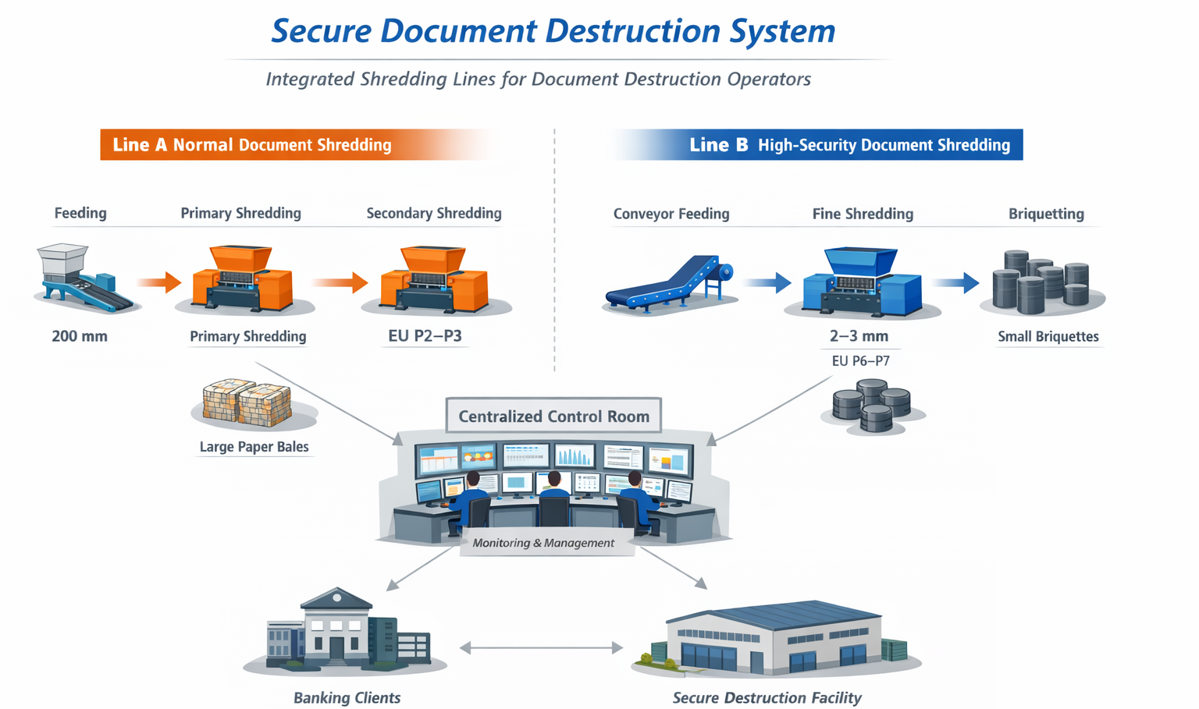

🔹 Line A｜普通文件粉碎 + 打包机
用于银行日常档案、普通文件集中处理
- 输送带自动进料
- 工业级粉碎机连续粉碎
- 粉碎后物料 直接进入打包机压块
- 压块成型，便于仓储与运输
👉 优势：
- 人工投入少
- 处理效率高
- 末端直接成块，降低物流成本

🔹 Line B｜高保密文件（EU P6–P7）粉碎成粉末 + 压块机
用于涉密文件、敏感档案、安全级别要求极高的文件
- 两条完全独立、结构相同的高保密粉碎线
- 每条线包含：
  - 一级粗碎
  - 二级细碎（达到EU P6–P7）,粉碎后为1~3mm粉末状
- 双线并行运行，保障连续性与冗余安全
- 粉碎后的纸粉进入液压式纸粉压块系统
- 压缩成小型圆柱状压块

三、每年产能
- 年处理总量：约 2,000 吨 / 年
  - 普通文件：约 1,500 吨/ 年
  - 高保密文件：约 500 吨/ 年

四、适用客户类型
- 银行档案中心
- 金融机构集中销毁中心
- 第三方专业保密销毁运营商
- 政府或金融外包销毁项目

📞 Contact Us

Johnny Deng, Managing Director
☎️ Phone: +86 159 0178 2779 (WhatsApp / WeChat / Facebook / Telegram)
📧Email: denghao8410@gmail.com

Shanghai YUEDU Technology Co., Ltd. (YUEDU Shredders)
🌐 Website(Global): www.yuedushredders.com (note: VPN required for China access, as the server is hosted by Google.)
📧 Email: yuedushredders@gmail.com / denghao8410@gmail.com
☎️ Sales Supervisor: +86 159 0178 2779 (WhatsApp / WeChat / Facebook / Telegram) ☎️ Administrative Supervisor: +86 137 6138 5116
☎️ Head Office Main Line: +86 21 519 000 20
📍 Company Headquarters: Building 12, No. 555 Chengyin Road, Baoshan City Industrial Park, Shanghai, China

与我们联系（中文普通话）

上海越都科技有限公司
📍公司总部：上海市宝山城市工业园区城银路555弄12号楼
☎️ 中文电话: 138 1115 0898（同微信）, 137 1700 3125（同微信）, 188 1682 6112（同微信）
☎️ 公司总机：021 - 519 000 20
☎️ 行政总裁：137 6138 5116
☎️ 投诉电话：159 0178 2779
📧 Email邮箱: denghao8410@gmail.com
🌐 Website(中文网站): www.91suizhiji.com
🌐 文档下载站： www.daxingsuizhiji.com

