📄 Secure Document Destruction Solution - for Professional Operators

Integrated Shredding Lines - 2,000 Tons / Year

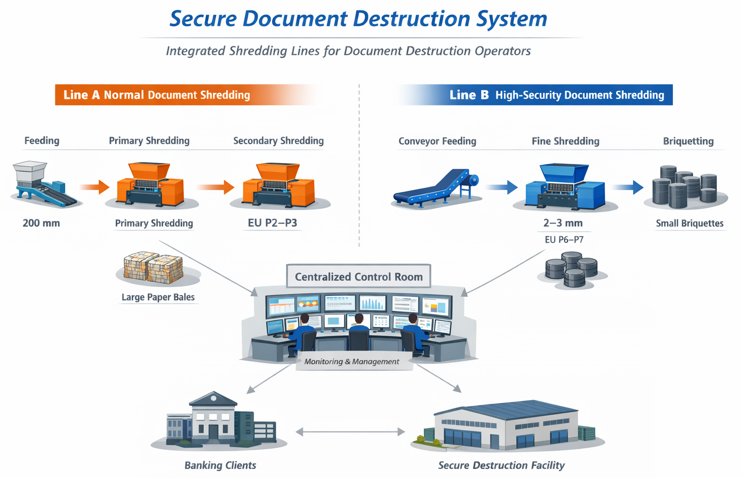

1. Project Overview
This solution is designed for professional document destruction operators providing outsourced services to banks and financial institutions.
The system focuses on long-term operational stability, security compliance, and cost efficiency, which are critical for service providers managing continuous workloads from multiple banking clients.
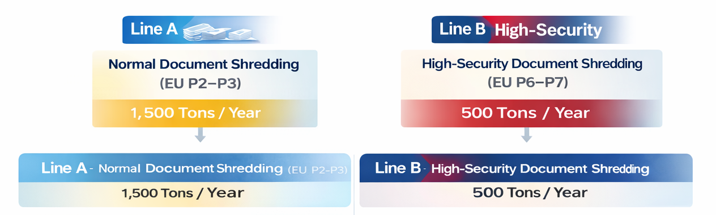
- Total annual volume: approx. 2,000 tons
  - Normal documents: 1,500 tons / year
  - High-security documents (EU P6–P7): 500 tons / year
- Operational assumption:
  - 200 working days per year
  - 6 operating hours per day
- Site condition:
  - Centralized operation at one facility
  - Available area ≥ 500 m², height approx. 6 m
- Design objective:
  - Stable, scalable operation for outsourced destruction services
  - Clear separation of security levels for different banking requirements

2. Overall System Concept
The proposed system is designed specifically for operators, not for one-time or internal bank use.
- Normal and high-security documents are processed on separate, dedicated lines
- Parallel line architecture ensures:
  - Continuous operation
  - Easy maintenance without full shutdown
  - Lower operational risk for service providers
- The system is suitable for multi-client, long-term service contracts

3. Line A – Normal Document Shredding (EU P2–P3)
Annual volume: approx. 1,500 tons
- Required throughput: 1.2–1.3 tons/hour
- Configuration: 2 parallel shredding lines
Each line includes:
- Primary shredder
  - Motor power: 15 kW
- Secondary shredder
  - Motor power: 10 kW
  - Security level: EU P2–P3
- Single-line capacity: 600–700 kg/hour
Discharge & baling:
- Shredded paper is sent directly to the customer’s existing baler
- Large paper bales for easy handling and resale
- No additional baler investment required

4. Line B – High-Security Document Shredding (EU P6–P7)
Annual volume: approx. 500 tons
- Required throughput: approx. 400–420 kg/hour
- Configuration: 2 parallel high-security shredding lines
Each line includes:
- Conveyor feeding system
- Primary shredder
  - Motor power: 11 kW
- High-security fine shredder
  - Motor power: 22 kW
  - Output size: 1–2 mm particles
  - Security level: EU P6–P7
- Single-line capacity: 150–200 kg/hour
Final treatment:
- Shredded paper powder is processed by a hydraulic briquetting system
- Compressed into small cylindrical briquettes

5. Key Advantages for Operators
- ✔ Designed for outsourced document destruction services
- ✔ Parallel production lines ensure high uptime and operational flexibility
- ✔ Separation of security levels improves workflow efficiency
- ✔ Industrial-grade design suitable for continuous daily operation
- ✔ Optimized investment structure and long-term ROI for operators

This solution concept is intended for professional operators serving banks, central banks, and financial institutions.

🌐 Contact Us 联系我们
Shanghai YUEDU Technology Co., Ltd. | 上海越都科技有限公司
📧 Email: yuedushredders@gmail.com | denghao8410@gmail.com
📱 WhatsApp / WeChat: +86 159 0178 2779
🌐 Website: www.yuedushredders.com
@YUEDUShredders – Empowering Global Industries with Intelligent Destruction Systems.

📞 Contact Us

Johnny Deng, Managing Director
☎️ Phone: +86 159 0178 2779 (WhatsApp / WeChat / Facebook / Telegram)
📧Email: denghao8410@gmail.com

Shanghai YUEDU Technology Co., Ltd. (YUEDU Shredders)
🌐 Website(Global): www.yuedushredders.com (note: VPN required for China access, as the server is hosted by Google.)
📧 Email: yuedushredders@gmail.com / denghao8410@gmail.com
☎️ Sales Supervisor: +86 159 0178 2779 (WhatsApp / WeChat / Facebook / Telegram) ☎️ Administrative Supervisor: +86 137 6138 5116
☎️ Head Office Main Line: +86 21 519 000 20
📍 Company Headquarters: Building 12, No. 555 Chengyin Road, Baoshan City Industrial Park, Shanghai, China

