💵 Central Bank & Banknote Printing Industry Solution

央行与印钞行业安全销毁解决方案

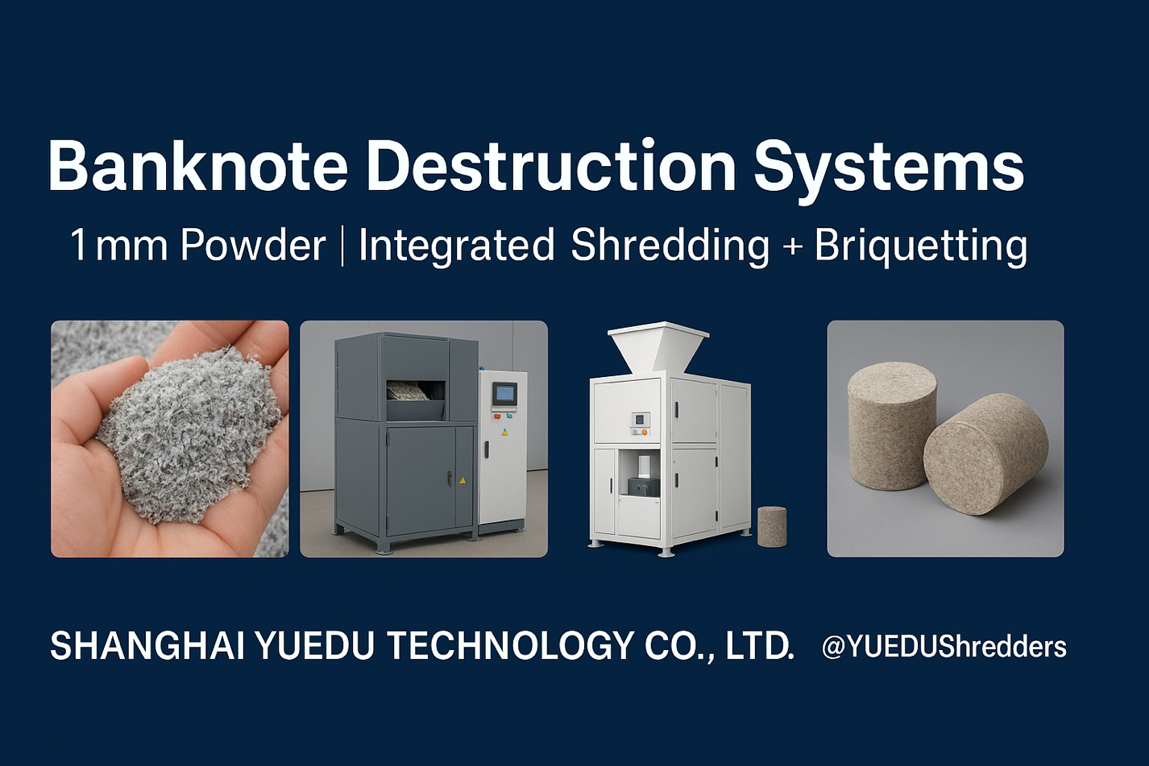
Secure. Efficient. Compliant.

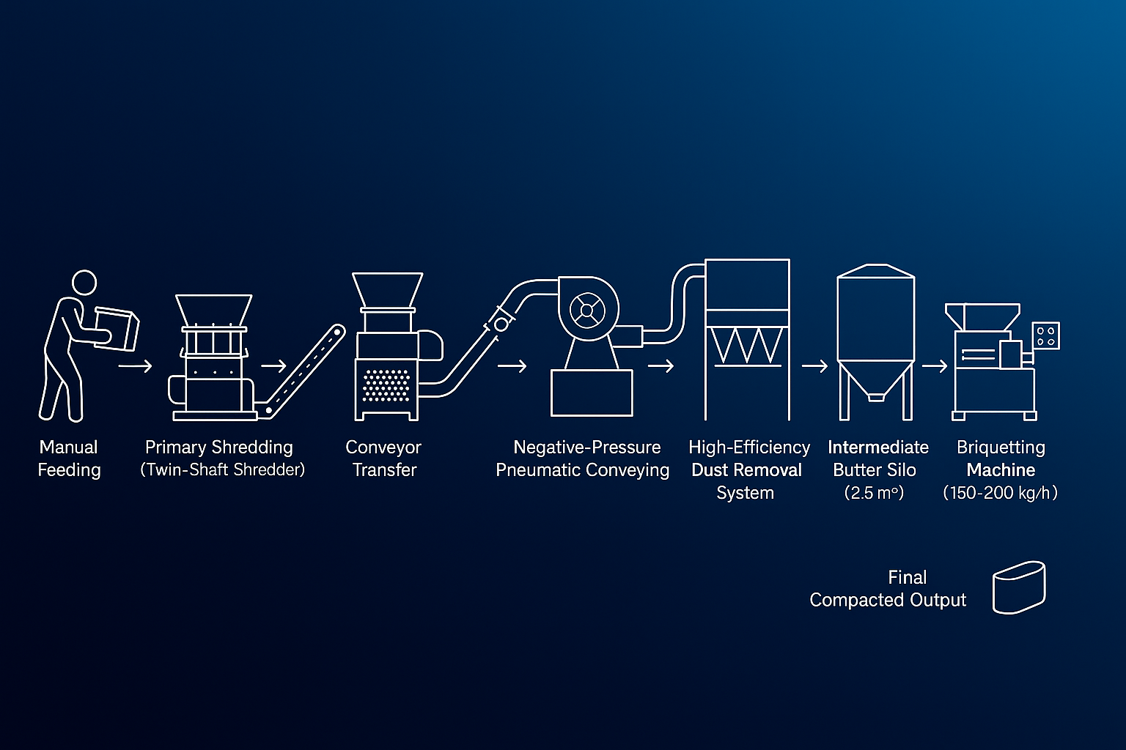
BDS for Central-bank-level:
Two-Stage Shredding / Dust Extraction & Filtration / Briquetting

Case study • Client A
Banknote Destruction Machine | Integrated Baler and Compactor | Output
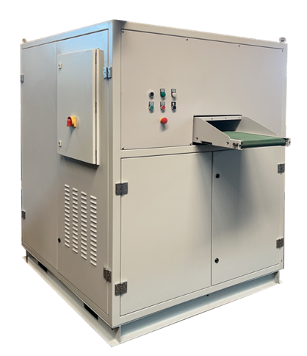 | 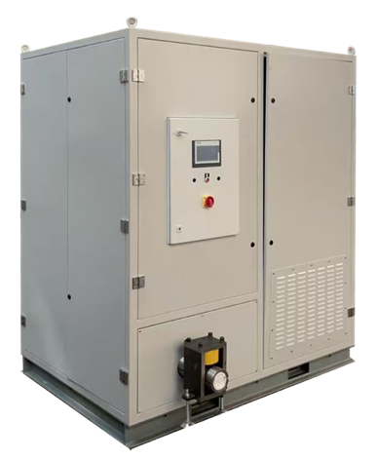 | 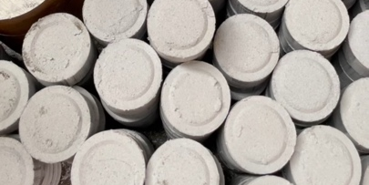 | 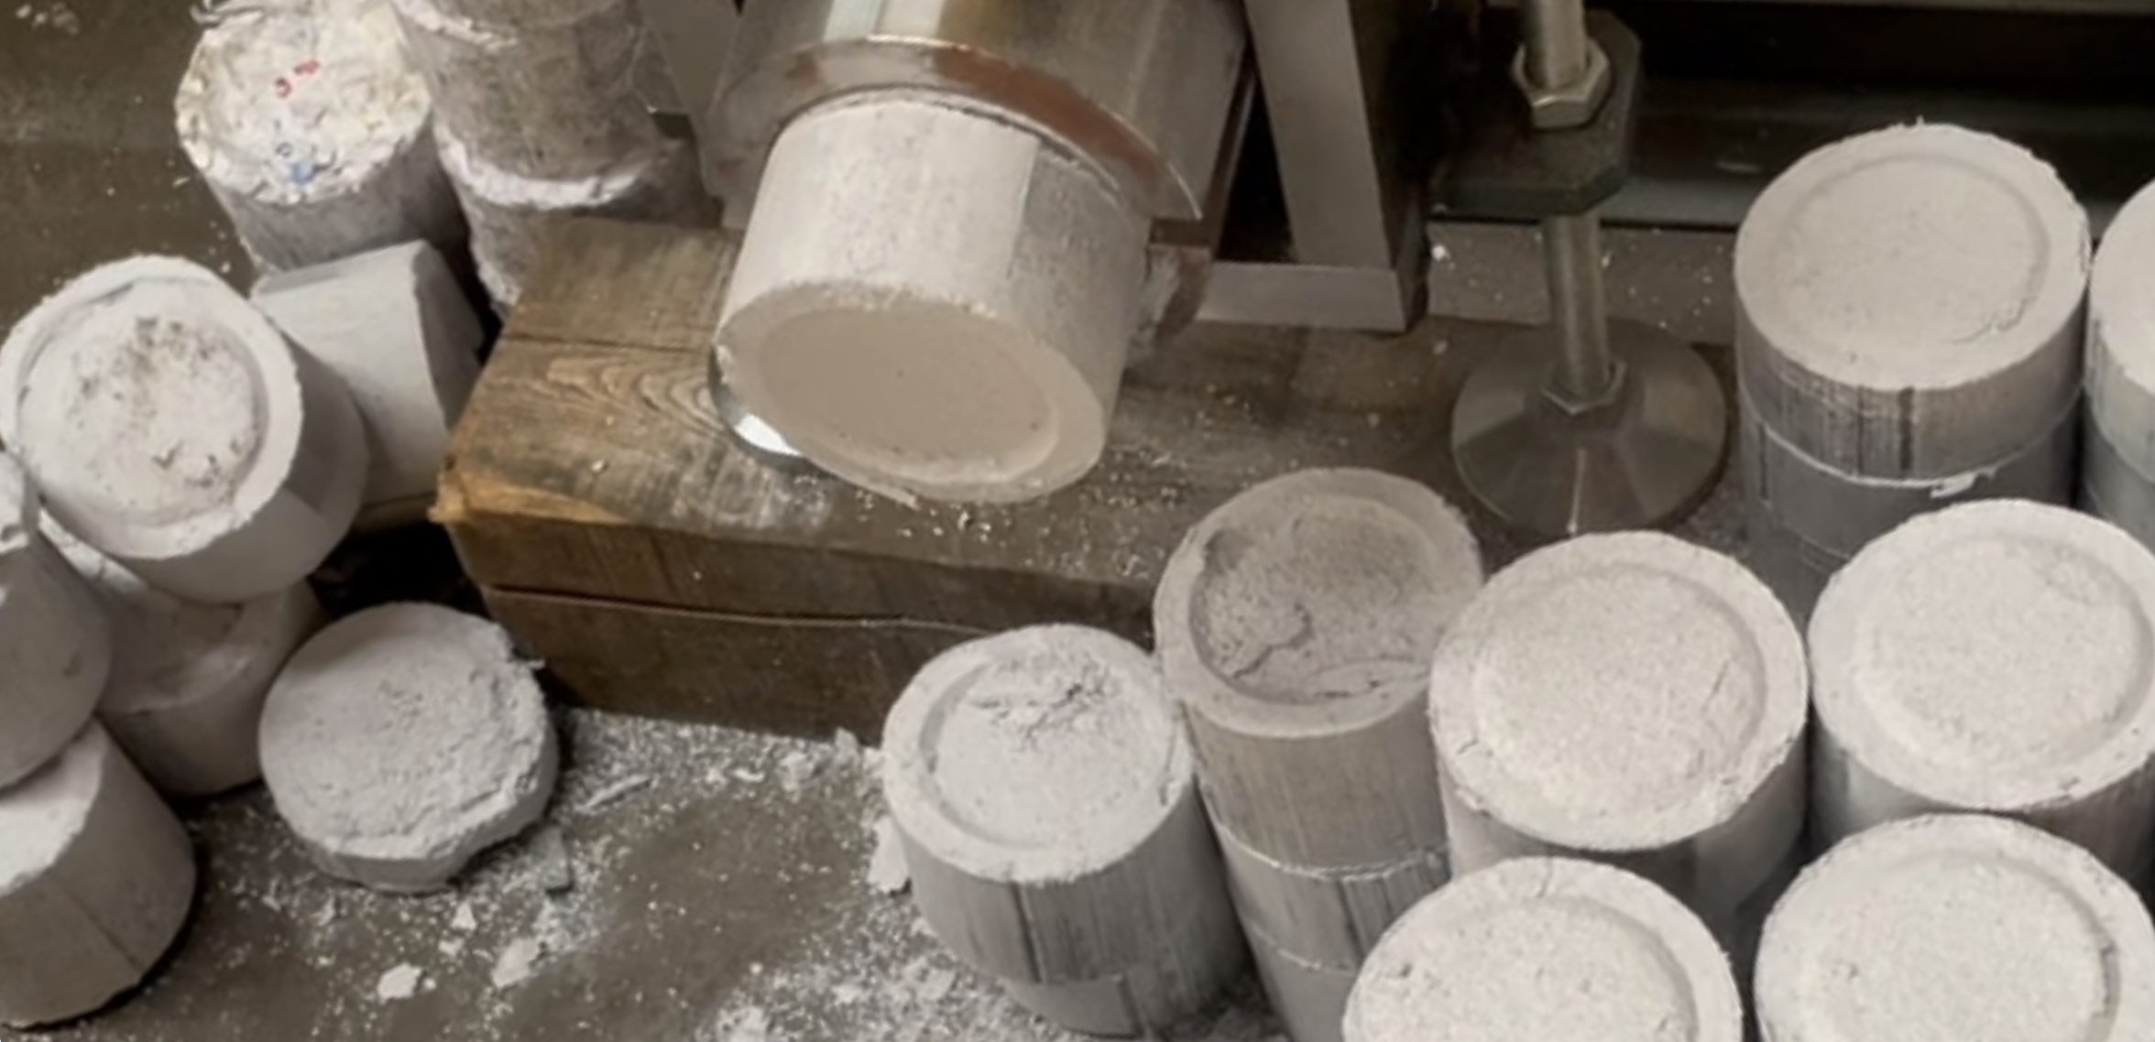
 |  | 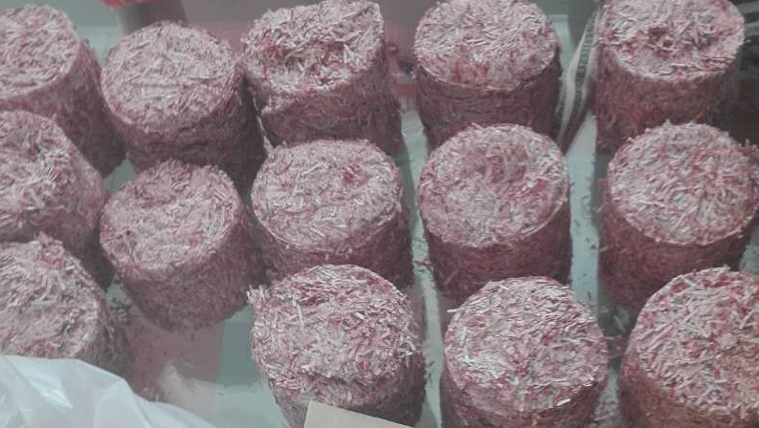 | 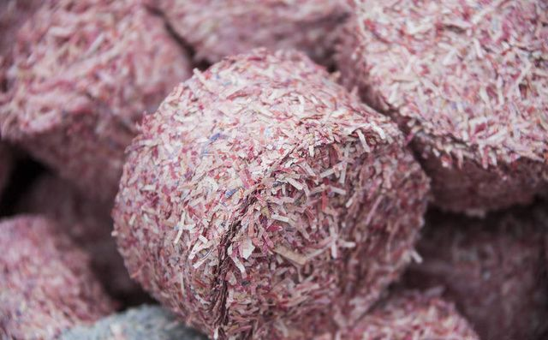

🔒 Industry Background 行业背景
Banknotes, securities, and confidential financial materials require strict, centralized destruction under national regulations.
In most countries, the Central Bank or Security Printing Corporation mandates that obsolete or damaged banknotes be shredded and compacted before final disposal — ensuring both security and traceability throughout the process.
钞票、证券及金融票据的销毁，必须在中央银行或安全印钞机构的监管下集中完成。
传统的单一碎纸设备已无法满足安全与环保的双重要求，现代化的销毁系统要求从粉碎到压块、除尘、集中收集、信息留痕的全流程闭环管理。

💡 YUEDU Solution Overview 越都解决方案总览
Goal: Provide a secure, reliable, and scalable destruction line from in-feed to briquette, with full process traceability and low TCO.
目标：从进料到压块的全流程安全销毁，提供可扩展产能、全程可追溯与低总拥有成本（TCO）。
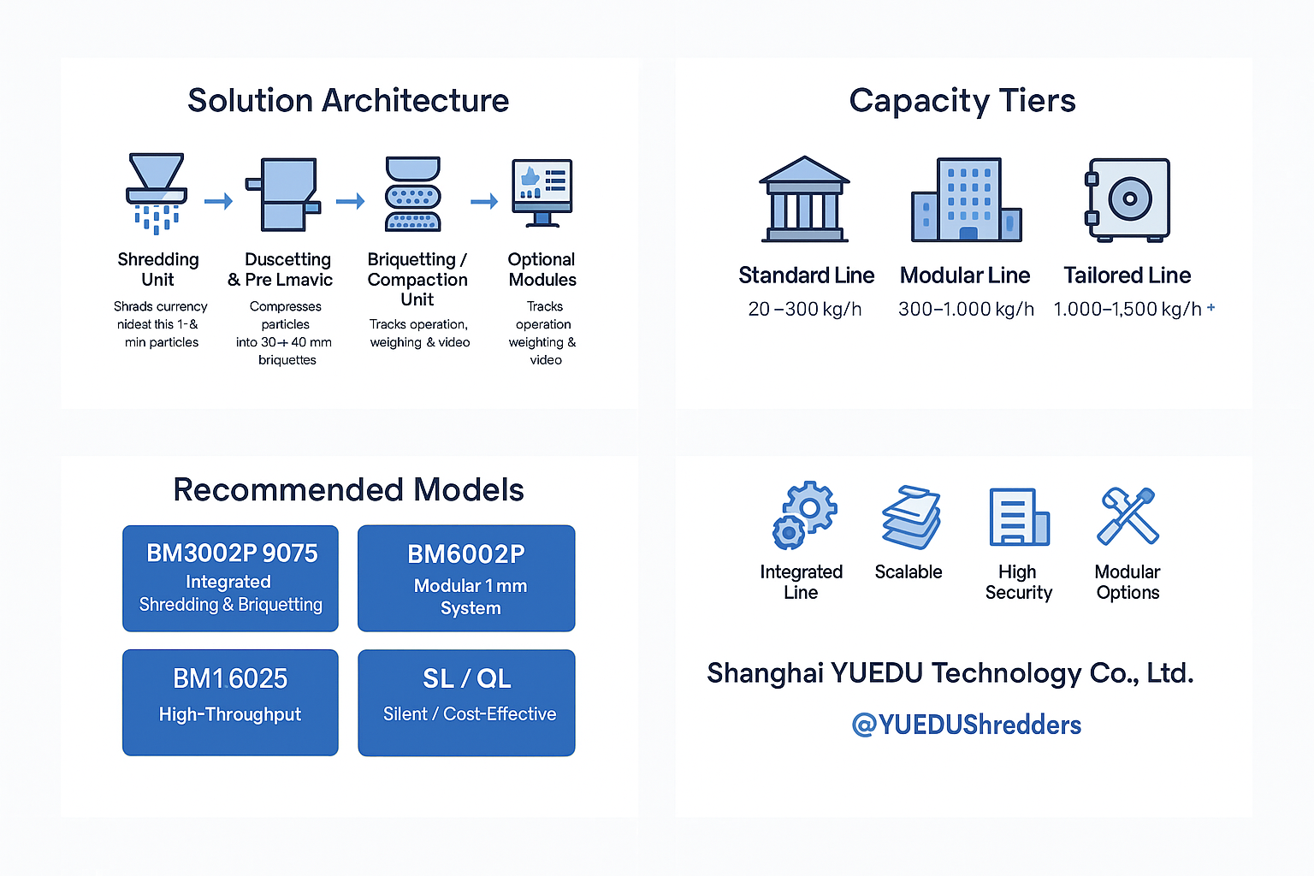
Structure solutions as Standard / Modular / Tailored Lines, all modular & scalable to site constraints and capacities.
标准线、模块化线与定制线三轨并行，按产能与银行场地灵活组合，均为模块化可扩展结构。
Capacity spans 20–1,000 kg/h (standard) and can be customized up to 1,500 kg/h; shredding, suction, dust filtration and briquetting are delivered as one coherent solution.
产能覆盖20–1000 kg/h（标准），可定制到1500 kg/h；粉碎、抽吸、除尘与压块作为统一方案交付。

🧩 Solution Architecture – 系统架构（模块化）

⚙️ System Workflow 系统运行流程
Feeding → Shredding → Dust Dust Extraction & Pneumatic Conveying→ Briquetting / Bagging → Monitoring & Control → Storage/Dispatch
进料 → 粉碎 → 抽吸/气力输送 + 除尘过滤 → 压块/装袋 → 监控与控制 → 储运
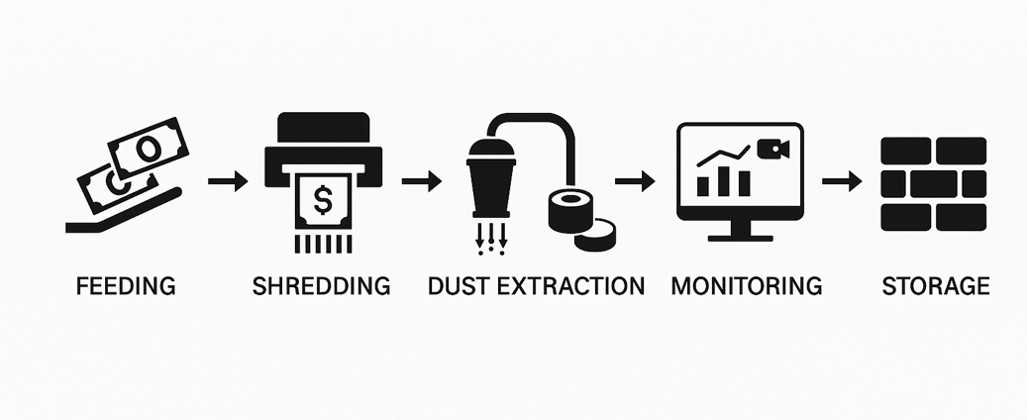
Each stage works seamlessly through modular design and centralized PLC control, ensuring continuous operation, data traceability, and high-level security for national banks, mints, and document destruction centers.
整线采用模块化结构与 PLC 集中控制，实现连续作业、数据留痕及高等级保密，适用于中央银行、造币厂及安全印务机构的集中销毁中心。

🔧 System Composition 系统组成结构
No. | Module 模块 | Description (English) | 中文说明
1️ | Feeding & Preparation Unit | Handles the intake of obsolete banknotes or securities. Designed with safety covers and anti-jam protection to ensure stable feeding. | 进料与准备单元，用于接收需销毁的废旧钞票或凭证，配备安全盖与防卡装置，确保进料稳定安全。
2️ | Shredding Unit | High-torque industrial shredder reduces banknotes into fine particles of 1–3 mm (up to 1 mm powder for top-security applications). | 高扭矩工业粉碎机，将钞票粉碎成1–3 mm颗粒（可达1 mm粉末级），满足高级别保密销毁需求。
3️ | Dust Extraction Unit | Multi-stage dust collection and filtration system maintains a clean, dust-free working environment and protects operators. | 多级除尘与过滤系统，实时吸附纸粉，保持销毁现场洁净无尘，保障操作环境安全。
4️ | Briquetting / Compaction Unit  / Bagging | Briquetting / Compaction Unit  Compress shredded particles into Ø90×40 mm briquettes for easy weighing, storage, and traceable disposal.  Bagging / Boxing  More economical and easier to handle and ship for small volumes or polymer notes. | 大量（高通量）：  液压压块（高压缩比，显著降低储运成本）。  小量（小批量或聚合物）：  装袋/装箱更经济，装运处理更轻松。
5️ | PLC & Monitoring with Traceability | Central control with touch-screen interface integrates all modules, providing real-time operation data, weighing records, and video traceability.  Lockable hoppers and the two-person rule ensure secure batch operations with full auditability. | 中央 PLC 触控控制系统整合全线设备，实时显示运行状态、称重记录及影像留存，确保全过程可追溯。可对接客户现金中心系统。  上锁料仓与“两人规则”支持批次化安全作业，满足审计留痕。
6️ | Optional Modules | Customizable extensions such as conveyor auto-feeding, magnetic separation units, weighing platforms, Remote diagnostics, Reports & dashboards. | 可选扩展模块：输送带自动进料、磁分选装置、称重台、远程诊断、报表与看板等，根据场地与需求灵活配置。

Capacity Tiers & Line Types / 产能档位与线路类型
Reference Line 参考线 | Typical Capacity 典型产能 | Usage Scenarios  场景 | Models
Standard Line 标准线 | 20–300 kg/h | Security Rooms / Municipal Destruction Room  涉密销毁室/地市销毁室 | Solution C: Cost-Effective 1–3mm Shredding  ✔ (6/7) QL300 – QL600 Series – Budget-friendly shredders from $2,000  ✔ (7/7) SL500 – SL700 Series – Silent, high-security shredding for offices
Modular Line  模块化线 | 300–1,000 kg/h | Provincial / National Treasury Large-Scale Center  省行/国库大型中心 | Solution B: Ultra-Fine 1mm Shredding System  ✔ (4/7) 300BM1 – 600BM1 Series – Ultra-fine shredding (1mm) for P-6 compliance  ✔ (5/7) Modular Systems 6002 & 4001 – Customizable with briquetting/baling
Tailored Line 定制线 | 1,000–1,500 kg/h+ | National Cash Center / Banknote Printing Plant / Central Banks  国家级现金中心/印钞厂 | Solution A: Integrated Shredding & Briquetting  ✔ (1/7) BM3002P-9075 – High-security integrated shredding & briquetting  ✔ (2/7) BM6002P – Dual-stage shredding for high-capacity destruction  ✔ (3/7) Models 5002 & 5001 – Shredding + baling combo

Case study • Client B
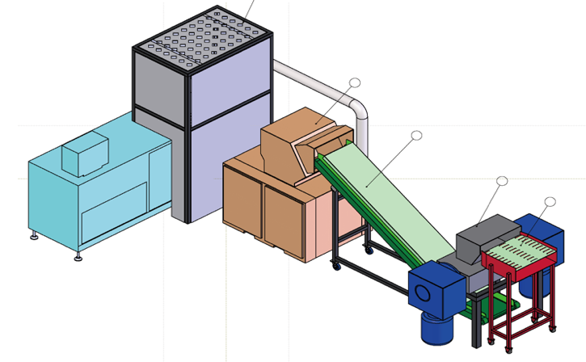 | 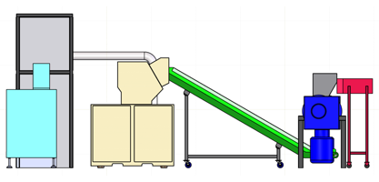
 | 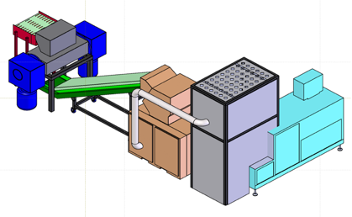

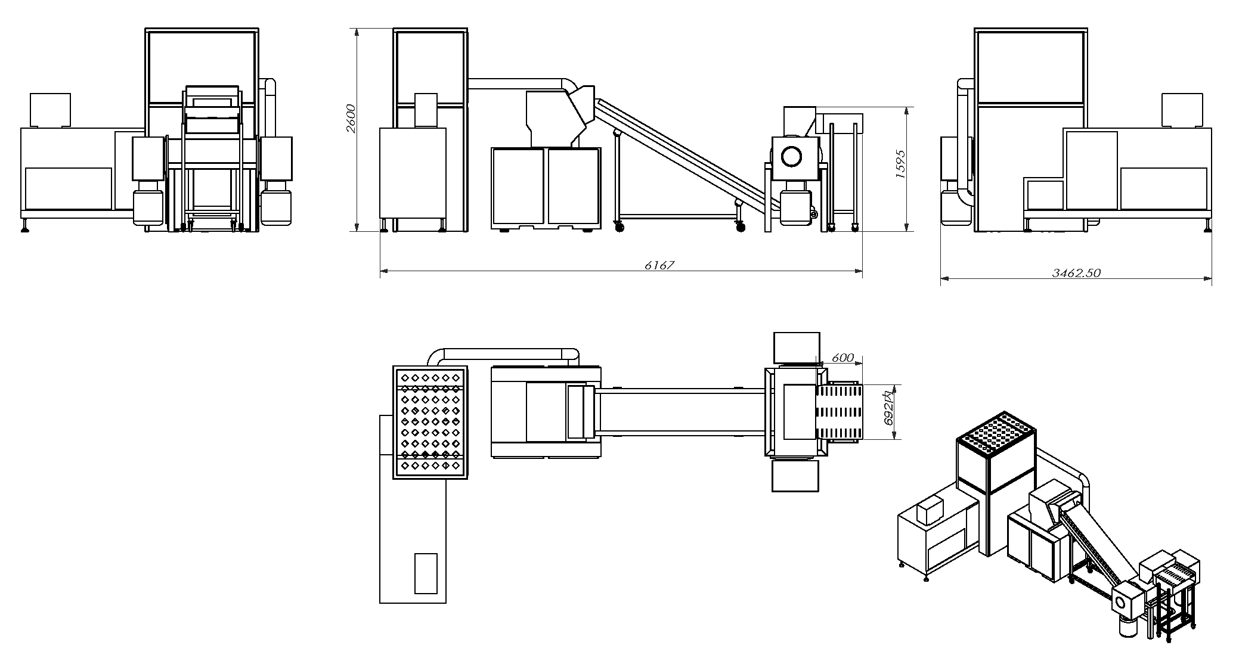

📦 Recommended Models 推荐机型
Model 型号 | Type & Positioning 类型与定位 | Target Scenario 适用场景 | Capacity / Throughput 产能 | Briquette / Baler 压块/打包 | Key Highlights 特点
BM3002P-9075 | Integrated shredding + briquetting 一体化粉碎+压块 | Provincial / Municipal Destruction Room 省级/地市销毁室 | 100–150 kg/h @ 3 mm；~75 kg/h @ 1 mm | Ø90×40 mm paper briquette 纸砖 | Closed feeding, dual-control, PLC HMI, video & weighing traceability 关闭式进料、双重控制、PLC触屏、视频与称重追踪
BM6002P | Modular 1 mm mainline 模块化1 mm主线 | Provincial Bank / Treasury Center 省行/国库中心 | 300–700 kg/h（scalable 可扩展） | Briquetter / Baler 可联机压块/打包 | Multi-point suction, long-run ducting, cross-room/floor 跨房间/楼层多点抽吸，主线扩展性强
BM6002P (Parallel) + YKJ90-75 / 90-250 | High-throughput parallel line 并联系统 | National Cash Center / Banknote Printer 国家级现金中心/印钞厂 | 1000 kg/h+（按需并联） | YKJ90-75 (single port) / YKJ90-250 (dual port) | Scalable, low TCO, high uptime 可扩展、低总拥有成本、稳定高可用
BM4001 | Compact 1 mm upgrade 紧凑1 mm升级 | Small rooms / retrofit 存量房间快速改造 | — | Works with existing system 可对接既有除尘/压块 | Quick fit-in; integrate with existing suction & briquetter 快速适配、易对接
5002 (or 5001/500CC2024) | Pre-shred + baling 预破碎+打包 | Pre-shred to offload main line 预破碎减载 | 500–600 kg/h（single line 单线） | Bale 50–75 kg 打包出块 | Reduces main load & raises stability 降低主机负载、提升稳定性
YTJ-BM1 Series (300/400/500/600BM1) | Ultra-fine 1×1 mm 超微粉末级 | Classified room / Military / Finance 涉密销毁室/军警金融 | 80–500 张/次（按机型） | — | Belt-feed; handles thick bound files 输送进料、整本厚档案直入
SL500 / SL600 / SL700 | Silent high-security 静音高保密 | Office / Voucher Room 办公室/票据室 | — | — | Low noise, compact footprint 静音、小占地；建议并联小型除尘
QL300–QL600 | Cost-effective line 经济型 | Small / Mid volume 中小量/基层网点 | — | — | Budget-friendly；prefer bagging/boxing 价格友好；建议装袋/装箱更经济
PSJ300 / 350 / 500 / 468（延伸选配） | Industrial pre-shred 工业级预破碎 | Books/archives pre-shred 书本/档案预处理 | 100–1000+ kg/h（依配置） | 可对接打包/输送 | Dual-inlet, continuous duty 双入口、可24h连续

🏛 Case Studies 案例参考
- People’s Bank of China (PBOC) – Provincial Destruction Centers
- Shanghai Mint & Nanjing Mint – Banknote printing & recycling
- National Security Printing Plant – Integrated shredding + briquetting
- African & Asian Central Banks – YD-BM3002P customized destruction line
- Classified/confidential entity – YD-BM6002 ultra-fine (powder-grade) shredding system.

Case study • client C

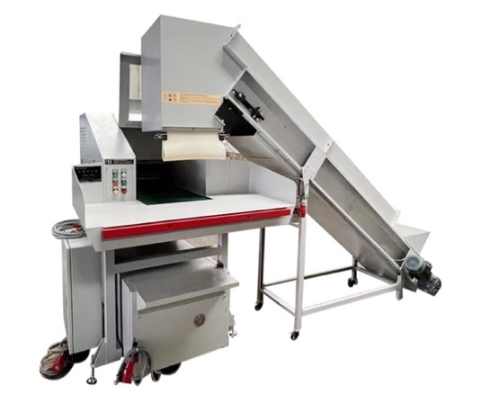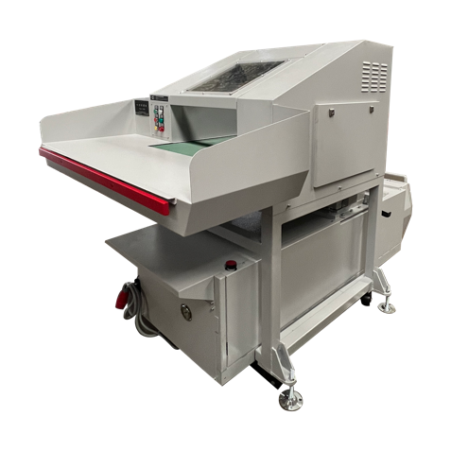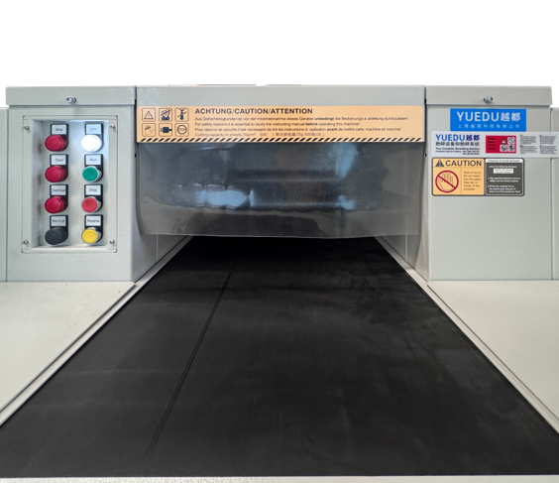
Case study • client D
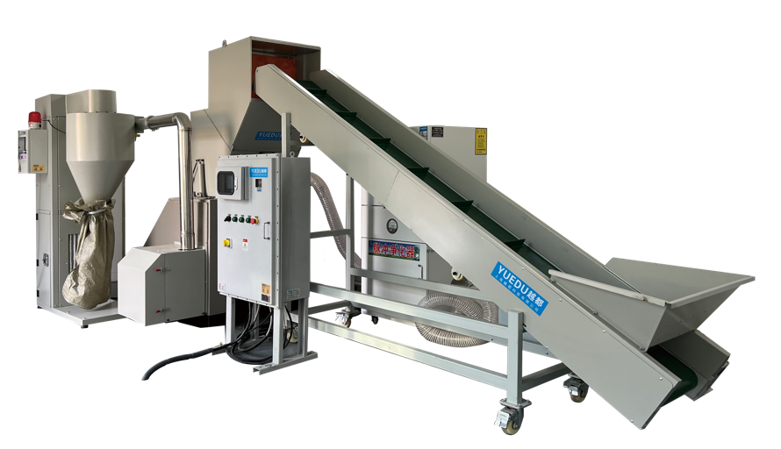
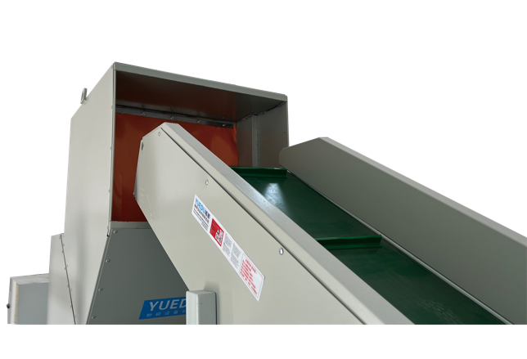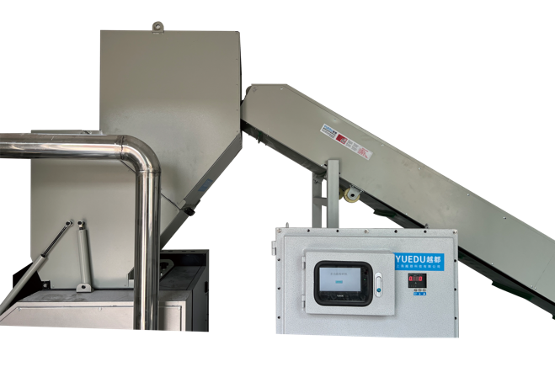
Case study • client E
A Central Bank in the Russian Region
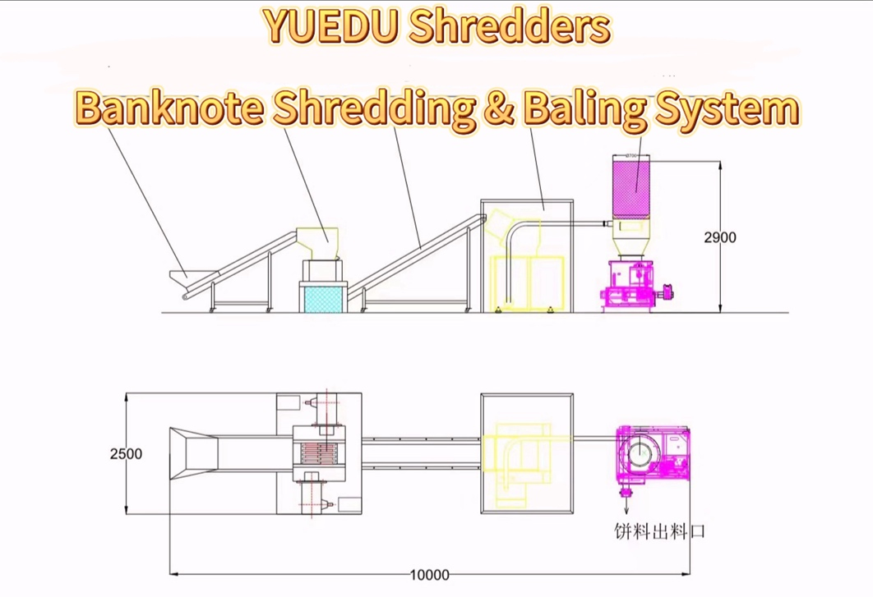

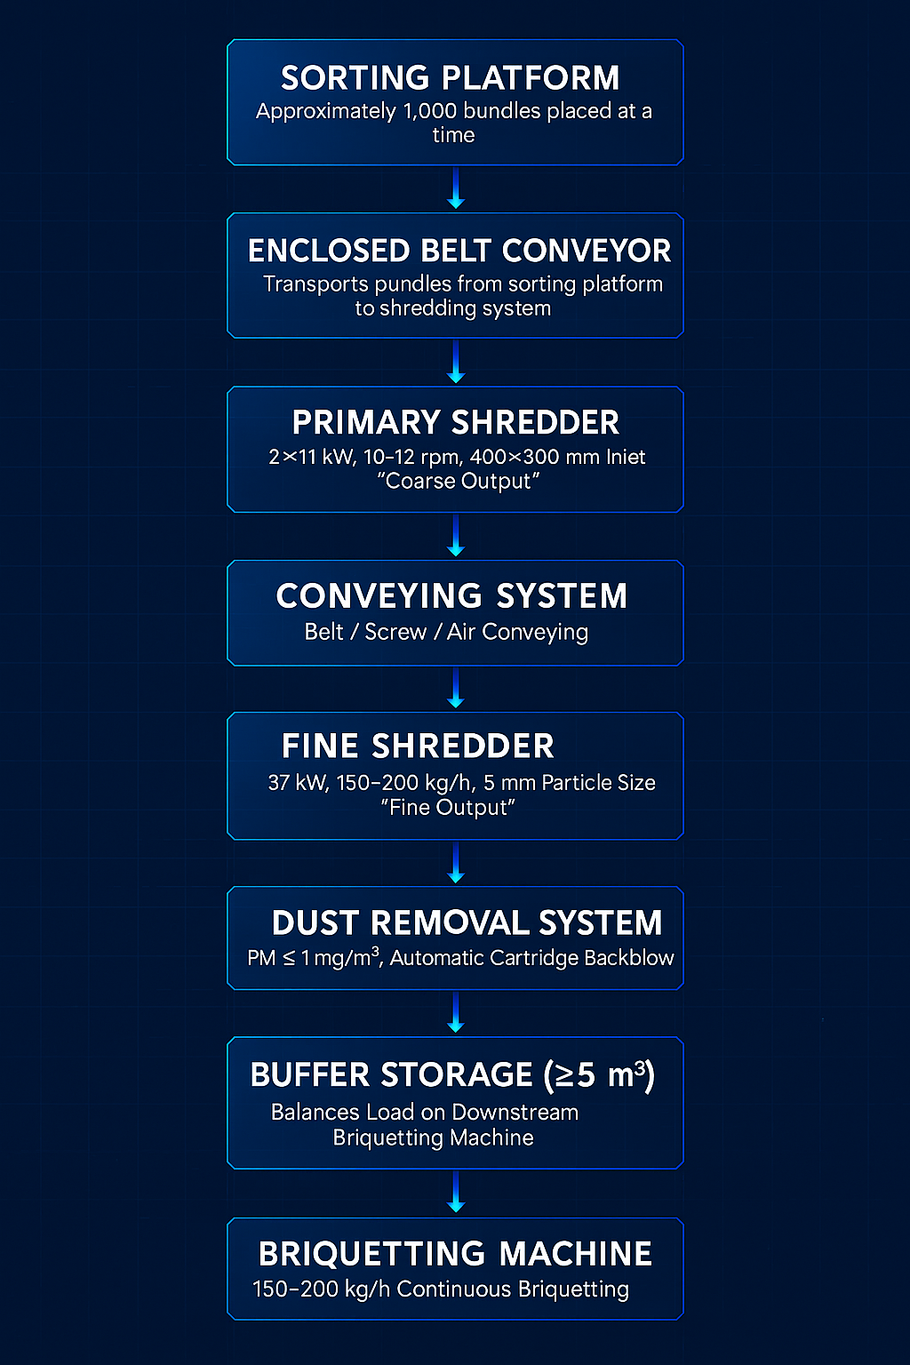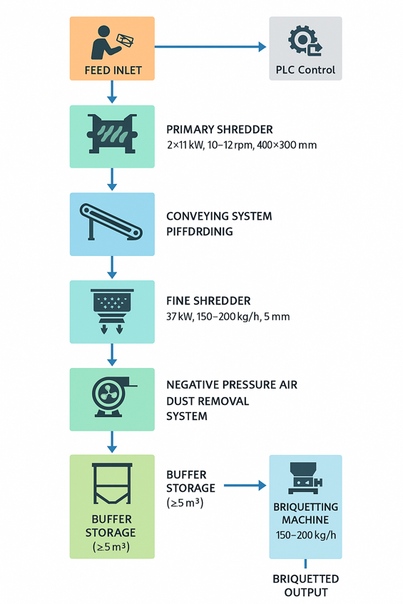

🌍 Compliance & Certification 符合标准与认证
✔ DIN 66399 P-6 / P-7
✔ China National Level 1 Confidentiality Standard
符合 DIN 66399 P-6/P-7 与中国 1 级保密

Why YUEDU / 为什么选越都
- Aligned with international architectures (Standard / Modular / Tailored) covering the full process—feeding, shredding, suction, briquetting, and monitoring—while delivering lower cost and faster lead times.
对标国际结构（标准/模块化/定制三轨 + 进料-粉碎-抽吸-压块-监控全流程），且成本更优、交付更快。
- Integrated + modular approach: from small destruction rooms to national cash centers, with optional briquetting or bagging configurations.
一体化与模块化并举：小型销毁房间到国家级现金中心全覆盖，可选压块/装袋方案。
✓ Proven technical capability in multi-stage shredding systems
✓ Compliance with central bank destruction standards
✓ Stable, durable, and safety-certified industrial machinery
✓ Experience integrating complete destruction lines
(coarse shredding → fine shredding → air conveying → dust removal → briquetting)
YUEDU is fully qualified to deliver:
- Safe
- Reliable
- International-standard
- Long-term maintainable
banknote destruction systems for the Central Bank.

🌐 Contact Us 联系我们
Shanghai YUEDU Technology Co., Ltd.
上海越都科技有限公司
📧 Email: yuedushredders@gmail.com | denghao8410@gmail.com
📱 WhatsApp / WeChat: +86 159 0178 2779
🌐 Website: www.yuedushredders.com
@YUEDUShredders – Empowering Global Industries with Intelligent Destruction Systems.

