📁 4. Twin-Shaft Shredder Series
Featuring a dual-shaft open feed design, suitable for processing industrial waste, boxed documents, plastic barrels, circuit boards, and other rigid materials.
Convenient for integration with upstream and downstream equipment in user production lines.
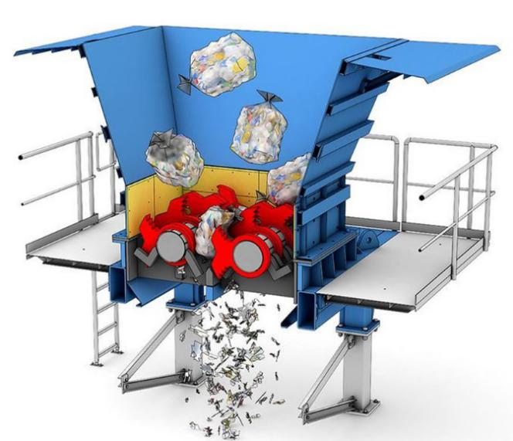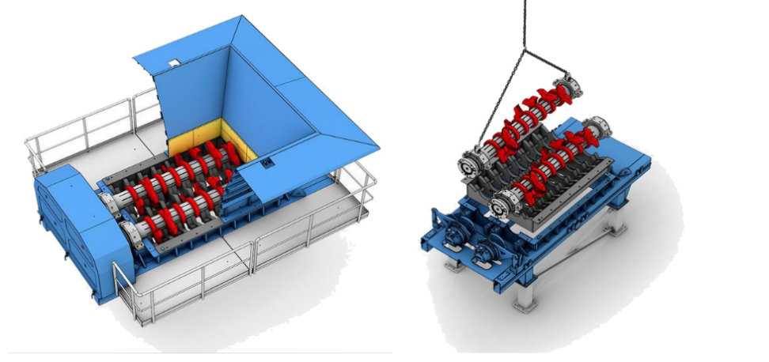
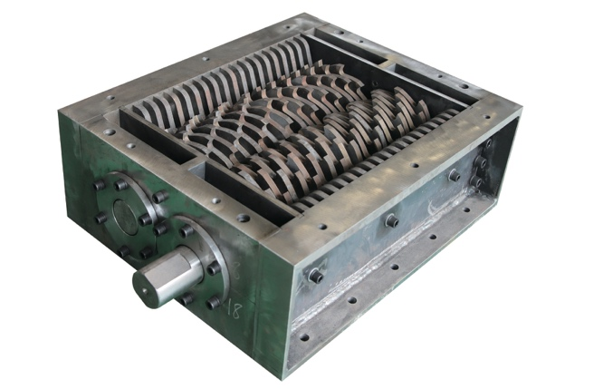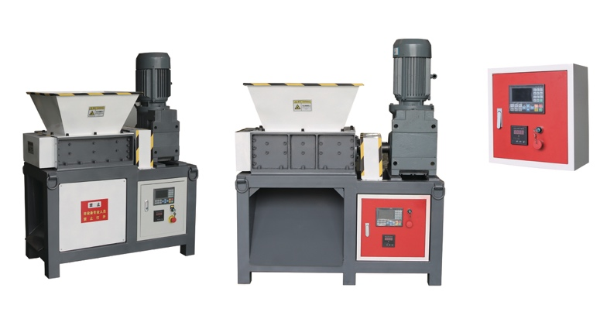

📁 4. 双轴撕碎机系列（Twin-Shaft Shredder Series）
采用双轴开放式大入口设计，适用于处理工业废料、整箱文件、塑料桶、线路板等各类硬质物料，便于与用户生产线前端和后端处理设备无缝对接。

➕ Custom Cases更多定制案例
🖼️Front View | 📥Feeding Inlet | 🆔Model |  | 💰Price (USD)

📄 YD-SSJ Series Twin-Shaft Shredder
Small Twin Shaft Shredders Selection Table v3
🆔Model | ⚡Motor | ⚙️Gearbox | 📏Blade Spec. | 🔢Blades Num. | 📥Hopper Size (mm) | 📏 L×W×H  (mm) | 💰Price (RMB) | 💰Price (USD)
🆔型号 | ⚡电机 | ⚙️减速机 | 📏刀片规格 | 🔢刀片数量 | 📥料斗尺寸 | 📏外形尺寸 | 💰人民币价 | 💰美元报价
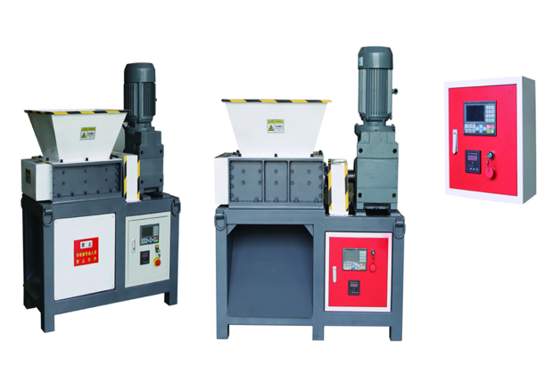
Single Motor Model单电机机型
YD-SSJ300SK | 3KW-4, 1 unit | k77,1 unit | Φ180*10 | 29 | 500*500*300 | 1100*650*1350 | 30500 | 4358
YD-SSJ400SK | 5.5KW-4,1 unit | K87,1 unit | φ180*15 | 27 | 500*600*300 | 1250*650*1450 | 41800 | 5972
YD-SSJ400SK | 5.5KW-4,1 unit | K87,1 unit | φ180*10 | 40 | 500*600*300 | 1250*650*1450 | 43800 | 6258
YD-SSJ500SK | 7.5KW-4,1 unit | K97,1 unit | Φ200*20 | 24 | 600*700*400 | 1400*750*1600 | 57300 | 8186
YD-SSJ600SK | 7.5KW-4,1 unit | K107,1 unit | Φ220*25 | 24 | 700*800*500 | 1600*900*1750 | 72500 | 10358
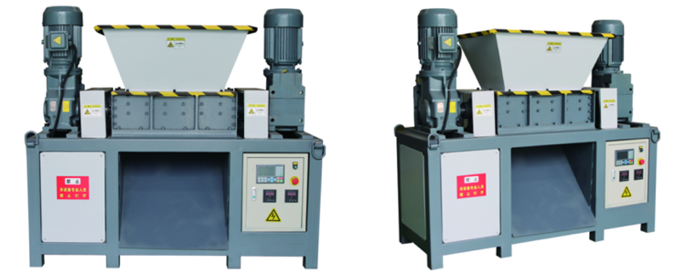
Dual Motor Model双电机机型
YD-SSJ400DK | 5.5KW-4, 2 unit | K87,2 unit | Φ180*15 | 27 | 500*600*300 | 1600*650*1450 | 62000 | 8858
YD-SSJ400DK | 5.5KW-4, 2 unit | K87,2 unit | Φ180*10 | 40 | 500*600*300 | 1600*650*1450 | 59900 | 8558
YD-SSJ500DK | 7.5KW-4,2 unit | K97,2 unit | Φ200*20 | 24 | 600*700*400 | 1900*750*1600 | 75400 | 10772
YD-SSJ600DK | 7.5KW-4, 2 unit | K107,2 unit | Φ220*25 | 24 | 700*800*500 | 2100*750*1800 | 98600 | 14086
🧩Custom Cases & Our Advantages 我们的优势
We provide on-site customized solutions based on your specific needs. With extensive experience in dual-shaft shredding applications, YUEDU Shredders is committed to efficient and honest communication to deliver precisely matched products and services.越都公司在撕碎机和粉碎的领域拥有丰富的应用经验。期待为您提供精准匹配的产品与服务。

📞 Contact Us

Johnny Deng, Managing Director
☎️ Phone: +86 159 0178 2779 (WhatsApp / WeChat / Facebook / Telegram)
📧Email: denghao8410@gmail.com

Shanghai YUEDU Technology Co., Ltd. (YUEDU Shredders)
🌐 Website(Global): www.yuedushredders.com (note: VPN required for China access, as the server is hosted by Google.)
📧 Email: yuedushredders@gmail.com / denghao8410@gmail.com
☎️ Sales Supervisor: +86 159 0178 2779 (WhatsApp / WeChat / Facebook / Telegram) ☎️ Administrative Supervisor: +86 137 6138 5116
☎️ Head Office Main Line: +86 21 519 000 20
📍 Company Headquarters: Building 12, No. 555 Chengyin Road, Baoshan City Industrial Park, Shanghai, China

与我们联系（中文普通话）

上海越都科技有限公司
📍公司总部：上海市宝山城市工业园区城银路555弄12号楼
☎️ 中文电话: 138 1115 0898（同微信）, 137 1700 3125（同微信）, 188 1682 6112（同微信）
☎️ 公司总机：021 - 519 000 20
☎️ 行政总裁：137 6138 5116
☎️ 投诉电话：159 0178 2779
📧 Email邮箱: denghao8410@gmail.com
🌐 Website(中文网站): www.91suizhiji.com
🌐 文档下载站： www.daxingsuizhiji.com

